Copper Based Multifunctional Nanocrystals for a Pragmatic Approach Towards Cancer Theranostics
M. Sheikh Mohamed¹, Srivani Veeranarayanan¹, Aby Cheruvathoor Poulose¹, Yasushi Sakamoto², Toru Maekawa¹, D. Sakthi Kumar¹

¹Bio Nano Electronics Research Centre, Toyo University, Japan
²Biomedical Research Centre, Saitama Medical University, Japan

Abstract
Multifunctional nanocrystals (NCs) for bio-applications are gaining momentum due to their advantageous role of performing multiple functions simultaneously. For example, NCs with simultaneous imaging and therapeutic potential are highly attractive as they can serve for image-guided therapy and can be considered for personalized cancer medicine. Especially Cu based NCs are garnering increased attention recently for their ease of preparation, biocompatibility and multimodal applications. Herein we present a series of plasmonically active Cu based NCs for cancer theranostics. The main features that would be discussed will be about multi-stimuli responsive chemotherapeutics as well as multimodal drug-free alternative theranostic options. The application of these NCs in diagnostic modalities such as photoacoustic, X-ray contrast, and optical (visible and NIR) imaging would be discussed. As far as therapeutic modality is concerned, chemo (external stimuli such as NIR and visible light responsive drug release), photothermal and photodynamic therapeutic options would be presented. The immense potential of these NCs cannot be undermined and they are sure to make a lasting impression in the nanomedicine/theranostics arena.

Cu Based NCs & Their Multifarious Applications
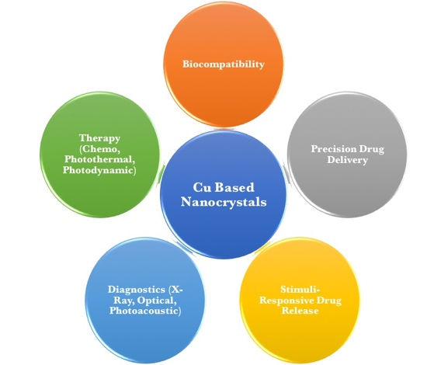
Recent Publications
- Poulose AC, Veeranarayanan S, Mohamed MS et al (2016) Multifunctional Cu_{2-x}Te Nanocubes Mediated Combination Therapy for Multi-Drug Resistant MDA MB 453. Sci Rep 6:35961.
- Poulose AC, Veeranarayanan S, Mohamed MS et al (2015) Multi-stimuli responsive Cu₂S nanocrystals as trimodal imaging and synergistic chemo-photothermal therapy agents. Nanoscale 7: 8378-8388.
- Mohamed MS, Poulose AC, Veeranarayanan S et al (2016) Plasmonic fluorescent CdSe/Cu₂S hybrid nanocrystals for multichannel imaging and cancer directed photo-thermal therapy. Nanoscale 8:7876-7888.
- Poulose AC, Veeranarayanan S, Mohamed MS et al (2015) Characterizing the Biocompatibility and Tumor-Imaging Capability of Cu₂S Nanocrystals In Vivo. Nanoscale 7:13061-13074.
- Veeranarayanan S, Mohamed MS, Poulose AC et al (2017) Ultra-Low Power NIR Laser Induced Photosensitizer-Free Photo-Dynamic Therapy and High Contrast X-Ray Imaging using Cu₃BiS₃ Nanocrystals. ACS Appl Mater Interfaces, Under Review.

Biography
Dr. M. Sheikh Mohamed, currently a post-doctoral researcher at Bio-Nano Electronics Research Centre, Toyo University, Japan has nearly 8 years of research experience in the field of Bio-Nano Fusion Sciences, with a focus on synthesis and application of multifunctional nanoparticles for cancer theranostics. He has received best young researcher and best poster awards at International conferences and has published 15 peer-reviewed research articles with five cover pages in reputed journals, which have also been featured as news articles. Previously, he received the University Gold Medal during his M.Phil. in India and subsequently the prestigious Monbukagakusho Scholarship to pursue his Ph.D. in Japan.
Email: m.sheikhmohamed@gmail.com

