Title: Sustained Release and Skin Permeability Enhancement of Pentazocine by Proniosome derived Niosomes and Niosomal Gel
Asadullah Madni^{1*}, Muhammad Abdur Rahem¹, Muhammad Ahmad Mahmood¹, Mubashar Rehman¹ and Nayab Tahir¹
¹Department of Pharmacy, The Islamia University of Bahawalpur, Bahawalpur 63100, Punjab, Pakistan
Corresponding Author:
Dr. Asadullad Madni,
Address: Assistant Professor, Department of Pharmacy, The Islamia University of Bahawalpur, Railway Road, Punjab, Bahawalpur 63100, Pakistan
Email: asadpharmacist@hotmail.com, Phone: +92 62925 5243, Fax +92 62925 5565
Abstract
Proniosomes (PN) are the dry water soluble carrier systems that may enhance the oral bioavailability, stability and topical permeability of therapeutic agents. The low solubility and low oral bioavailability due to extensive first pass metabolism make Pentazocine as an ideal candidate for oral and topical sustained release delivery. The present study was aimed to formulate the PNs by quick slurry method that are converted to niosomes (liquid dispersion) by hydration, and subsequently formulated to semisolid niosomal gel. The PNs were found in spherical shape in the SEM and stable in the physico-chemical and thermal analysis (FTIR, TGA and XRD). The quick slurry method produced high recovery (>80% yield) and better flow properties (θ=28.1-37.4°). After hydration, the niosomes exhibited desirable entrapment efficiency (44.45-76.23%), size (4.98-21.3µm) and zeta potential (-9.81mV to -21.53 mV). The in vitro drug release (T_{100%}) was extended to more than three half-lives (2-4 hrs) and showed good fit to Fickian diffusion indicated by Korsmeyer-Peppas model (n=0.136-0.365 and R²=0.9747- 0.9954). The permeation of niosomal gel was significantly enhanced across rabbit skin compared to the pure drug-derived gel. Therefore, the PNs are found promising candidates for oral as bioavailability enhancement and sustained release for oral and topical delivery of pentazocine.
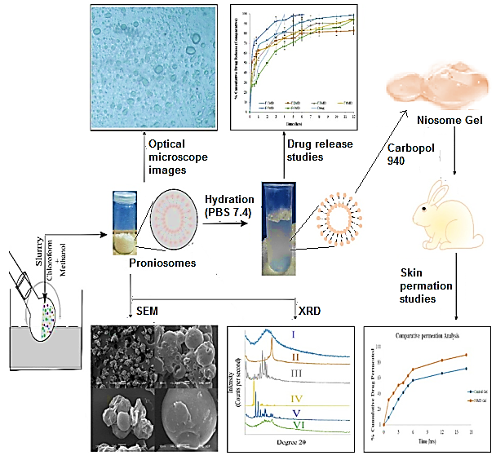
Figure. Graphical abstract of PN vesicular delivery for the Pentazocine.
Biography
Dr. Asadullah Madni has completed his PhD from the Faculty of Pharmacy and Alternative Medicine, The Islamia University of Bahawalpur, Pakistan and postdoctoral studies from University of Auckland, New Zealand. He is working as Assistant professor in the Faculty of Pharmacy and Alternative Medicine, The Islamia University of Bahawalpur, Pakistan. His area of research include the pharmaceutical nanotechnology and novel drug delivery systems for the targeted therapy of different diseases. He has published more than 60 research papers in well reputed international journals.

