Combined Use of Zoledronic Acid Augments Ursolic
Acid-Induced Apoptosis in Human Osteosarcoma
Cells through Enhanced Oxidative Stress and Autophagy
Chia-Chieh Wu ^{1,2,3}, Yi-Fu Huang ², Yao-Li Chen ^{4,5} and Pin-Ju Chueh ¹
1. Institute of Biomedical Sciences, National Chung Hsing University, Taichung, Taiwan
2. Orthopedics & Sports Medicine Laboratory, Changhua Christian Hospital, Changhua, Taiwan;
3. Department of Orthopedic Surgery, Changhua Christian Hospital, Changhua, Taiwan
4. Transplant Medicine & Surgery Research Centre, Changhua Christian Hospital, Changhua, Taiwan
5. Department of Surgery, Changhua Christian Hospital, Changhua, Taiwan

Abstract (300 word limit)
Ursolic acid (UA), a naturally occurring pentacyclic triterpene acid found in many medicinal herbs and edible plants, triggers apoptosis in several tumor cell lines but not in human bone cancer cells. Most recently, we have demonstrated that UA exposure reduces the viability of human osteosarcoma MG-63 cells through enhanced oxidative stress and apoptosis. Interestingly, an inhibitor of osteoclast-mediated bone resorption, zoledronic acid (ZOL), also a third-generation nitrogen-containing bisphosphonate, is effective in the treatment of bone metastases in patients with various solid tumors. In this present study, we found that UA combined with ZOL to significantly suppress cell viability, colony formation, and induce apoptosis in two lines of human osteosarcoma cells. The pre-treatment of the antioxidant had reversed the oxidative stress and cell viability inhibition in the combined treatment, indicating that oxidative stress is important in the combined anti-tumor effects. Moreover, we demonstrated that ZOL combined with UA significantly induced autophagy and co-administration of autophagy inhibitor reduces the growth inhibitory effect of combined treatment. Collectively, these data shed light on the pathways involved in the combined effects of ZOL and UA that might serve as a potential therapy against osteosarcoma.

Image

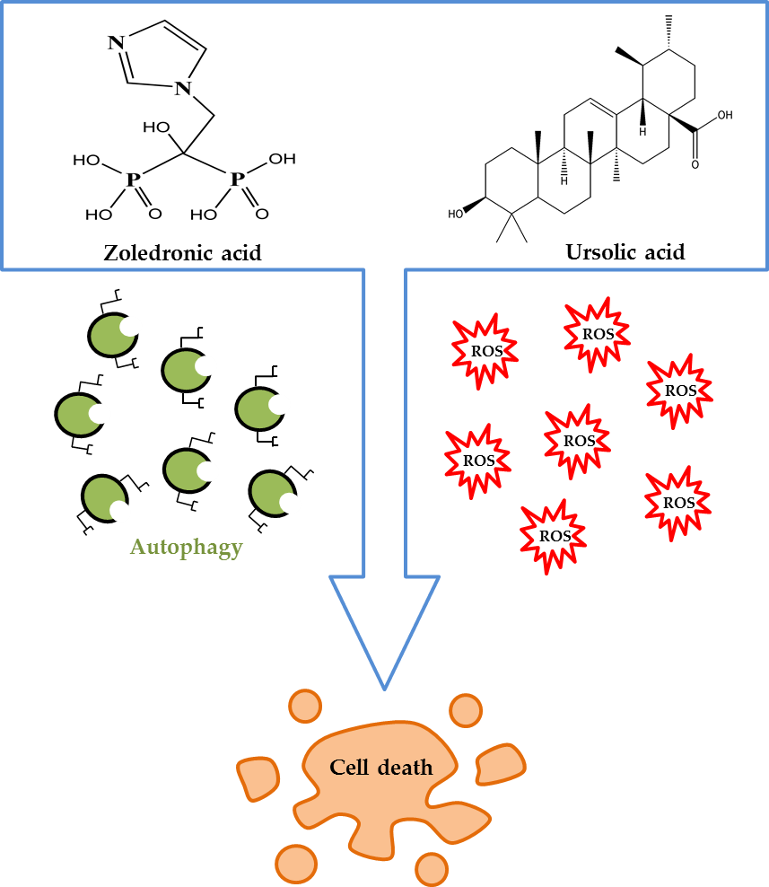
Recent Publications (minimum 5)
- Broadhead, M.L.; Clark, J.C.; Myers, D.E.; Dass, C.R.; Choong, P.F. (2011) The molecular pathogenesis of osteosarcoma: A review. Sarcoma, 2011, 959248.
- Wu, C.C.; Cheng, C.H.; Lee, Y.H.; Chang, I.L.; Chen, H.Y.; Hsieh, C.P.; Chueh, P.J. (2016) Ursolic acid triggers apoptosis in human osteosarcoma cells via caspase activation and the ERK1/2 MAPK pathway. J. Agric. Food Chem.64, 4220–4226.
- Chang,J.;Wang,W.; Zhang, H.; Hu, Y.; Yin, Z. (2012) Bisphosphonates regulate cell proliferation, apoptosis and pro-osteoclastic expression in MG-63 human osteosarcoma cells. Oncol. Lett. 4, 299–304.
- Moriceau, G.; Ory, B.; Mitrofan, L.; Riganti, C. (2010) Zoledronic acid potentiates mTOR inhibition and abolishes the resistance of osteosarcoma cells to RAD001 (everolimus): Pivotal role of the prenylation process. Cancer Res. 70, 10329–10339.
- Wang, I.T.; Chou, S.C.; Lin, Y.C. (2014) Zoledronic acid induces apoptosis and autophagy in cervical cancer cells. Tumour Biol. 35, 11913–11920.
- Koto, K.; Murata, H.; Kimura, S. (2013). Zoledronic acid significantly
enhances radiation induced apoptosis against human fibrosarcoma
cells by inhibiting radioadaptive signaling. Int. J. Oncol. 42, 525–534.
- Schumacker, P.T. (2015) Reactive oxygen species in cancer: A dance with the devil. Cancer Cell, 27, 156–157.

Fig. Combined use of zoledronic acid augments ursolic
acid-induced apoptosis in human osteosarcoma cells
through enhanced reactive oxidative stress and autophagy


Biography (150 word limit)
Chia-Chieh, Wu is a medical doctor specializes in orthopedics and currently working toward his PhD degree in the Institute of Biomedical Sciences, National Chung Hsing University in Taiwan. I focus on chemoprevention by natural products for their anti-growth activity against cancer cells, in particular, the apoptotic properties of dodecyl gallate and ursolic acid in human osteosarcoma cells.
Through these studies, I am able to explore different cellular mechanisms induced by these natural products in their varied forms. In addition, the knowledge of these mechanisms comes in handy while bridging the gap between the basic research and clinical practice.
I always believe that working hard to pursue your goals and keeping a positive attitude are important qualities that help you to success. Thus, I would like to take up new projects to study all the properties of different natural products, in the hope of finding better anticancer agents.

Email: cedric.jeep@gmail.com

Notes/Comments:

