Solid-state characterization and stability tracking of drug-loaded micro- and nanofibrous delivery systems
Romána Zelkó, PhD, DSc, University Pharmacy Department of Pharmacy Administration, Semmelweis University Budapest

Abstract (300 word limit)

The formulation of novel nanofiber-based drug delivery systems focusing on specific delivery purposes has been investigated worldwide. The favorable physico-chemical properties (high specific-area-to-volume ratio, high porosity and the possibility of controlling the crystalline-amorphous phase transitions of the loaded drugs), make them a desirable formulation pathway to satisfy the needs of modern pharmaceutical development. In regenerative medicine, a peculiar importance has been attributed to the structure of nanofibers because microarchitecture very similar to that of the extracellular matrix can be achieved. Fibrous delivery systems can facilitate drug release and increase solubility of small molecules. Moreover, they are capable for controlled drug delivery over time for local or systemic drug administration. The solubility of the polymer, the fiber diameter and the fiber structure are the primary parameters affecting drug release. In the case of small molecules, developments focus mostly on overcoming the unfavorable physicochemical feature of the active agents. However, the physical and chemical stability of these systems has not yet been thoroughly investigated and thus poses a challenge in their development.

The presentation intends to provide a comprehensive overview of non-invasive spectroscopic methods applied for the characterization of fibrous delivery systems, including a sensitive nuclear technique (Positron Annihilation Lifetime Spectroscopy), which enabled effective means for the detection and the prediction of possible supramolecular interactions based on the free volume changes initiated by stress conditions during storage. Since most of these interactions involve secondary bonds thus their rearrangements modify the size and distribution of free volume holes as a function of storage time. The applied experimental setup represents a useful approach to track the effect of ageing of the polymeric carrier on the solid-state changes of the active and the functionality-related characteristics of the delivery system.

Image

Recent Publications (minimum 5)
- Kazsoki A, Szabó P, Süvegh K, Vörös T, Zelkó R (2017) Macro- and microstructural tracking of ageing-related changes of papaverine hydrochloride-loaded electrospun nanofibrous buccal sheets. Journal of Pharmaceutical and Biomedical Analysis 143:62-67.
- Sebe I, Ostorházi E, Bodai Zs, Eke Zs, Szakács J, Kovács NK, Zelkó R (2017) In vitro and in silico characterization of fibrous scaffolds comprising alternate colistin sulfate-loaded and heat-treated polyvinyl alcohol nanofibrous sheets. International Journal of Pharmaceutics 523:151-158.
- Szabó P, Zelkó R, Antal I (2016) The Role of Solid State Characterization in Predicting Stability of Solid Dosage Forms. Current Pharmaceutical Design 22: 5019-5028.
- Sebe I, Szabó P, Kállai-Szabó B, Zelkó R (2015) Incorporating small molecules or biologics into nanofibres for optimized drug release: A review. International Journal of Pharmaceutics 494: 516-530.
- Szabó P, Sebe I, Kállai-Szabó B, Zelkó R (2015) Tracking of crystalline-amorphous transition of carvedilol in rotary spun microfibers and their formulation to orodispersible tablets for in vitro dissolution enhancement. Journal of Pharmaceutical and Biomedical Analysis 115:359-367.
- Szabó P, Kállai-Szabó B, Sebe I, Zelkó R (2014) Preformulation study of fiber formation and formulation of drug-loaded microfiber based orodispersible tablets for in vitro dissolution enhancement. International Journal of Pharmaceutics 477: 643-649.

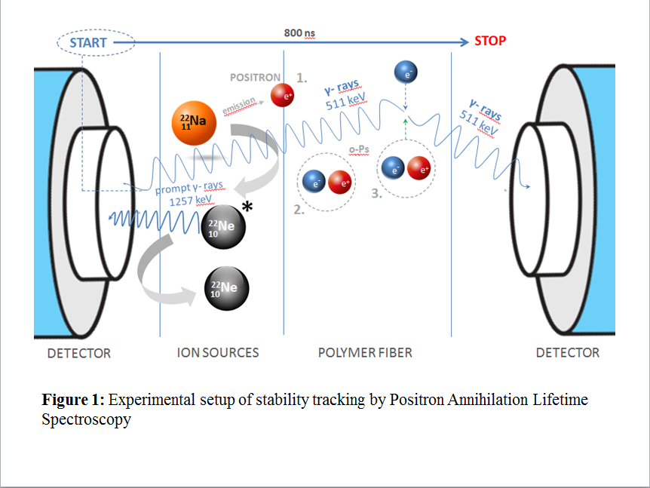

 Biography (150 word limit)
Romána Zelkó has her expertise in formulation and stability tracking of polymer-based drug delivery systems including various micro- and nanofibrous systems. Her research work focuses on different synthetic and natural polymeric delivery systems, physical ageing of polymers, microstructural characterization of dosage forms associated with their functionality-related characteristics. She is the author of 190 journal full papers and 5 patents and expert works. From 1991 she is employed by the Faculty of Pharmacy of the Semmelweis University. She advanced her studies in the pharmaceutical technology at the Ghent University, Belgium. She has been successfully passing the achievements of her scientific research work on to her students at various Ph.D. studies. She has held a variety of functions. She has served as a Vice-Dean (2003-2009) and from 2013 as the Dean of the Faculty of Pharmacy of the Semmelweis University.

Email: zelko.romana@pharma.semmelweis-univ.hu

Notes/Comments:

