Synthesis of Benzopyrano[4,3-d]-Pyrimidine Derivatives and Some of their Antimicrobial and Cytotoxicity Activities
Haya A Abubshait, Imam Abdulrahman bin Faisal University, Dammam, KSA

Abstract

Benzopyrano [4,3-d]-pyrimidine Derivatives (3a-c and 4) were prepared via cyclocondensation of 3-ethoxycarbonyl coumarin derivatives (2a-c) with guanidine hydrochloride and thiourea under reflux. Acetylation of (3b, c) with acetic anhydride provided N-acetyl derivatives (5a, b) of benzopyrano-imidazolo-[2,1-a]-benzopyrano [4,3-d]-pyrimidin-1, 6-dione (6) was obtained by treatment of 2-amino-benzopyrano [4, 3-d]-pyrimidine with ethylchloroacetate. Structures of these compounds were established on basis of IR, ¹H-NMR and MS data. Some of the prepared compounds were evaluated for antimicrobial and antitumor activities.

Image

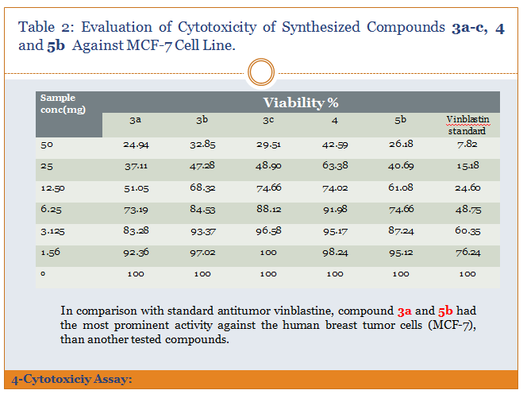

Recent Publications (minimum 5)
- Sherif M, Yossef A, (2013), Synthesis and anticancer evaluation of some fused coumarino-[3, 4- d]ñpyrimidine derivatives, organic chemistry 9: 239-243
- Rambhau G, Ambarsing R, (2013) A review on recent progress in multicomponent reactions of pyrimidine

Drug Invention Today 5:194-159

- Paliwal P, Srinivasa R, Shubha Jain (2013), Green approach towards the facile synthesis of dihydropyrano(c)chromene and pyrano[2,3-d]pyrimidine derivatives and their biological evaluation Medicinal Chemistry Research, 22: 2984–2990

- Ajmal R. Bhat A, Dongre R, Shalla A, Naikoo G, Ul Hassan I
(2016) Computational analysis for antimicrobial active
pyrano[2,3-d]pyrimidine derivatives on the basis
of theoretical and experimental ground, University of Bahrain
Journal of the Association of Arab Universities for Basic and Applied Science, 20:19-25
- Mostafa M, Abd El-Salam N, Alothman O (2013) Synthesis and Microbial Activity of Novel 3-Methyl-2-pyrazolin-5-one Derivatives. Journal of Chemistry 2013:7

Biography (150 word limit)
Haya A Abubshait , worked at department of chemistry, teaching undergraduate courses for medical college and health trach, I am interested in multidisciplinary research , like Nano-synthesis of pharmaceuticals compounds, Computational chemistry Microbiology Pharmaceutical Chemistry Organic Chemistry, synthesis, mechanism, spectroscopy …etc Email: habubshait@uod.edu.sa

