Title: Genetically engineered and domain-exchanged streptokinase molecules with enhanced kinetics of fibrin-dependent proteolytic activity and resistance to α2-antiplasmin

Maryam Rafipour^{1,4}, Faegheh Kazemi^{1,4}, Malihe Keramati², Seyed Shahriar Arab³, Nasir Mohajel¹, Arash Arashkia¹, Mohammad Mehdi Aslani⁴ and Farzin Roohvand¹*

¹Virology Department, ²Nano-Biotechnology Department and ⁴Microbiology Department, Pasteur Institute of Iran and ³Biophysics Department, Faculty of Biological Sciences, Tarbiat Modares University (TMU), Tehran, Iran.

Keywords: Streptokinase, Plasminogen, α2-antiplasmin
- Abstract Body (up to 250 words)
Streptokinase (SK), a heterogeneous plasminogen activator (PA) protein from groups A, C, and G streptococci (GAS, GCS, GGS, respectively) contains three structural domains (SKα, SKβ, and SKγ). Based on the variable region of SKβ, GAS-SK (ska) are clustered as SK1 and SK2 (including SK2a & SK2b). We report the first β-domain exchange study for skcg and cluster 2‐ska alleles to elucidate the contribution of SKβ for a broad range of functional characteristic including kinetics of specific/ proteolytic activity, fibrinogen‐bound Pg activation and α2‐antiplasmin resistance. Results pointed to the ‘minor to determining’ contribution of SKβ in these functionalities which might be potentially accompanied by a few critical residues substitutions. Our findings indicated minor contribution of the SKβ for highly different SA* between co-clustered skcgβ and SK2aβ variants but major role of the SKβ on enhancement of proteolytic activity between skcg‐SK and SK2b. Using computational approaches, SKC.μPm complex with/without residual substitutions that contributed to the changes in PA properties were modelled. Results of molecular dynamics (MD) simulations and residue interaction networks (RINs) analyses showed generally enhanced structural flexibility of SK but more stabilization of the catalytic complex by residual substitutions. These in silico results were confirmed in vivo by production of the E.coli-derived residual-substituted SKs (via site-directed mutagenesis) with higher proteolytic activities and higher levels of fibrinogen-bond Pg activation.

- Image:

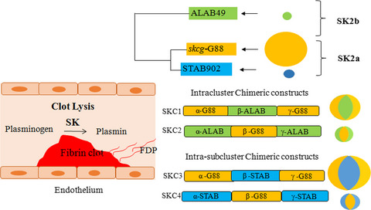
- Reference:
- The β-domain of streptokinase affects several functionalities, including specific/proteolytic activity kinetics. FEBS Open Bio. 2019 Jul;9(7):1259-1269. Rafipour M, Keramati M, Aslani M, Arashkia A, Roohvand F.
- Computational simulations assessment of mutations impact on streptokinase (SK) from a group G streptococci with enhanced activity - insights into the functional roles of structural dynamics flexibility of SK and stabilization of SK-μplasmin catalytic complex. Kazemi F, Arab SS, Mohajel N, Keramati M, Niknam N, Aslani MM, Roohvand F. J Biomol Struct Dyn. 2019 May;37(8):1944-1955.
- Study Break: Streptokinase for Treatment of Thrombotic Disorders: The End? Or the End of the Beginning? Roohvand F. Iran Biomed J. 2018 May 1;22(3):140-1.
- Biography:
Farzin Roohvand received his Ph.D in Biotechnology (Middle East Tech Univ; Ankara-Turkey) in 1999. In 2002, he did Post-doc in Pasteur Institute of Paris. In 2004, he served as a guest scientist in the same institute and in 2008 as Principal investigator for ANRS (France). Since 2012, he served as principal investigator in Pasteur Institute of Iran. He is author of more than 60 international articles and served as invited speaker for presenting keynote lectures in several international symposiums. He serves as Editorial Board in several scientific Journals.
- Presenting author details


Full Name: Farzin Roohvand
Contact number: +989124129269
Session name/ number:
Category: Oral presentation
Passport Number:

