Abstract Template

Title: Synthesis and cytotoxic evaluation of some new 4-(4oxo-4H-quinazoline-3yl)-thiobenzoic acid-S-(1-H-benzimidazole-2-yl)ester derivates

Shirin Banitalebi Dehkordi¹, Farshid Hassanzadeh¹, Marzieh Rahmani Khajouei^{,2}, Hojat Sadeghi-aliabadi¹, Nasim Dana³

¹Department of Medicinal Chemistry, School of Pharmacy and Pharmaceutical Science, Isfahan University of Medical Sciences, Isfahan, I.R.Iran.
²Isfahan Pharmaceutical Sciences Research Center, Isfahan, I.R.Iran
³Physiology Research Center, Isfahan University of Medical Sciences, Isfahan, Iran.

Keywords: quinazoline, imidazole, cytotoxicity, MTT assay

- Abstract Body
Quinazolines are a group of heterocyclic compounds that have different biological activities such as cytotoxicity, anti-bacterial, anti-fungal, etc. Benzimidazoles on the other hand are also a group of heterocyclic compunds with anti-tumor, anti-virus, anti-fungal and anti-inflammatory effects. Due to significant cytotoxic effects of both quinazoline and benzimidazole derivatives, in this work a group of quinazolinone-benzimidazole hybrids were prepared. The structures of synthesized compounds were confirmed by IR and 1H-NMR. cytotoxic activity of these compounds were evaluated at concentrations of 1, 10, and 100 μM against MCF-7 and HT-29 cell lines using the MTT colorimetric assay. Results show that compound 9d has highest cytotoxic activity against both MCF-7 and HT-29 cell lines.

- Image:

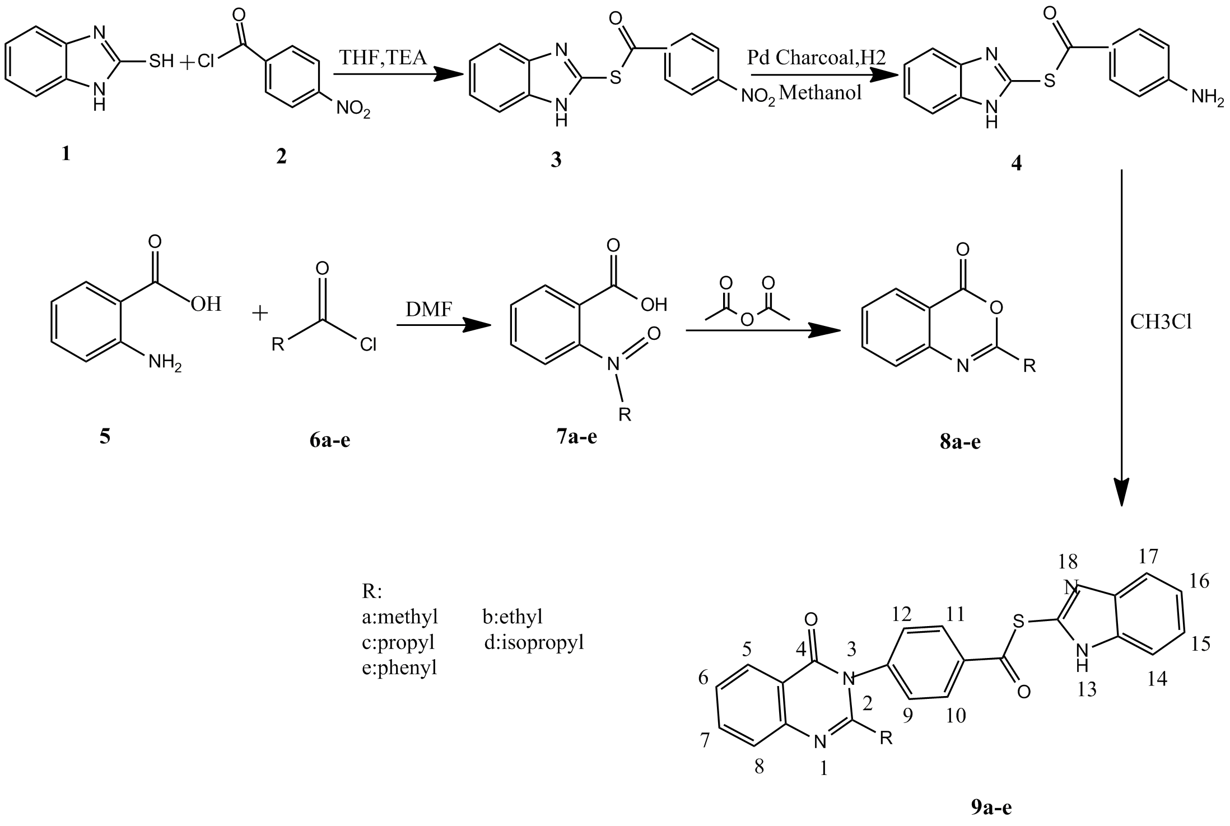
- Reference:
- Paul K, Sharma A, Luxami V. Synthesis and in vitro antitumor evaluation of primary amine substituted quinazoline linked benzimidazole.Bioorg Med Chem Lett. 2014;24(2):624-29.
- Kuemmerle J, Jiang S, Zhang H, Sirisoma N, Kasibhatla S, Crogan-Grundy C. Discovery of 1-benzoyl-3-cyanopyrrolo[1,2-a]quinolines as a new series of apoptosis inducers using a cell- and caspase-based high-throughput screening assay. Part 1: Structure–activity relationships of the 1- and 3-positions. Bioorg Med Chem Lett. 2008;18:6259-6264.
- Solomon VR, Hu C, Lee H. Design and synthesis of anti-breast cancer agents from 4-Piperazinylquinoline : a hybrid pharmacophore approach.Bioorg Med Chem Lett. 2010;18(4):1563-72.

- Mhaske SB, Argade NP. The chemistry of recently isolated naturally occurring quinazolinone alkaloids.Tetrahedron Lett. 2006;62:9787-826.

- Gursoy A, Unal B, Karali N, Otuk G. Synthesis,Characterization and Primary Antimicrobial Activity Evaluation of 3-Phenyl-6-methyl-4-(3H)-quinazolinone-2-yl-mercaptoaceticAcid Arylidenehydrazides. Turk J Chem.2005;29:233-45.

- Mourad AE, Aly AA, Farag HH, Beshr EA.Microwave assited synthesis of triazoloquinazolinones and benzimidazoqinazolinones.Beilstein J Org Chem. 2007;3:1-5.

- Zhou Y, Murphy DE, Sun Z, Gregor VE. Novel parallel synthesis of N-(4-oxo-2-substituted-4-Hquinazolin-3-yl)-substituted sulfonamides. Tetrahedron Lett. 2004;45:8049-51.

- Dinakaran M, Selvam P, DeClercq E, Sridhar SK. Synthesis, antiviral and cytotoxic activity of 6-bromo-2, 3-disubstituted-4 (3H)-quinazolinones.Biol & Pharm Bull. 2003;26:1278-82.
.
- Biography:
I have completed my Pharm.D at the age of 25 years from Isfahan University of Medical Sciences.I've worked as pharmacist for 3 years and have hospital experience.I'vr worked on my dissertation for a year in medicinal chemistry department.

- Presenting author details



Full Name:Shirin Banitalebi Dehkordi
Contact number:+989131852744
Linked In account:shirin banitalebi
Category: Oral presentation
Passport Number:J34181553

