Abstract Template

Design, Synthesis of New Pyridine and Pyrimidine Sugar Compounds as Antagonists Targeting the ERα via Structure-Based Virtual Screening
Ibrahim F. Nassar^{1*}, Wael A. El-Sayed², Tamer I.M. Ragab³, Al Shimaa Gamal Shalaby³ and
Ahmed B.M. Mehany⁴
¹Faculty of Specific Education, Ain Shams University, Abassia, Cairo, Egypt; ²Photochemistry Department, National
Research Centre, El-Behouth St, Dokki, Cairo, Egypt; ³Chemistry of Natural and Microbial Products Department,
Pharmaceutical and Drug Industries Research, Division, National Research Centre, Dokki, Cairo, Egypt, ⁴Department
of Zoology, Faculty of Science Al-Azhar University, Cairo, Egypt

Keywords: Cyclohepta[d]pyrimidine, 1,3,4-Oxadiazolyl acyclic C-nucleoside, Haemolytic, Prebiotic, Anticancer, Antimicrobial.

Abstract Body: New aryl substituted cyclohepta[b]pyridine and cyclohepta[d]pyrimidine derivatives were synthesized. The sugar hydrazones of the synthesized pyridine and pyrimidine compounds were also prepared. In addition, the 1,3,4-oxadiazolyl acyclic C-nucleoside analogs of the pyridine system were prepared. The hemolytic, prebiotic, anticancer and antimicrobial activities of some of the synthesized compounds were also studied. Compounds 10 and 12 showed high activity against MCF-7, HEPG-2 and HCT-116 cell lines with IC50 at range 3.56-8.55 μg/mL. In addition, the synthesized condensed thiopyrimidine derivative 10 exhibited more potent bactericidal activity while compound 7 demonstrated potent antifungal activity against Aspergillus niger. Furthermore, the synthetic compounds of the pyrimidine base promoted the growth of lactic acid bacteria. The predicted binding patterns of three of the prepared derivatives as possible antagonists against ERα were investigated which showed good binding patterns.
- Image:

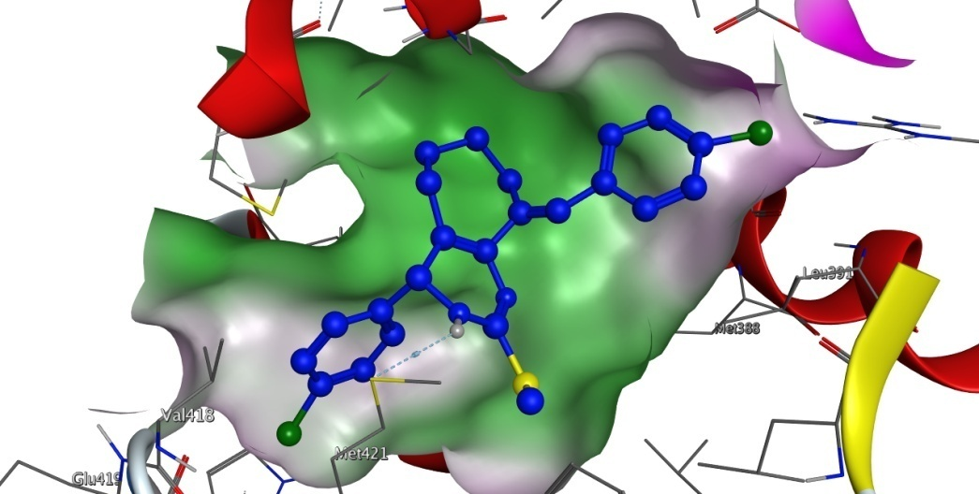

- Reference:
- Nassar I. F., Atta-Allah S. R., Elgazwy A. S. H.; A convenient synthesis and molecular modeling study of Novel Pyrazolo[3,4-d]pyrimidine and Pyrazole derivatives as antitumor agents J. Enzym. Inhib. Med. Chem. 2015, 30, 396.
- Chevallier F., Halauko Y. S., Pecceu C., Nassar I. F., Dam T. U., Roisnel T., Matulis V. E., Ivashkevich O. A., Mongin F.; N-aryl pyrazoles: DFT calculations of CH acidity and deprotonative metallation using a combination of lithium and zinc amides Org. Biomol. Chem. 2011, 9, 4671.
- Nassar, I. F.; El Farargy, A. F., Abdelrazek, F. M.; Ismail. N. S. M. Design, synthesis and anticancer evaluation of novel pyrazole, pyrazolo [3, 4-d] pyrimidine and their glycoside derivatives Nucleosides, Nucleotides and Nucleic Acids 2017, 36:4, 275.
- Biography:
- Ibrahim F. Nassar has completed his PhD at the age of 30 years from Faculty of Science, Ain Shams University, Cairo, Egypt and has 3 postdoctoral studies at 1) Rennes 1 University, UMR6510, Rennes, France in 2010, 2) Organic Chemistry dept., University of Granada, Spain in 2012 and 3) Organic Chemistry dept., Faculty of Chemistry, Oviedo University, Spain in 2014. He is the director of Organic chemistry lab. Faculty of Specific Education, Ain Shams Univ., a member of SILAE organization.Italy, Swiss chemical society, RSC, ASC and Egypt heterocyclic society. He has published more than 25 papers in reputed Scopus journals and has been serving as an editorial board member of American Journal of heterocyclic chemistry.

- Presenting author details


Full Name: Ibrahim Fathy Nassar
Contact number: 00201001396728
Twitter account: https://twitter.com/Ibrahimnassar72
Linked In account: https://www.linkedin.com/in/ibrahim-nassar-49b22a45/
Session name/ number:
Category: (Oral presentation/ Poster presentation) poster presentation
Passport Number: A17800923

