Abstract

Title: Interactive effects of Caffeine on Lumefantrine using in vitro and in vivo models

ADENIYI THOMPSON ADEWUMI ^{a, b}, CHINEDUM PEACE BABALOLAª, OLAYINKA KOTILAª, ADAM SKELTON ^{b}
- Department of Pharmaceutical Chemistry, University of Ibadan, Ibadan, Oyo State, Nigeria
- Department of Pharmaceutical Chemistry, University of Kwazulu-Natal, Durban 4000, SA

Keyword: caffeine-halofantrine, interactions, Lumefantrine, % parasitemia, physicochemical properties
The caffeine (CF)-halofantrine (an arylamino alcohol) interactions were reported to show significant degrees of the results. Halofantrine (HF) is no longer prescribed as an antimalarial drug but Lumefantrine (LF) is. This suggested potential interaction (low/high drug absorption probable) between LF and Caffeine/Caffeine-containing products if concurrently administered together. This study determined the effects of CF on the physicochemical properties of LF and its malaria parasite clearance. The effect of Caffeine on the aqueous solubility of LF at pH 1.3, 5.9, and 7.4; partition coefficient (Log P) at pH 5.9; and its dissolution profile at pH 6.8 were investigated with HPLC using standard methods. Caffeine’s impact on the curative effect of LF to treat P. berghei-infected mice was investigated and compared with chloroquine’s. Statistical analyses were carried out using ANOVA, t-test, and Kaplan-Meier (survival analysis). Calibration line for LF was linear (R² = 0.9955) over 10 – 80 µg/ml concentration range. The Log P of CF-LF and LF alone were 0.49 ± 0.26 (less liposoluble) and 0.79 ± 0.05, respectively. The released amounts of LF in 60 minutes were 40.69 ± 0.00, 63.45 ± 0.05, 76.37 ± 0.07, 89.95 ± 0.07, 71.86 ± 0.04, and 79.19 ± 0.02 mg. These studied pHs represent a good approximation of gastric, duodenal and physiological pH respectively. The % parasitemia of the treated groups significantly (p < 0.05) cleared, compared to the negative and the CF groups, both of which increased exponentially. The t-Test showed that LF-CF significantly (p < 0.05) cleared parasites more than LF alone. Survival estimates of 56 % censored mice after 30 days implied that median survival time was impossible. Therefore, caffeine impacts the profile of LF.

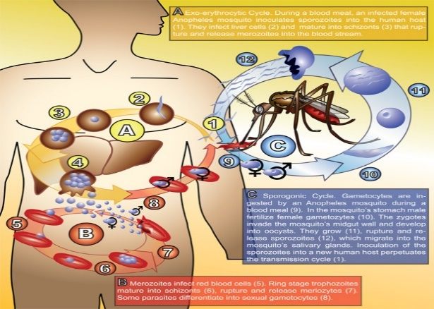

Figure 1: Life cycle of Plasmodium falciparum (Adapted from the Centre for Disease Control and Prevention, 2014)
References

Chinedum.Peace Babalola., Kolade Y.T., Adeyemo M.A., Kotila O.A. Ameh S.J., Adelakun T. A., Adewuyi S. Godwin Njaprin Kwosi, Scriba G.K (2014) Effect of Caffeine Containning Beverages on Physiochemcial and Release Properities of Halofantrine. Global Journal of Medical Researh B. Pharma, Drug Discovery, Toxicology and Medicine, 14 (1): 4-9

J. Sunil, M. Sanjith Nath, U. Samba Moorlthy (2010). HPLC Method Development and Validation for Simultaneous Estimation of Artemether and Lumefamtrine in Pharmaceutical Dosage Forms: International Journal of Pharmacy and Pharmaceutical Science, 1: 95-99.
Lee-Yong Lim, Mei-Lin G.O. (2000). Caffeine and Nicotinamide enhance the aqueous solubility of the antimalarial agent halofantrine. European Journal of Pharmaceutical Sciences, 10: 17-28.

Biography of The Presenting Author

Adeniyi Thompson Adewumi lives in Westville, Durban presently. He’s a student who is working towards becoming a researcher and will be graduating with his Ph.D. Pharmaceutical Chemistry in February 2020 from the University of Kwazulu-Natal, Durban, South Africa. He has spent some years in the experimental laboratories to gain better ideas of what he’d be doing in his future. Adeniyi hopes to work with renowned researchers. He has collaboratively published three international peer-reviewed journals.

Presenting Author’s Details



Full Name: Adewumi Adeniyi Thompson
Contact number: +27632140708
Twitter account: Adeniyi Adewumi@Jesutomisin0707
Linked In account: jesutomisin0707@gmail.com
Session name/ number: Pharmaceutical Analysis
Category: Oral presentation
Passport Number: A50084026

