Graph Theoretical analysis and in silico modeling and molecular dynamic studies of thiazole analogues as promising anti-breast cancer agents

Panneerselvam Theivendren¹*, Selvaraj Kunjiappan², Parasuraman Pavadai³, Murugananthan Gobal⁴, Saravanan Govindaraj⁵, Jaikanth Chandrasekaran⁶, Sankaranarayanan Murugesan⁷

¹Department of Pharmaceutical Chemistry, Swamy Vivekanandha College of Pharmacy, Elayampalayam-637205, Namakkal, Tamil Nadu, India

²Department of Biotechnology, Kalasalingam Academy of Research and Education, Krishnankoil-626126, Tamil Nadu, India

³Department of Pharmaceutical Pharmaceutical Chemistry, Faculty of Pharmacy, M.S. Ramaiah University of Applied Sciences, M S R Nagar, Bengaluru-560054, Karnataka, India
⁴Department of Pharmacognosy, Swamy Vivekananda College of Pharmacy, Elayampalayam, Namakkal, Tamilnadu 637205, India

⁵Department of Pharmaceutical Pharmaceutical Chemistry, MNR College of Pharmacy, Fasalwadi, Sangareddy - 502 294, Telangana, India
⁶Department of Pharmacology, School of Pharmacy & Technology Management, SVKM'S NMIMS University, Telangana, India
⁷Department of Pharmacy, Birla Institute of Technology & Science Pilani, Pilani Campus, Vidya Vihar, Pilani-333031. Rajasthan. India.

Abstract
Cancer is one of the first leading causes of death in economically developed countries and the second leading cause of death in developing countries The most common cancer is breast (2.26 million cases), lung (2.21 million cases), colon and rectum (1.93 million cases), prostate (1.41 million cases), skin cancer (non-melanoma) (1.20 million cases), and stomach (1.09 million cases) [1-6]. Based on the serious factor there is an urgent need to develop a novel chemotherapeutic agent with lowest toxic side effects and targeting mutated for efficient cancer treatment. In this view, the present research work deals with design, synthesis, and characterization of various analogous of (5-((2-chloropyridin-4-yl)oxy)-3-phenyl-1H-pyrazol-1-yl)-2-(4-substitutedphenyl)-N,N-dimethylethen-1-amine [5a-5r] derivatives and evaluation of their anticancer activity against breast cancer cell line (MCF-7 cells).
Methodology: Fourteen new compounds have been synthesised using suitable synthetic route and are characterized by FT-IR, ¹H NMR and Mass spectral data. Molecular docking studies of the title compounds were carried out using PyRx 0.8 tool in AutoDock Vina program. All the synthesised compounds were exhibited well conserved hydrogen bonding with one or more amino acid residues in the active pocket of Epidermal Growth Factor Receptor [EGFR] tyrosine kinase (PDB ID: 1m17).
Findings: The docking score of the derivatives showed significant score ranged from -7.4 to -10.3 Kcal mol⁻¹ as compared with standard drug Imatinib with -9.9 Kcal mol⁻¹ Figure 1 and reference drug AQ4 -7.4 Kcal mol⁻¹. The designed compound (5-((2-chloropyridin-4-yl)oxy)-3-phenyl-1H-pyrazol-1-yl)-2-(2-bromo phenyl)-N,N-dimethylethen-1-amine 5r showed least energy value -10.3 Kcal mol⁻¹against EGFR tyrosine kinase receptor Figure 2, remarkably top scored compound, 5r was found to be most significant against MCF-7 breast cancer cell line with IC₅₀ value of 0.0730 µM/mL, TGI of 0.0932 µM/mL, GI₅₀ of 0.00412 µM/mL, LC₅₀ of 1.720 µM/mL, comparable that of standard drug.
Conclusion: The compound (5-((2-chloropyridin-4-yl)oxy)-3-phenyl-1H-pyrazol-1-yl)-2-(2-bromo phenyl)-N,N-dimethylethen-1-amine 5r showed better anticancer activity as compared to standard drug Imatinib. The molecular docking studies reveals that the synthesised compounds exhibit comparable results to that of standard drug Imatinib.
References
- Jemal A, Bray F, Center M, et al. Global cancer statistics. Cancer J Clin 2011: 61: 69.
- Priolkar RNS, Shingade S, Palkar M, MamleDesai S. Design, synthesis and characterization of novel Linomide analogue and evaluation for anticancer activity. Current Drug Discovery Technology. 2020;17(2):203-12.
- https://www.medicinenet.com/cancer/article.htm#what_are_cancer_symptoms_and_signs. Visited on 17-06-2020.
- https://www.cancerresearchuk.org/about-cancer/what-is-cancer. Visited on 17-06-2020.
- https://www.who.int/news-room/fact-sheets/detail/cancer. Visited on 18-06-2020.
- http://cancerindia.org.in/globocan-2018-india-factsheet/. Visited on 19-06-2020.

Biography
Dr. T. Panneerselvam working as a Professor cum Director R&D, Department of Pharmaceutical Chemistry, Swamy Vivekanandha College of Pharmacy, Elayampalayam-637205, Namakkal, Tamil Nadu, India. He has 15 years of teaching and research experience with the credential of 24 patents, 01 textbook 21-research books and 85 scientific research articles with impact in international and national journals. He has guided 4 PhD more than 20 B. Pharm, 15 M. Pharm students in the fulfillment of their project type courses. His recent research about Graph Theoretical Network Analysis and Pharmacoinformatics-Based Investigation of Bioactive Compounds of Rasam (South Indian Recipe) Against Human Cancer was published in Scientific Reports, Nature

About Current Research Topic
The titled work Graph Theoretical analysis and in silico modeling and molecular dynamic studies of thiazole derivatives for the modulation of glucose metabolism in 3T3-L1 adipocytes was mainly to emphasis the efficiency of glucose uptake capacity of novel thiazole derivatives

About Institution
Swamy Vivekanadha College of Pharmacy was established in the Year 1992 by Angammal Educational Trust under the Chairmanship of Prof. Dr. M. Karunanithi, B.Pharm., M.S., Ph.D., D.Litt. The College offers Diploma, Degree, Post Graduate and Doctoral level programmes in Pharmacy. The college has well equipped laboratories, central instrumentation laboratory and full air conditioned computer laboratory with internet facility. The college library has stacked with wide range of books, periodicals and journals. All our laboratories are well equipped with modern instruments and we have modernized animal house which is approved by CPCSEA for carrying out animal experiments and projects. Our medicinal gardens possess heritagious collection of endogenous medicinal plants. We have tie-up with Vivekanandha Medical Care Hospital, Tiruchengode for Hospital training and established Drug and poison information centre for imparting hospital training to the students. The defined Vision, Mission and quality policy of our institution have ensured standard of students at high esteem who are globally competitive. The institute is approved by AICTE, PCI, Accredidated by NBA and is affiliated to The Tamilnadu Dr. M.G.R. Medical University, Chennai.

Figure 1: 3D and 2D image Imatinib
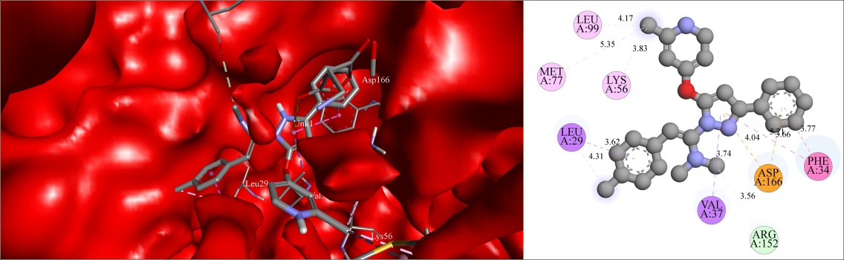

Figure 2: 3D and 2D image of (5-((2-chloropyridin-4-yl)oxy)-3-phenyl-1H-pyrazol-1-yl)-2-(2-bromo phenyl)-N,N-dimethylethen-1-amine 5r
