Title: Implementation of Interfacial Tension and Contact Angle Measurements to Optimize Brine Salinity for Water Flooding Tests in High and Low Acidity Crude Oil Reservoirs

Essa Georges Lwisa¹, Moza Almansouri ¹, Salma Abdelwahid ¹
¹Department of Chemical & Petroleum engineering, United Arab Emirates University, Al Ain, United Arab Emirates

Keywords: Enhanced oil recovery, smart water flooding, high acidity crude oil. Low acidity crude oil, interfacial tension, contact angle.

- Abstract
The interfacial tension and contact angle are believed to have direct impact on wettability alteration of crude oil/water/rock systems.
An important factor that controls the fluid distribution in a reservoir is formation wettability. Most carbonate reservoirs are preferentially oil wet and they do have a negative capillary pressure. These reservoirs exhibit reduced oil recovery compared to sandstones because of their fractured nature.
This study has been conducted to find the optimum water salinity that may be used in water flooding in either the secondary or tertiary stages of a reservoir development depending upon interfacial tension between crude and brine, and contact angle measurements. Two crudes were taken from reservoirs in the UAE, Bu-Hassa (low acidity) and Thamama (high acidity), and five types of brine with different salt concentration were examined to find the relationship between the acidity numbers of the crude oil and the salinity of brine.

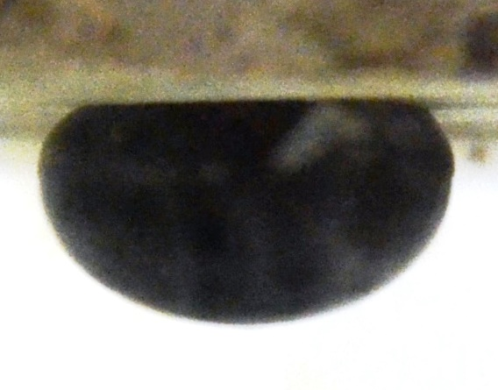
- Image:

- Reference:
- A. Lafuma, D. Quere, Nat.Mater.2, 457 (2003(
- T. Young, Philos. Trans. R. Soc. Lond.95, 65 (1805)
- Fan, T., and Buckley, J.S., Acid Numbers Measurements Revisited, SPE Journal, December 2007.
- Buckley, J.S., and Fan, T., Crude Oil/Brine Interfacial Tensions, Petrophysics, 2007, 48(3), 175-185.
- Bai, J., Fan, W., Nan, G., Li, S., and Yu, B., Influence of Interaction Between Heavy Oil Components and Petroleum Sulfonate on the Oil-Water Interfacial Tension, Journal of Dispersion Science and Technology, 2010, 31, 551-556.
- RezaeiDoust A.; Puntervold T.; Strand S.; Austad T. Smart water as wettability modifier in carbonate and sandstone: A discussion of similarities/differences in the chemical mechanisms. Energy Fuels2009, 23, 4479–448510.1021/ef900185q
- Biography:
Essa Georges Lwisa has a Master’s degree in Petroleum Engineering, he works as a Core Analysis lab instructor at the Chemical & Petroleum Engineering dept. UAE University. He published 15 scientific papers in Enhanced Oil Recovery methods, and honored with IAAM Scientist Medal of year 2017 for notable research in the Advanced Material Science and Technology during award ceremony of International Association of Advanced Materials, Stockholm, Sweden.

- Presenting author details


Full Name: Essa Georges Lwisa
Contact number: +971507825357
Linked In account:
https://www.linkedin.com/in/essa-lwisa-7b980771/
Session name/ number: To be filled
Category: Oral presentation
Passport Number: N-012323138

