Title: Enhanced Oil Recovery in Carbonate Reservoirs by Carbonated Water Flooding (CWF)

Essa Georges Lwisa¹, Hajar Alnaqbi¹, Manal Alahamd¹
¹Department of Chemical & Petroleum engineering, United Arab Emirates University, Al Ain, United Arab Emirates

Keywords: Enhanced oil recovery, Carbonated water flooding, Smart water flooding, WAG flooding, Tight carbonate reservoirs.

- Abstract
Over the years, CO₂ injection has become a leading EOR method, the method can significantly increase the oil recovery while at the same time reduces CO₂ emission. CO₂ is considered as an excellent fluid for enhanced oil recovery due to its favorable interaction with the reservoir oil. The relative low density and viscosity of CO₂ compared to reservoir oil that result in poor sweep efficiency has been a problem in CO₂ floods, another scheme of injection can be used to mitigate this problem, like alternating (WAG) or simultaneous injection of CO₂ and water (SWAG). An alternative, more efficient CO₂ injection scheme is carbonated (CO₂ -enriched) water injection. The objective of this study is to experimentally examine the residual oil recovery performance by carbonated water injection in low permeability carbonate reservoirs. Two EOR flooding test were conducted on a selected tight carbonate core sample, taken from Zakuum oil field in Abu Dhabi. First test was done by flooding the sample with carbonated sea water followed by sea water. another test was done by sea water flooding followed by low salinity water. The results show that, the improvement in residual oil recovery is higher when CW is injected in the secondary recovery mode, compared to the injection of low salinity water injection in the tertiary recovery mode.

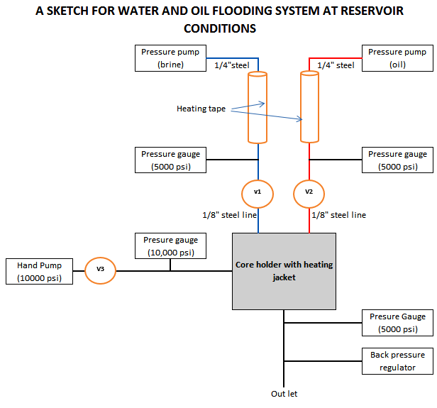
- Image:

- Reference:
- Mathiassen, O.M.” CO₂ as Injection Gas for Enhanced Oil Recovery and Estimation of the Potential on the Norwegian Continental Shelf”. Page 18, 2003.
- Willhite, G. P. & Green D. W., “Enhanced Oil Recovery”, Textbook series, SPE Richardson, Texas, 1998.
- James G. Speight, Offshore Oil and Gas Operations, USA, 2015, first edition, page 176
- Oistein, G., “Miscible Displacement: Recovery Tests with Nitrogen”, SPE 17278, 1990.
- Sohrabi, M. & Riazi, M. & Jamiolahmady, M. & Ireland, S. & Brown, C.” Enhanced Oil Recovery and CO2 Storage by Carbonated Water Injection”. p.3,2009
- Meyer, J. P.” Summary of Carbon Dioxide Enhanced Oil Recovery (CO₂ -EOR) Injection Well Technology”, American Petroleum Institute, p. 54, 2007.
- Biography:
Essa Georges Lwisa has a Master’s degree in Petroleum Engineering, he works as a Core Analysis lab instructor at the Chemical & Petroleum Engineering dept. UAE University. He published 15 scientific papers in Enhanced Oil Recovery methods, and honored with IAAM Scientist Medal of year 2017 for notable research in the Advanced Material Science and Technology during award ceremony of International Association of Advanced Materials, Stockholm, Sweden.

- Presenting author details


Full Name: Essa Georges Lwisa
Contact number: +971507825357
Linked In account:
https://www.linkedin.com/in/essa-lwisa-7b980771/
Session name/ number: To be filled
Category: Oral presentation
Passport Number: N-012323138

