Abstract Template

Title: Improving Upstream Performance, including Product Reliability, Service Quality and Safety Performance through the Service Execution Cycle.

Keywords: API Q2, Service Quality, Reliability, Engineering, Process Efficiencies, NPT

- Abstract Body (up to 250 words)
The Service Execution Cycle™ was developed to enhance service execution and well performance for the Upstream Service Sector of the Petroleum & Natural Gas Industry. This Industry Model pulls together the key & essentials functions and industry controls to ensure a successful service execution, including Contract Review, Planning, Risk Management, Service Design, Contingency Planning, Controls of Critical Suppliers, Service Execution, and Service Performance Validation. The model has been deployed and tested by State Owned, International and National Operators and Service Supply Organizations, resulting in significant NPT (downtime) reductions, while improving organizational efficiencies and safety performance. In addition to improving performance, the model ensure compliance with multiple ISO Standards and the API Q2 Specification. Implementation improves coordination and performance between Operators, Service Supply Organizations and their Critical Suppliers. The presentation will cover the 8 steps of the Service Execution Cycle as well as results from companies who have deployed and tested the model over the past five years. This model was developed following the 2010 Macondo Disaster and the development of the API Q2 Specification for the Upstream Service Sector. This presentation will cover the critical elements and results of the companies who have deployed it around the globe. The following functions will benefit from implementation: Contracts & Legal, Engineering, Operations, Quality, HSE, Procurement, Demand Management, Human Resources, Maintenance and Finance for organizations who tie Activity Based Costing to the Service Execution Cycle.

- Image:

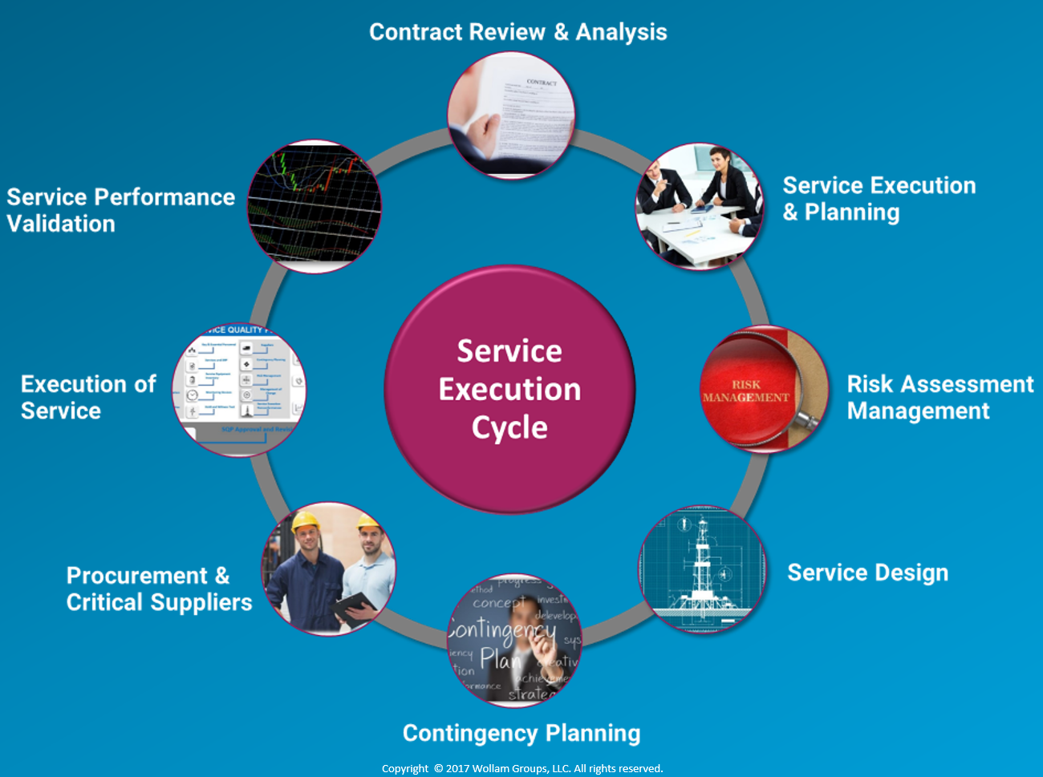

- Reference:
- API Q2 1st Edition Specification
- API Q2 Professional Course, by Wollam Groups
- Biography:
Bryan Wollam is the founder and CEO of Wollam Petroleum Advisory Group, Wollam Groups and Wollam Auditing Services. He has three college degrees and holds industry recognized certifications in the areas of quality, occupational health and safety, environmental, reliability and risk management. His education and credentials are backed by more than 30 years of industry and management experience. He is a member of the API Committees that develop the API Specifications and an accomplished professional with broad experience and recognition in operational excellence, quality, reliability, and HSE in multiple industries. He has expertise in leading organizational transformation resulting in profitability and shareholder value.
- Presenting author details


Full Name: Bryan Wollam
Contact number: (1) 832-656-3382
Twitter account:
Linked In account: https://www.linkedin.com/in/bryan-wollam-6a0a8a59/
Session name/ number:
Category: (Oral presentation)
Passport Number:

