Challenge of water saturation in Low resistivity cretaceous reservoirs
Bita Arbab PhD, Hamid Ali Zanjani
Iranian offshore oil company (IOOC)

Abstract

This study presents causes and reasons for lowering resistivity logs in carbonate deposit. Moreover this abstract elucidate methods for relieving of challenge water saturation estimation in cretaceous carbonate deposits with Low Resistivity Pay, in Persian Gulf. Reservoirs in the Cretaceous like Zubair, Buwaib, Shuaiba and Khatiyah formations of Southern fields have been analyzed as low resistivity carbonate. Resistivity responses reach less than 6 and even less than 1 ohm.m. Significant hydrocarbon accumulations are "hidden" these Pay zone, (LRPZ). Experimental analysis shows that reservoirs contain clay-coated grains of Lithocodyum algal and is along with Micrtization, Pyritization of digenetic process are reasons for effect on resistivity response. On the other side Smectite and Kaolinite of main clays types have high CEC and greater impact on lowering resistivity. Lønøy method applied to address pore throat sizes which contain Inter crystalline porosity, Chalky Limestone, Mudstone micro porosity. NMR (Nuclear magnetic resonance and Pulse Neutron-Neutron logs have been used to modify the calculated water saturation of the wells. The study shows that reduced specific resistivity is due to texture change and presence of microscopic porosity. For defining reliable water saturation, Core NMR and Log NMR results have been used. NMR results explain that decreasing of resistivity in pay zone is related to texture and grain size variation not being existence of moved water. Irreducible water for the reservoirs is estimated between 30 to 50 %. Low resistivity zone related to microspores with less than 3 micron.Variable T2 cut off is allows to choice suitable T2 cutoff values to differentiate movable from bound fluids adapted for the specific carbonate rock.T2 cutoff varies between 45 to 110ms. The proper T2cutoff for these formations are extremely crucial to being able to estimate permeability and water saturation.

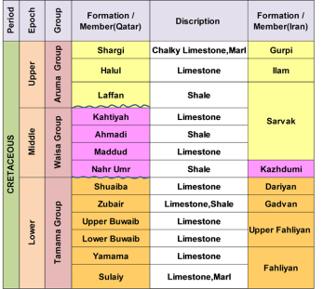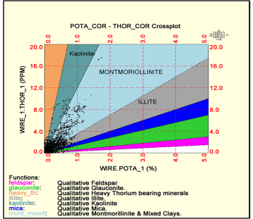
Figure 1 Figure 2
Figure 1: Stratigraphic column from the lower, middle, upper cretaceous.
Figure 2: Thorium potassium cross plot for clay types. Plot shows that a type of clay of mixed Illite, Montmorillonite and kaolinite for LRPZ formation.

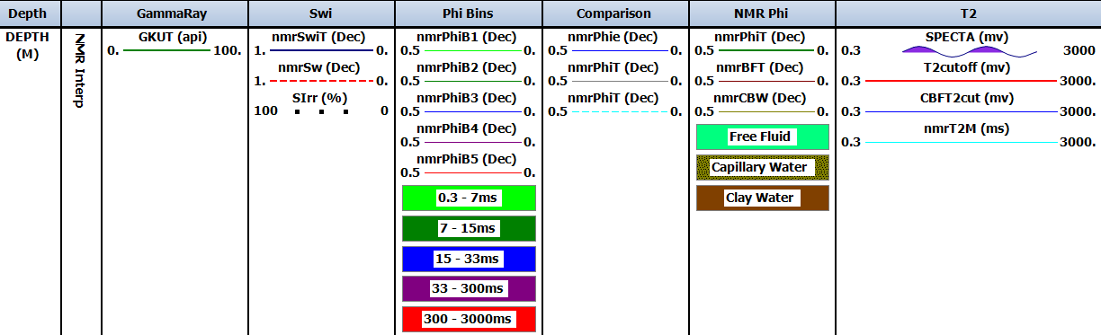

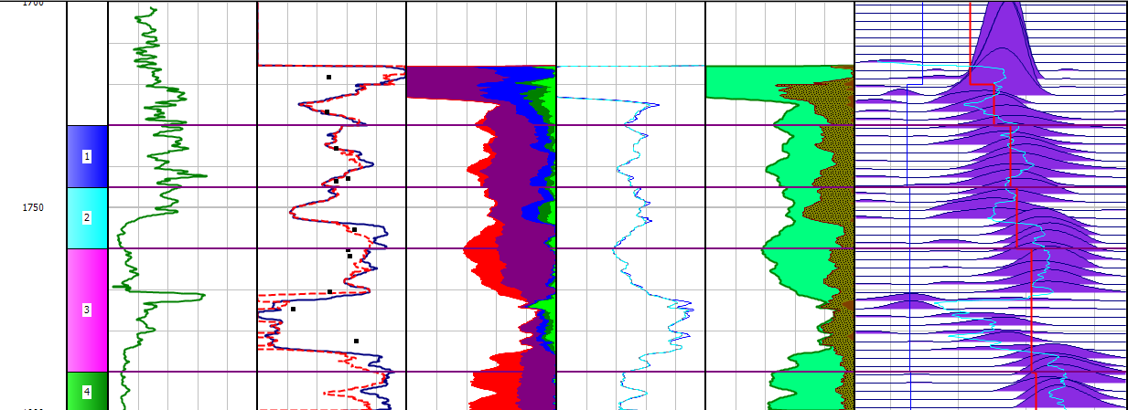

Figure3: Combination between full set logs and NMR logs with NMR core results in Shuaiba formation. Water saturation varies between 35% to 50% results extract based on 15 core samples selected for NMR analysis in oil brine and air brine condition to get information about pore size clay bound water, moved oil and water and residual water saturation.

Recent Publications
- Lønøy, A., 2006, Making sense of carbonate pore system: AAPG Bulletin, v. 90, no.9, pp. 1381–1405.
- Lucia, F. J., 1999. Carbonate reservoir characterization. Springer, New York, 226 p.
- Obeidi A, Al Aryani F, Al Amoudi M (2010) Developed approach for better understanding of low resistivity pay carbonate reservoirs. In: Paper SPE-137663 presented at Abu Dhabi International Conference and Exhibition, Abu Dhabi
- Serra, O., 1984. Fundamental of Well-Log Interpretation, the Acquition of logging data. Elsevier, 423 p.
- Winland, D., 2006 of Amoco, Carbonate Reservoir Characterization, Publication of articles in the paper journal "Oil and Gas Business".2006.p206-217


Dr.Bita Arbab is a Senior Petrophysicist in Iranian Offshore Oil Company (IOOC). She has been working for 15 years as a Petrophysicist and Geologist .She obtained MSc Degree in Sedimentology and Sedimentary Rocks of University of Shahid Beheshti Tehran-Iran, Then she studied at degree of Doctor of Philosophy (Ph.D) of Tehran Shomal university. She has been working many carbonate and Clastic project .Also she has published many papers at Petrophysic and Geology studying. She has a good knowledge for Formation Evaluation using High Tech Petrophysical logging including: LWD, Vision Services (GVR), PEX, CMR, NMR, DSI, Sonic Scanner MDT,FMI ,UBI,CBL,USIT and traditional logs.
Email: bitaarbab@yahoo.com

