Natural hydrocarbon reservoir modelling: Advantages and disadvantages of different geostatistical methods for borehole data interpolation
Evgeniy Kovalevskiy, PhD, GPD JSC, Russia

Abstract
An interpolation of well data requires taking into account the following. (1) A geological environment is of a categorical nature, and it is thus impossible for the quantitative properties to be interpolated among different categories. The quality of property interpolation in such an environment is controlled by comparing histograms. (2) The interpolated values should represent the actual variability of a geological environment, where the term “actual” means meeting a certain criterion. This requirement can be achieved only by means of multiple stochastic realizations. Where a variogram is used as a mentioned criterion, the quality of interpolation is controlled by comparing variograms. (3) It is geostatistical techniques that are mostly applied to compute stochastic realizations. In all these methods it is assumed that the geological environment is statistically uniform. Is a real geological environment statistically uniform? Certainly it is not. So, in stochastic methods, the key to a successful implementation is dividing the interpolated parameter into deterministic (non-random) and random components. (4) The deterministic features of initial well data (trends, categories, anomalous zones, etc.) are not obvious, and, if not specially marked, will be erased in the realizations. Stochastic realizations are “sterile” with respect to the deterministic features, and for this reason are not preferred by geologists. (5) In order to overcome this “sterility”, a number of “non-classical” (heuristic) geostatistical methods have been developed. The object modeling technique generates realizations which include sand bodies of a particular shape. Being able to manage the shape of individual bodies, the geologist however cannot manage the configuration of the set thereof. (6) To enable managing such combinations, multiple-point statistics (MPS) has been introduced and employed. Its heuristics consists in using a training image. Advantages and disadvantages of different geostatistical methods for borehole data interpolation are discussed.

Image
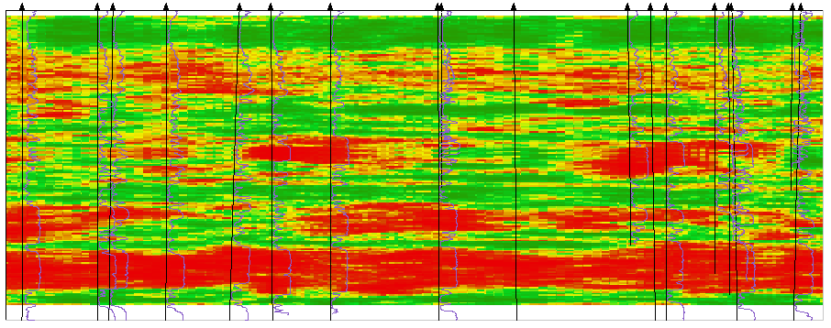
Figure 1: Classical geostatistical interpolation (one realisation) excellently represents variability, but erases all deterministic features of the geological medium. The red and green colors approximately demonstrate sands and clays.
Recent Publications
- Volkova M, Perepechkin M, Kovalevskiy E (2017) A comparative analysis of geostatistical methods for a field with a large number of wells. Geostatistics Valencia 2016. Quantitative Geology and Geostatistics, vol. 19: 745-758.
- Kovalevskiy E (2015) Fuzzy geological model - stochastic realizations preserving deterministic features of data. EAGE Conference on Petroleum Geostatistics: 338-342.
- Kovalevskiy E (2011) Geological modelling on the base of geostatistics [in Russian]. EAGE Student Lecture Tour: 117.
- Kovalevskiy E (2014) Geological modelling on the base of geostatistics [in Chinese]. The Chinese translation edition is published by arrangement with EAGE: 113.
- Kovalevskiy E (2007) Fuzzy geological model. EAGE Conference on Petroleum Geostatistics: P10.

 Biography

Evgeniy Kovalevsky graduated from the Moscow Physical-Technical Institute in 1981. In 1984 he has finished postgraduate study in the Institute of Oceanology of the Russian Academy of Sciences (IO RAS). Since 1985 to 1995 he worked in the department of geophysics in the Institute of Marine Engineering Geology in Riga. In 1991 he defended in IO RAS a dissertation named "Stoneley wave interpretation" and received Candidate's degree in physics and mathematics. Since 1996 up to 2015 he worked in the Central Geophysical Expedition, in Moscow, dealing with development of DV-Geo geological modelling system. After 2015 the development of the same modelling system (under the name Geoplat Pro-G) continues in GPD. Since 2007 Evgeniy Kovalevsky reads lectures about geostatistics. Area of interests includes geological models of natural hydrocarbon reservoirs, fuzzy geological models, geostatistics, hydrodynamic modeling, abiogenic theory of petroleum origin. The author of more than 30 scientific works.
Email: e.kovalevskiy@gpd.emai

