Wellbore stability post-analysis for several depths in the south of Iran
Ehsan Jafari Dastgerdi, Petroleum Engineering MSc, Sahand University of Technology, Iran
Mohammad Fazaelizadeh, Assistant Professor, Sahand University of Technology, Iran
Eghbal Sahraei, AssociateProfessor, Sahand University of Technology, Iran
Javad Hosseinian, Petroleum Engineering MSc, Sahand University of Technology, Iran

Abstract

Nowadays with the emergence of directional and horizontal drillings and the problems regarding that, having a stable well is a necessity. Wellbore stability has critical importance in the success of drilling operations. One of the main objectives of any drilling operation is drill the well as cost-eﬀective and stable as possible. Several parameters such as in-situ stress, formation strength, drilling direction, pore pressure and drilling fluid pressure play role in wellbore instability. The controllable parameters are the mud weight and wellbore trajectory. The proper choice of drilling fluid plays a prominent role in wellbore stability. Exceeding from allowed mud density may cause tensile failure and cause fractures in the wellbore, whereas, lowering mud weight from a certain value causes shear failure and wellbore collapse. In this study, few reported depths of several wells located in the south of Iran that had imposed wellbore instability on drilling operation were analyzed. In daily drilling reports for this depth, collapse, tight hole, and the stuck pipe were reported. At first, geo-mechanical parameters were extracted from well logging data and DGRs (daily geological reports). At next, the simulation results of collapse pressure, fracture pressure, normalized yielded zone radius, fracture initiation angle, wellbore shape and mud window were shown for few instable depths of these wells. At final stage, sensitivity analysis was run and also appropriate mud window and stable direction for solving or decreasing the problems were recommended.

Image

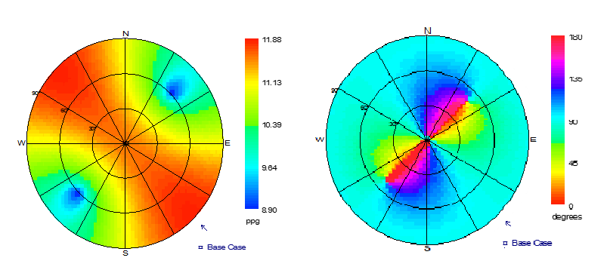
Recent Publications
- Al-Ajmi, Zimmerman, A new well path optimization model for increased mechanical borehole stability, Journal of Petroleum Science and Engineering, November 2009.
- Wang and sterling, (2009).’’Stability Analysis of a borehole wall during horizontal directional drilling’’. Tunneling and underground Space technology
- Rudarsko-geološko-naftni Zbornik, WELLBORE INSTABILITY: CAUSES AND CONSEQUENCES, Zagreb 2007
- M.Bai et al, (2012).’’ Parametric sensitivity investigation: Analysis of wellbore stability.’’ Harmonizing Rock Engineering and the Environment – Qian &Zhou (Eds) © 2012 Taylor & Francis Group, London, ISBN 220-0-703-00777-0
5. Wang and sterling, (9002).’’ Stability Analysis of a borehole wall during horizontal directional drilling.’’ Tunneling and underground Space technology 99,290-259.



Ehsan Jafari Dastgerdi obtained a BS degree in Reservoir Engineering from the Shiraz University, Iran. He is MS Student in Drilling and Production Engineering at Sahand University of Technology, Tabriz, Iran. His research interests include Drilling Engineering and Rock Mechanic.
.
Email: e_jafari@sut.ac.ir

