Effectiveness of indigenous microbial enhanced oil recovery in a post-polymer flooded reservoir
Jian-Jun Le Exploration and Development Research Institute of PetroChina Daqing Oilfield Company, Ltd. , Heilongjiang, PR China
Xiao-Lin Wu Exploration and Development Research Institute of PetroChina Daqing Oilfield Company, Ltd. , Heilongjiang, PR China

Abstract (300 word limit)
The two round field trials of activating indigenous microbial community were carried out in an oil reservoir post polymer flooding. The trial test effect showed that the dominant bacteria of 4 production wells, Thauera of β-proteobacteria, Pseudomonas and Acinetobacter of γ-proteobacteria were directed activation, which showed a consistent enhancement. The abundance of Methanosaeta and Methanolinea increased, and showed a regular alternation with an increase of oil production. It contributes to production of biogas, leading to increasing of the injection pressure from 11.3MPa to 13.9MPa before the experiment which increased by more than 2.0MPa.The contents of CO2 and CH4 varied alternately with each other, which was consistent with the order of injection of each activator. H2 was detected in the reservoir associated with the gas in the observation area. A large amount of enriched bio-gas was dissolved into and mixed with crude oil, which brought increasing of the proportion of light components in the whole hydrocarbon of the recovered oil. The other effect was activated microbial metabolites productions formed bio-plugs, which benefits for improving of the absorption profile and the production profile. Under the conditions of activator injection concentration of 1.34%, dosage of 0.0785 PV and injection volume of 21,419m3, the cumulative oil production was 20,524t, the cumulative increment oil was 6,243t, the recovery rate was 3.93% (OOIP), and the input / output ratio was 1: 6.38 in the trial. Our trial suggested that IMEOR can be implemented for effective enhancement of further oil recovery from polymer flooded oil reservoirs.
Key word
Post-polymer flooded Reservoir, Activator, Indigenous microbial, Biogas, Dynamic change, Indigenous microbial enhanced oil recovery (IMEOR).

Image
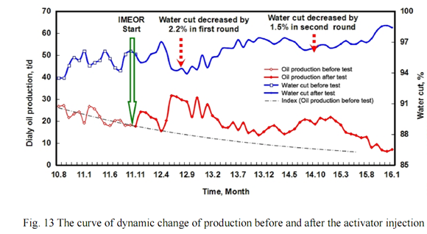
Recent Publications (minimum 5)
- Le, J.-J., Bai, L.-L., Wang, R., (2015) Laboratory evaluation and field trial of activation indigenous microbial displacements in the reservoirs after polymer flooding. China. J. Biotech. July 25, 31, 99–106 .
- Le, J.-J., Liu, F., Zhang, J.-Y., (2014) A field test of activation indigenous microorganism for microbial enhanced oil recovery in reservoir after polymer flood. Acta. Petrol. Sin. 35, 99–106.
- Le, J.-J., (2014) Evaluation and Application of Endogenous Microorganism Activator in Reservoir after Chemical Flooding. Advanced Materials Research，Publication date: 2014.12.9，Chapter 3: Biology, Biotechnologies and Biomedical Engineering， vol 1051, 404-409.
- Le, J.-J., (2015) Progress in pilot testing of microbial-enhanced oil recovery in the Daqing oilfield of north China. International Biodeterioration & Biodegradation. Volume 97,188–194.
- Le, J.-J., (2013) Combined oil displacement system and field test of composite surfactant. Advanced Materials Research , DOI: 10.4028/www.scientific.net/AMR. vol 641-642,77-81.

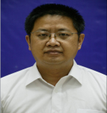Biography (150 word limit)
Jian-Jun Le is a senior engineer. The main research work involves the microbial species and their distribution characteristics, the selection and application of microbial oil displacement, the development and production of high efficient oil-displacing bacteria (bio-surfactant), Molecular biology analysis (DGGE, T-RFLP and 454 Pyrosequencing) of endogenous microorganisms in the oil reservoir, and field tests of activated endogenous microorganisms after chemical flooding. He has engaged in Microbial enhanced oil recovery (MEOR) and published in the core journals 43 papers, which were SCI, EI retrieval of more than 10 papers. In March,2006. co-written the book "Daqing Oilfield to enhanced oil recovery practice and knowledge, " and 13 invention patents.
Email: lejj@petrochina.com.cn.

Notes/Comments:

