Torque and Drag Comparison in Directional Conventional, Slim Hole and Casing Drilling Methods
Davood Zivar, Petroleum Engineering MSc, Sharif University of Technology, Iran
Saeed Jamshidi, Petroleum Engineering PhD, Sharif University of Technology, Iran
Ehsan Jafari Dastgerdi, Petroleum Engineering MSc, Sahand University of Technology, Iran

Abstract
Due to different location and field conditions, various drilling methods have been used to produce from oil and gas reservoirs. Three major operational methods defined as slim holes, conventional and casing drilling. Each type has some advantages and disadvantages. Despite many affecting parameters, torque and drag are two highlighted factors to choose best the drilling method. Torque and drag play significant role in the feasibility of drilling and final costs. In this study, the influence of two mentioned outstanding parameters are investigated to choose optimum drilling types with consideration of the same horizontal well trajectory and also without length and fatigue limitation. Consequently, slim hole drilling shows minimum torque and drag value in comparison with conventional and casing drilling. Furthermore, casing drilling displays maximum torque and drag in this case.

Image
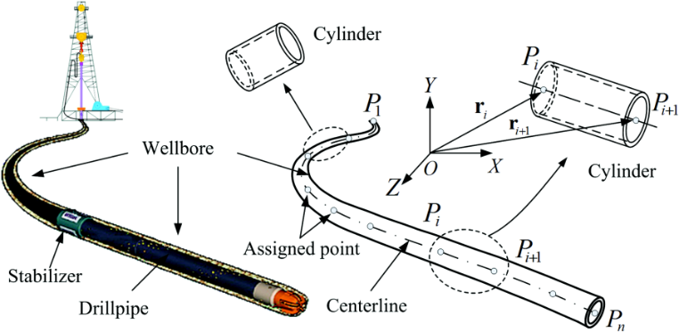
Recent Publications
- Wu A, Hareland G, Fazaelizadeh M (2011) Torque & Drag Analysis Using Finite Element Method. Modern Applied Science, Vol. 5, No. 6
- Francisco J. Sánchez, Houqani Said, Mounir Turki, Marco Cruz (2012) Casing While Drilling (CwD): A New Approach To Drilling Fiqa Formation in he Sultanate of Oman--A Success Story. SPE-136107-PA
- Mirhaj A, Kaarstad E, Aadnoy B (2011) Improvement of Torque-and-Drag Modeling in Long-Reach Wells. Modern Applied Science, Vol. 5, No.5.
- Abdirisak A.Osman (2015) Analysis of slim hole drilling operations. University of Stavanger, Masteroppgave/UIS-TN-IPT/2015.
5. Yang Caijin, Cheng Zaibin, Jang Wei, Jiang Shiquan, Ren Gexue (2015) A Multibody Dynamic Model of Drillstring for Torque and Drag Analysis. J. Offshore Mech. Arct. Eng 137(3), 031403 (jun 01, 2015)

 Biography
Davood Zivar obtained a BS degree in Reservoir Engineering from the Shiraz University, Iran. He is MS Student in Drilling Engineering at Sharif University of Technology, Tehran, Iran. His research interests include drilling engineering and rock mechanic.
.
Email: D_Zivar@che.sharif.ir

Notes/Comments:

