Fracturing Fluid with Cellulose Nanofiber and Viscoelastic Surfactant
Jiang Yang, Lei Wu, Xiaoxiang Wang, Wenlong Qin,
Lei Yue，Xi'an Petroleum University, Xi'an, Shaanxi 710065, China.

Abstract (300 word limit)
The viscoelastic surfactant (VES) fluids have been used in stimulation for many years. VES fluids have low formation damage as it is originated from entanglement of wormlike micelle from self association of small surfactant molecule. In comparison, the metallic crosslinked guar fracturing fluids have residues which cause formation damage. However, VES fluids are used at much higher concentration than that of crosslinked guar fluids. The application of VES fluid is also limited below 130 °C. This paper studies a new fracturing fluid based on mixture of cellulose nanofiber and VES with reduced VES concentration and higher temperature limit. The cellulose nanofiber with 4-10 nm in diameter is an environmental-friendly and biodegradable material, which is the unit in plant cell wall. The VES is an ultralong-chain betaine surfactant. Cellulose nanofibers with hydroxyl group, carboxylate and quaternary derivatives were studied. It was found that the cellulose nanofibers with carboxylate derivatives give better enhancement in viscosity of VES fluid. The more carboxylate group in the cellulose nanofibers is, the higher viscosity in the mixture will be. Addition of 0.2% cellulose nanofibers to 1.4% VES fluid increases the upper temperature limit from 130 to 150 °C. In comparsion, there is no enhanced viscosity and upper temperature limit with conventional cellulose. The increased viscosity and higher temperature limit for the mixed fluid of cellulose nanofiber and VES is due to their cooperative force among hydrogen bonding and electrostatic interaction with nanoscale fiber. The mixed fluid is more shear thinning than cellulose, and has high viscosity at low shear rates, and low viscosity at high shear rates. This rheological property gives good proppant suspension at low flow rate in the fracture and low friction during high shear pumping in the wellbore. The gel can be completely broken by breaker as VES itself. Hence, fluid with cellulose nanofibers and viscoelastic surfactant could be an effective fracturing fluid for fracturing operation.

Image:

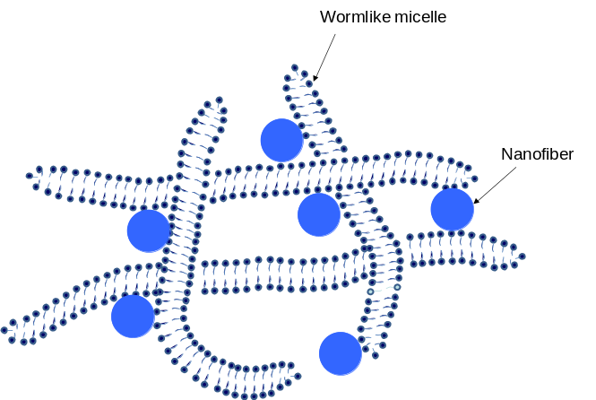

Figure 1: Model of Interaction between Cellulose Nanofiber and Viscoelastic Surfactant (wormlike micelle)

Recent Publications
- Qing WL, Yang J (2017), Effect of Multi-walled Carbon Nanotubes on Linear Viscoelastic Behavior and Microstructure of Zwitterionic Wormlike Micelle at High Temperature, Chemical Engineering Research and Design 123:14-22.
- Yang J, Cui W, Guan B (2016), Supramolecular Fluid of Associative Polymer and Viscoelastic Surfactant for Hydraulic Fracturing, SPE Production & Operations, SPE 175762-PA, April.
- Yang J, Liu X, Jia S (2016), A Highly Effective Corrosion Inhibitor by Use of Gemini Imidazoline, SPE 173777, SPE Journal, January.
- Wei Y, Wang Y, Yang, J (2015), Hydrogel Formed by the Co-Assembly of Sodium Laurate and Silica Nanoparticles，RSC Advances 5, 106005.
- Wang Y, Gao X, Xiao Y, Yang, J (2015). Temperature dependent coordinating self-assembly, Soft matter 11(14): 2806-2811.
- Yang J, Cui W, Lu Y (2015), Instant Gel Formation of Viscoelastic Surfactant Fracturing Fluids by Diluting Through Lamellar Liquid Crystal, J. Petroleum Sci. Eng 125: 90-94.
- Yang J, Wang X (2016), Effect of Hydrocarbon Structure on Phase Behavior of Dihydrogenated Tallowalkyl Dimethyl Ammonium Chloride and Water, J. Mol Liquid. 213:8-12.
- Yang J (2015), Advances of nanotechnologies in oil and gas industries, Energy Exploration & Exploitation 33(5): 639-657.

Biography (150 word limit)
Jiang Yang is a professor at Xi'an Petroleum University, China. Previously, he has worked in Baker Hughes and Petrochina for over 10 years. His research interests include oilfield chemicals such as corrosion inhibitors, fracturing fluid, surfactant, foam, emulsion etc. Yang holds a Ph.D degree in chemistry from the University of Missouri-Rolla. Yang has authored and/or coauthored more than 80 technical papers and holds 40 of patents..
Email: jyang98@126.com

Notes/Comments:

