Flow Pattern and liquid holdup prediction by machine learning

Sridharan C, Research Scholar, Petroleum Engineering Program, Department of Ocean Engineering, IIT-Madras
Taufan Rusady, Data Analyst, Petrolink.
Suresh Kumar G, Professor, Petroleum Engineering Program, Department of Ocean Engineering, IIT-Madras

Abstract (300 word limit)

Statement of the problem: A multiphase flow model represents the flow phenomenon in the wellbore accurately unlike single phase flow models when influx of formation fluids happens in the wellbore (kick), or the pipe transport of fluids in the mid-stream applications. This is significant because early alerting and mitigation of kick, which is a multiphase flow, is important from the safety of the drillers and preventing unwanted catastrophe of life and property. In the production process of petroleum industry, addressing this problem is significant to know about the productivity of the well, design of the transport system and refining process. Modeling multiphase flow measurements is very challenging in oil and gas industry due to non-availability of rheological properties and assumptions in mathematical formulations. Methodology: In this work, data models are developed by artificial intelligence techniques to predict the flow patterns and to predict liquid hold up during multiphase flow in the drilling/production phase of petroleum exploration process. Findings: It is shown that these methods were able to match and improved the prediction performance from multiphase empirical correlations. Different neural network model structures and machine learning classification and regression algorithms were evaluated and optimized to determine the best models that performs prediction accurately. The data for developing the models was collected from experiments in literature where two phase flow of air –kerosene in inclined pipes were studied. Conclusion: The prediction accuracy of the data model matches and in few cases, exceeds the predictions of the empirical models making it attractive for running in real time computer applications on the rig along with the data acquisition units.

Image

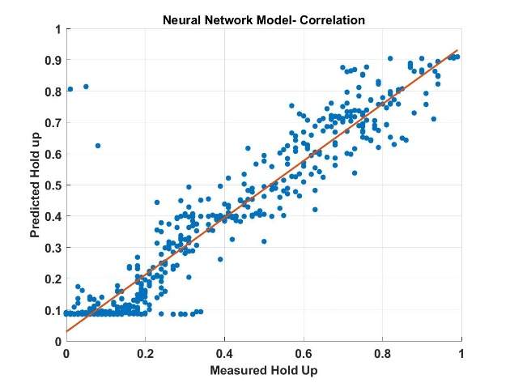
Figure: Comparison of data model with measured hold up predictions

Biography (150 word limit)
Sridharan C is a part-time research scholar in Indian Institute of Technology, Madras and a full-time data scientist in Petrolink Data Services Ltd. His research work is in the field of developing grey models which is a hybridization of physical model and data models in addressing drilling related problems.
Email: sridharavc@gmail.com

Notes/Comments:

