Short-Term and Long-Term Mechanical Behaviors of Wellbores Considering Whole Service Cycle
Wenjun Huang, PhD, Tsinghua University, China University of Petroleum-Beijing, China

Abstract (300 word limit)
Wellbore is the key channel for oil and gas extracting from underground formation to ground. Accurate prediction of the mechanical behaviors of wellbores can help people improve wellbore quality and avoid serious down-hole accidents. At present, there have been a lot of studies on wellbore mechanical behaviors, which involve various factors such as non-uniform in-situ stress, formation creep, temperature change, fault and so on. However, the coupling effect of annulus pre-stress, cement consolidation and formation creep has not been fully revealed.
In this paper, short-term and long-term mechanical models are respectively established based on the whole service cycle of wellbores. The short-term model corresponds to the completion process, in which annulus pre-stress, cement consolidation and non-uniform in-situ stress are included. A new constitutive equation of cement consolidation is introduced, and the annulus pressure caused by cement consolidation is calculated by integral method. The long-term model corresponds to the production process, in which the completion stress, formation creep, etc. are considered. The formation creep behavior is depicted by a general linear viscoelastic model and calculated with correspondence principle of viscoelastic mechanics and inversion Laplace transformation. The short-term and long-term stress are respectively presented and compared with the results from other researchers.
The results indicate that volume change and stiffing effect should be simultaneously considered to reveal the mechanical behaviors of cement consolidation. Formation creep decreases casing stress formed in the completion stage, but leads to additional casing stress in the production stage. Overall, the casing stress increases in the production process, which increases the probability of casing failure a lot. Formation creep properties are also closely related to ultimate casing stress when production time tends to infinity. Therefore, the combined effects of annulus pre-stress, cement consolidation and formation creep should be comprehensively considered in the completion design process.

Image
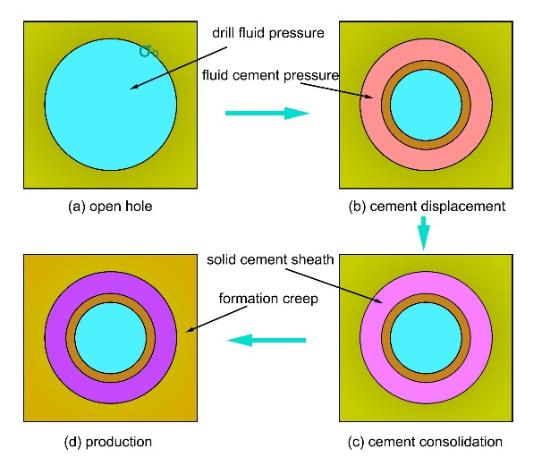
Schematic of wellbore states in the serve cycle
Recent Publications (minimum 5)
- Huang, W. and Gao, D. (2014). Helical Buckling of a Thin Rod with Connectors Constrained in a Cylinder. International Journal of Mechanical Sciences, 84: 189-198.
- Huang, W., Gao, D. (2015). and Liu F. Buckling Analysis of Tubular Strings in Horizontal Wells. SPE Journal, 20(2): 405-416.
- Huang, W., Gao, D. (2015). and Wei S. Boundary Condition: A Key Factor in Tubular String Buckling. SPE Journal, 20(6): 1,409 - 1,420.
- Huang W., Gao, D. (2015). A theoretical study of the critical external pressure for casing collapse. Journal of Natural Gas Science and Engineering, 7: 290–297.
5. Huang, W., Gao, D., Liu, Y. (2017). Inter-helical and Intra-helical Buckling Analyses of Tubular Strings with Connectors in Horizontal Wellbores. Journal of Petroleum Science and Engineering, 152: 182-192.

Biography (150 word limit)
Wenjun Huang has his expertise in Oil and Gas Drilling Engineering. He earned his Doctor Degree in Oil & Gas Drilling engineering in China University of Petroleum-Beijing in 2016. Since then, he worked as a post-doctor in Aerospace Engineering School in Tsinghua University. His modification on the traditional wellbore mechanical model creates new pathways for more accurately predicting the short-term and long-term mechanical behaviors of wellbores based on the whole service cycle.
Email: huangwenjun1986@126.com

Notes/Comments:

