Energy recovery from natural gas hydrates: Numerical modelling of natural gas hydrate dissociation in porous media by depressurization with parametric study
Zhenyuan YIN, B.Eng., National University of Singapore, Singapore
Zheng Rong CHONG, B.Eng., National University of Singapore, Singapore
Praveen LINGA, PhD, National University of Singapore, Singapore

Abstract (300 word limit)
Natural gas hydrates (NGH) are stable under low temperature and high pressure conditions. They are abundant in nature located at permafrost and deep-water locations. With the current estimation of ~ 20,000 trillion cubic meter natural gas trapped in hydrate-form, NGH are considered to be a very promising next-generation fuel source. This has provided a strong research impetus for understanding the kinetic behavior of NGH dissociation in porous media and the corresponding gas and water production. In this work, a 2D cylindrical axi-symmetric model was constructed to simulate NGH dissociation in porous media by depressurization method. The simulation domain accurately describes the geometry of the 1.0 L hydrate reactor used in one of our recent experimental studies. The physics involved includes multi-component heat and mass transfer, multi-phase fluids flow through porous media and NGH dissociation intrinsic kinetic rate. The initial condition of the simulation is at temperature of 281.4 K and pressure of 6.1 MPa, with pore volume saturation of 40% hydrate, 56% aqueous and 4% gas. The bottom hole pressure of the outlet is maintained at 4.0 MPa during hydrate dissociation. The cumulative gas production is estimated and validated against experimental data, showing a good agreement between observations and numerical predictions. The predictions of the spatial distributions of temperature, hydrate saturation and gas saturation over time show that hydrate dissociates layer by layer with a diffusive hydrate dissociation front. Excess gas from reactor is produced initially before production of gas dissociated from hydrate. In addition, a parametric study on critical heat and fluid transport parameters, i.e. thermal conductivity, intrinsic permeability, are conducted to elucidate their effects on hydrate dissociation and gas production behavior.
Image
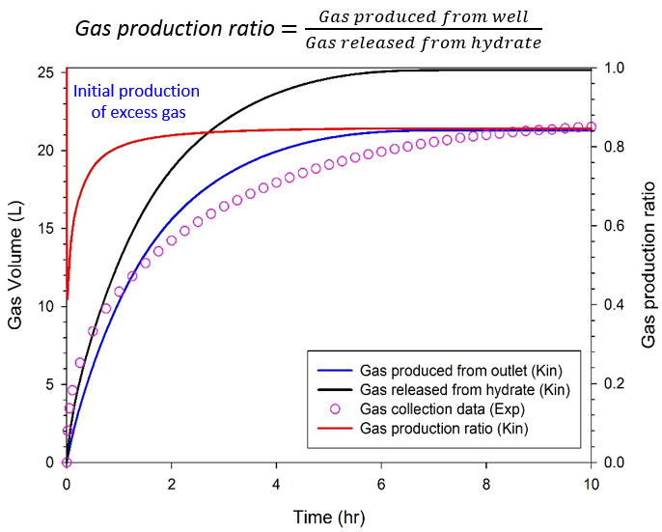
Figure 1: Cumulative gas production from reactor outlet compared with experimental data
Recent Publications (minimum 5)
- Yin, Z.; Chong, Z. R.; Tan, H. K.; Linga, P. (2016). Review of gas hydrate dissociation kinetic models for energy recovery. Journal of natural Gas Science and Engineering, 35, 1362-1387.
- Chong, Z. R.; Yin, Z.; Tan, J. H. C.; Linga, P. Experimental investigations on energy recovery from water-saturated hydrate bearing sediments via depressurization approach. Appl. Energy, in press. [DOI: 10.1016/j.apenergy.2017.04.031].



Biography (150 word limit)
Zhenuan Yin is a second year Ph.D student working under Associate Professor Praveen Linga in the Department of Chemical and Biomolecular Engineering at National University of Singapore. His research interests are in the areas of numerical modelling of natural gas hydrate formation and dissociation kinetic behavior, hydrate reservoir simulator (TOUGH+Hydrate) and multiphase fluids flow in porous media and pipeline.
Email: zhenyuan.yin@u.nus.edu

Notes/Comments:

