The Mechanism of Wormholes Propagation Based on CT Scanning and Digital Core Analysis

Fei Liu, Post-Doctoral Research Center, PetroChina Southwest Oil & Gas Field Company, China

Yu Sang, Nanxing Xie, Rong Zeng, Engineering Technology Research Institute, PetroChina Southwest Oil & Gas Field Company, China

Jiajun Xie, Middle Sichuan Oil and Gas Field, PetroChina Southwest Oil & Gas Field Company, China

Abstract
The formation of acid dissolved wormhole is derived from heterogeneous physical and chemical transportations and reactions. The propagation of wormhole is vital important for matrix acidizing and acid fracturing in carbonate reservoirs. Dissolved pores, vugs, and caverns, which are the major reservoir spaces of the Sinian dolomite formation in the Anyue gas field of the Sichuan Basin, which make the formation and propagation of acid dissolved wormhole particularly complicated. Firstly, the topological structure of three dimensional spaces of dissolved pores, vugs, fissures and throats inside cores is quantitatively scanned by CT imaging technology for its feature of vivid and damage-free. Secondly, 3-D patterns of wormhole are obtained with CT scanning after core flooding by acid. Meanwhile, the wormhole pattern gained by CT scanning and simulating with multi-scale model is compared. Additionally, the pore-throat network model is reconstructed with digital cores technology. Then, the size and ratio of pore and throat before and after core flooding by acid is analyzed and compared to understand the influence of pores and vugs distribution on wormhole propagation coupled with numerical simulation of absolute permeability of pore scale flow. The results show that the distribution and connectivity of pores and vugs is the primary cause for the formation and propagation of acid etched wormholes. Lastly, the corrected multi-scale model is utilized to simulate the wormhole propagation for matrix acidizing of Sinian fractured-vuggy dolomite in Anyue gas field, Sichuan Basin. The simulation results accurately reflect the characteristics of matrix acidizing operation curve. The theoretical model of wormhole propagation can be used to optimize the matrix acidizing of such formations.

Image
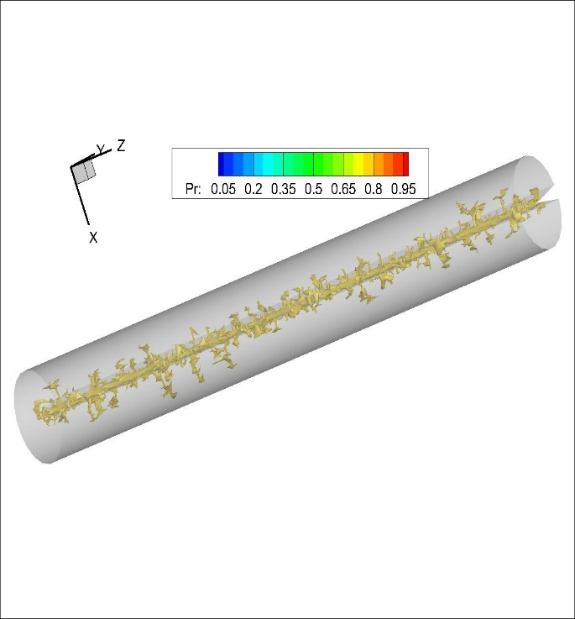
Fig.1 3-D wormhole pattern simulated with two-scale continuum model for Well D under optimal acid injection rate and volume
Recent Publications
- Liu P L, F Liu, C Y She, et al., (2016) Multi-phase fracturing fluid leakoff model for fractured reservoir using extended finite element method. Journal of Natural Gas Science & Engineering, 28:548-557.
- Liu F, L Q Zhao, P L Liu, et al., (2015) An Extended Finite Element Model for Fluid Flow in Fractured Porous Media. Mathematical Problems in Engineering, 2015:1-10.
- Liu F, Z F Luo, Z K Wang, et al., (2015) Gas seepage rule and productivity analysis in designing coalbed methane wells. Chemistry and Technology of Fuels and Oils, 35(4):516-524.
4. Liu F, Y Sang, N X Xie, et al., (2017) Wormholes Propagation for Fractured-Vuggy Formation: Laboratory Tests, Numerical Simulation and Field Application, Petroleum, accepted.
5. Liu F, Z F Luo, Y Sang, et al., (2017) Deformation Behavior between Hydraulic and Natural Fracture Using Fully Coupled Hydro-Mechanical Model with XFEM, Mathematical Problems in Engineering, In Press.
6. Zhao L Q, F Liu, P S Wang, et al,. (2014) A review of creation and propagation of complex hydraulic fracture network, Oil & Gas Geology, 35(4):562-569.
7. Liu P L, F Liu, L Q Zhao, et al., (2013) Predicting productivity of hydraulic fracturing with pre-pad acid, 47th US Rock Mechanics / Geomechanics Symposium.
8. Liu F, L Q Zhao, X L Meng, et al., (2014) Simulation of Acid-rock Reaction in Hydraulic Fracturing with Pre-pad Retarded Acid, Journal of Oil & Gas Technology, 36(1):104-108.



Biography
Liu Fei has his expertise in theory and technique in reservoir stimulation. He got his doctor degree of engineering from Southwest Petroleum University, China, in 2015. He is employed in Post-Doctoral Research Center of PetroChina Southwest Oil & Gas Field Company and Post-Doctoral Mobile Research Station of Southwest Petroleum University.
Email: liufei2015@petrochina.com.cn
Notes/Comments:

