Analysis of Petroleum Systems of the Kura Basin, Azerbaijan

Gasham A. Zeynalov, Khazar University, Azerbaijan

Abstract
Statement of the Problem: Main objective is analysis of key elements and processes of Petroleum Systems in Kura intermountain basin.
Methodology. Comparatively has been analyzed elements of petroleum systems of the Kura basin as properties of source rocks, reservoir rocks, trapping mechanism and sealing properties and generation, migration, accumulation and preservation processes which allowed to evaluate further hydrocarbon exploration in different depression zones of the Kura basin. As an elongate NW-SE regional depression, Kura intermountain basin is subdivided into the Upper Kura (Kartli), the Middle Kura and the Lower Kura sub-basins on the complicated geological structure and evolution pattern and is bordered with South Caspian basin in SE (figure 1) and has complicated development history, sharp facial variations in deposition of sedimentary rocks, occurrence different type volcanogenic processes and oil and gas saturation in volcanoclastic, carbonate and siliciclastic sedimentary rocks. Only, Lower Kura sub-basin in east part of the basin has resembling properties to the South Caspian basin which is characterized by high sedimentation rates in Pliocene-Quaternary time.
Conclusions. Mentioned multiphase tectonism of the Kura Basin was caused to rise formation of multiple structural and stratigraphic traps in various stratigraphic units within the sub-basins of the intermountain depression which made it very exciting basin in exploration of oil and gas fields. Kura intermountain basin has several petroleum systems which is characterized with various stratigraphic ranges of elements and processes in different sub-basins from Cretaceous, Tertiary to Quaternary rocks. Variation of stratigraphic and depositional range of oil and gas generation and accumulations in the Kura intermountain basin were caused by different multiphase structural-geologic processes. All above-mentioned properties has been analyzed comparatively and their results allowed to determine further direction of exploration works for discovering new oil and gas fields in the Kura basin.
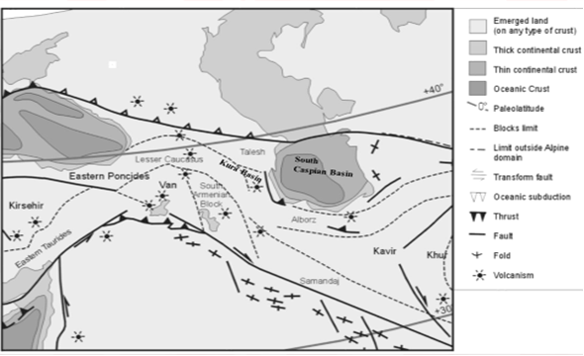Figure1. Sketch of the present-day tectonics of the Caucasus mountain systems, Kura Basin and surrounding regions (modified Philip et al., 1989, Nemcok et all., 2011).
Reference
- Forte, A. M., Cowgill, E., Bernardin, T., Kreylos, O., and Hamann, B., 2010, Late Cenozoic deformation of the Kura fold-thrust belt, southern Greater Caucasus: Geological Society of America Bulletin, v. 122, no. 3-4, p. 465-486.
- Inan, S., Namik Yalçin, M., Guliev, I. S., Kuliev, K., and Akper Feizullayev, A., 1997, Deep petroleum occurrences in the Lower Kura Depression, South Caspian Basin, Azerbaijan: an organic geochemical and basin modeling study: Marine and Petroleum Geology, v. 14, no. 7-8, p. 731-762.
- Jackson, J., Priestley, K., Allen, M. B., and Berberian, M., 2002, Active tectonics of the South Caspian Basin: Geophysical Journal International, v. 148, no. 2, p. 214-245.
- M. Nemčok, A. A. Feyzullayev, F.A. Kadirov, G.A. Zeynalov, R. Allen, C. Christensen and B. Welker, 2011, Neotectonics of the Caucasus and Kura Valley, Azerbaijan, “Global Engineers and Technologist Review” journal , Vol.1,No 1, Malaysia, p.1-14
- Philip, H., Cisternas, A., Gvishiani, A., and Gorshkov, A., 1989, The Caucasus: an actual example of the initial stages of continental collision: Tectonophysics, v. 161, no.1–2, p. 1-21.
- Smith-Rouch, L.S., 2006, Oligocene–Miocene Maykop/Diatom Total Petroleum System of the South Caspian Basin Province, Azerbaijan, Iran, and Turkmenistan:U.S. Geol. Survey Bulletin 2201,p.1-27.

e-mail: gzeynalov@khazar.org

