Understanding Worst Case Discharge Through Large Pipe Diameters Using Computational Fluid Dynamics (CFD) Simulations
Mayank Tyagi, Louisiana State University, USA
Muhammad Zulqarnain, Louisiana State University, USA
Richard G. Hughes, Louisiana State University, USA

Abstract (300 word limit)

Deepwater drilling and production operations are extremely challenging due to the environment as well as the complexity of operations. In the aftermath of Deepwater Horizon accident, it became clear that the capping and containment system design as well as environmental risk assessment need a reasonable estimate for the worst case discharge (WCD) flow rates. Almost all the experimental as well as numerical data in the published literature show the glaring gap due to the lack of high flow rate data for multiphase flows through pipes with large diameters (greater than 6-in). A systematic analysis is presented to demonstrate the diminishing role of frictional pressure losses for the oil wells in the blowout scenarios. On the contrary, the importance of estimating liquid hold-up and flow transitions is highlighted in the WCD calculations.

Computational Fluid Dynamics (CFD) simulations provide a detailed description of complex flow field using the volume-of-fluid (VOF) multiphase closures along with turbulence models to model WCD through large pipes. Due to overwhelming computational requirement, only the discharge point section of the wellbore is modeled in CFD calculations. It is shown that CFD can accurately predict the pressure-loss and therefore, the discharge rate more accurately than existing approaches. To that end, importance of flowing bottomhole conditions in the wellbore and reservoir fluid properties on such discharge estimates is highlighted.

Image
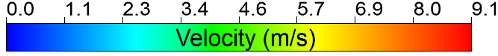
Figure 1: Iso-surface of volume fraction value of 0.9 showing approximate gas structures colored by velocity magnitude for low slip velocity ratio in different WCD multiphase flow regimes (Bubbly to Churn/Annular).
Recent Publications (minimum 5)
- Dahi-Taleghani, N., Tyagi, M., Vector Autoregression Simulation Study of Multiple Shocks on Louisiana’s Economic Performance, Accepted for publication in SPE Economics & Management, 2016 (SPE-185175-PA).
- Zulqarnain, M. (2015). “Deepwater Gulf Of Mexico Oil Spill Scenarios Development and Their Associated Risk Assessment”. PhD Dissertation, Louisiana State University.
- Zulqarnain, M., Tyagi, M., Development of Simulations Based Correlations to Predict the Cement Volume Fraction in Annular Geometries after Fluid Displacements during Primary Cementing, Journal of Petroleum Science & Engineering, 145, 1-10, 2016.
- Parsi, M., Agrawal, M., Srinivasan, V., Vieira, R. E., Torres, C. F., McLaury, B. S., Shirazi, S. A., Schleicher, E. Hampel, U. 2016. Assessment of a hybrid CFD model for simulation of complex vertical upward gas–liquid churn flow, Chemical Engineering Research and Design 105: 71-84.
- Zabaras, G. J , Schoppa, W.,., Menon, R., & Wicks, M., 2013, May 6. Gaps and Advancements for Deepwater Production and Remote Processing: Large Diameter Riser Laboratory Gas-Lift Tests. Offshore Technology Conference. doi:10.4043/23968-MS.

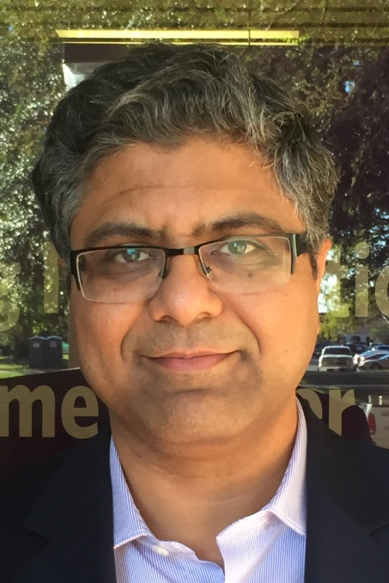 Biography (150 word limit)
Prof. Mayank Tyagi is Chevron #3 designated associate professor at the Craft & Hawkins department of petroleum engineering, Louisiana State University (LSU). He also holds a joint faculty appointment at the Center for Computation & Technology (CCT), LSU since 2007. He obtained his Ph.D. in mechanical engineering from LSU and undergraduate in mechanical engineering from Indian Institute of Technology (IIT), Kanpur. His current research interests span across high performance computing (HPC) and data analytics for interdisciplinary petroleum engineering applications, image-based pore-scale modeling using lattice Boltzmann method (LBM), multiscale multiphase computational fluid dynamics (CFD), geothermal reservoir engineering, and unconventional reservoir simulations. He has also worked on the issues in the quantitative risk assessment (QRA) of offshore petroleum engineering operations and their impacts on regional economy. He has given numerous invited talks at India, China, and several US universities and published over forty (40) peer-reviewed technical publications.
Email: mtyagi@lsu.edu

Notes/Comments:

