


Oil potentiality of kharita
Formation in western desert

Dr/ Ahmed Sadeq
Team: Ahmed Abdelrazeq Ali, Abdullah elsayed abdelsalam, Saeid Mahmoud, Aly Ehab ghorab, Mahmoud nomer.

Abstract
The oil potentiality of Kharita Fm in western desert vary from place to place, Can be Reservoir and source rock, Usually High quality of sand, But the risk in (OWC) oil water contact that Kharita may filled by water under. Therefore, it depend on Burial history and Oil window, after research, Kharita play as a source before oil window or as a reservoir marginally mature in early stage of maturation. In addition, we found gas prone potentially discussed in this research.
We provide different areas with different Hydrocarbon potentiality to be discussed and to make sure about the important of using different tools and methods to evaluate the potentiality of a formation.

Background (1)
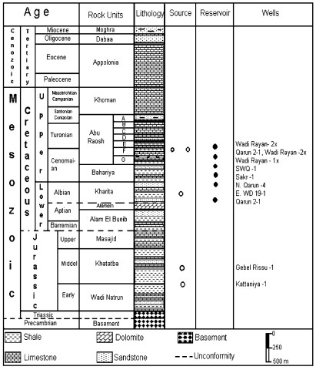

Source rock characterization
Toward the east in North Qarun-1x, El Sagha-1A, and E.WD19-1x wells the drilling stopped at Kharita Formation and the wells describe nearly a complete sequence of rock units from Cretaceous to Tertiary rocks. The Kharita, Bahariya, Abu Roash, Khoman, Appolonia, Dabaa, and Moghra formations are well represented with increasing thickness toward the east direction
On the other hand, these formations show a noticeable decrease in their thickness in the west direction at Gebel Rissu-1 and Kattaniya-1 wells.
This may be due to the tectonic regime prevailing in the area.

Isopach and Lithofacies Maps

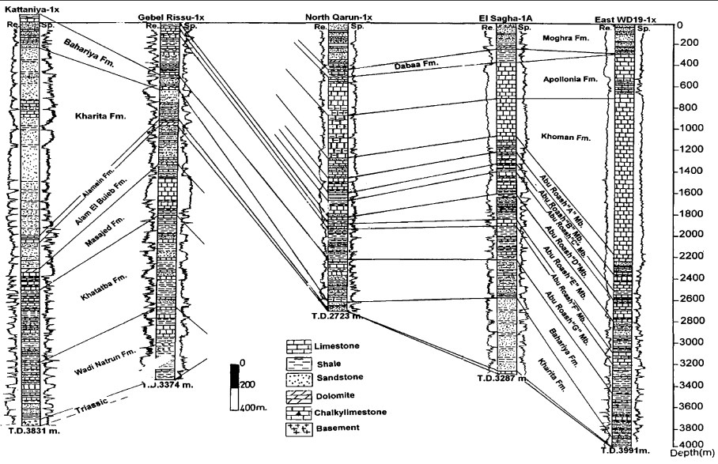
The isopach map of Kharita Formation (Figure 5A) shows the increase in its thickness from east to west direction. Also, it reflects two main sub-basins of deposition. The first one occupies the western part at Kattaniya-1 well with maximum thickness reaching 1,780 m. The second depocenter locates at the central part around El Sagha-1A well (697 m). Moreover, there is a remarkable thinning of this formation towards the eastern part of the study area, where its thickness reaches to zero at Gindi Deep-1x well. This may be due to the uplifting followed by erosion of Kharita Formation at this area or may be tectonically high and not received any material of sedimentation.
The predominance of reservoir sandstones in the succession leads to juxtaposition of, and communication between sandstones across faults. This explains the reliance on three- or four-way dip closed structures in the Western Desert fields. Mesozoic sediments of the Western Desert were derived from a fluvial system which flowed northwards from the African continen . This fluvial system reached a shallow marine sea within the area studied in this paper, giving rise to deposition in delta and shallow marine conditions. Consequently, the Jurassic and Cretaceous, succession is dominated by shallow marine and fluvial sandstones. Variations in sea level during the Jurassic and Cretaceous, led to the migration of facies belts, and the deposition of similar lithologies across the whole of the study area. This depositional model gives rise to laterally extensive sandstone-dominated lithofacies. Thick, porous and permeable sandstones are deposited during regressive phases, such as during deposition of the Kharita Formation (Albian) and the Alam el Bueib Formation (NeocomianBarremian) . During transgressive phases, shaly lagoon and delta-top facies are preferentially preserved, and beach barrier sandstones are less well developed.
Types of sealing faults considered:
- Juxtaposition seals
- Shale smear seals
- Cataclasis seals (Knipe 1992)

