

Abstract Template

Title: A forward modeling method based on electromagnetic theory to measure the parameters of hydraulic fracture
Liming Zhang¹ Ji Qi¹, Lixin Li¹, Kai Zhang^{1,*}, Zhixue Sun¹, Yongfei Yang¹,Qin Luo²
1 School of petroleum engineering, China University of Petroleum (East China), QingDao 266580,P R China.
2 School of computer Science, Southwest Petroleum University, Chengdu 610000, P R China.

Keywords: electromagnetic monitoring; hydraulic fracturing; effective propped volume; conductive proppant; forward modeling.

- Abstract Body (up to 250 words)
Hydraulic fracturing is the pivotal technology of tight unconventional reservoir, and accurate monitoring of fracture morphology is related to fracturing effect evaluation, well productivity prediction and the follow-up measures. Compared with traditional methods, electromagnetic monitoring can obtain the Effective Propped Volume (EPV) that actually reflects the productivity, solve the abuse such as low fracture identification accuracy, limited by the specific time. This paper introduces an physical and numerical model that uses electromagnetic characteristics to accurately monitor the parameters of the fracture. A triaxial transmitting - triaxial receiving instrument which is approximate to the construction site is set up, the relationship of electromagnetic monitoring signals and the fracture parameters is obtained. By placing the transmission source plane perpendicular to an appropriate coordinate axis in a three-dimensional rectangular coordinate system the length and height of the fracture could be monitored by the signal of the long receiver while the transmitting source surface being perpendicular to the Z-axis. The azimuth could be inverted according to the magnitude of the signal peak when the transmitting source surface is perpendicular to the X-axis. The sign of azimuth could be determined by setting a M-axis (the Z axis rotates counterclockwise 45 degrees in the XZ plane).

Image:
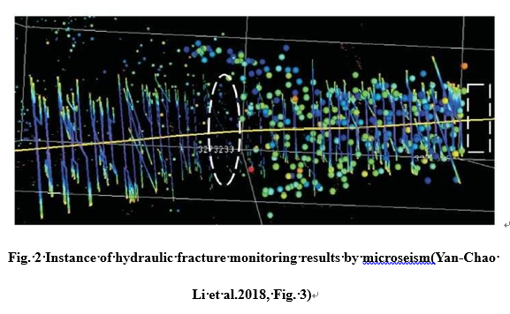
- Reference:

[1] Shawn Maxwell. Microseismic Hydraulic Fracture Imaging: The Path Toward Optimizing Shale Gas Production [J]. Shales, 2011, 30 (3):340-346.
[2] Robert C Downie, Le Calvez Joel H, Ken Kerrihard. Real-Time Microseismic Monitoring of Simultaneous Hydraulic Fracturing Treatments in Adjacent Horizontal Wells in the Woodford Shale [J]. Frontiers+Innovation-2009 CSPG CSEG CWLS Convention, 2009, 26（1）：484-492.
[3] Mayerhofer, M., Demetrius, S., Griffin, L., Bezant, R. B., Nevans, J., & Doublet, L. (2000, January 1). Tiltmeter Hydraulic Fracture Mapping in the North Robertson Field, West Texas. Society of Petroleum Engineers. doi:10.2118/59715-MS， 2000.

Biography:
Liming Zhang (1982-), female, born in jinan, shandong province, Ph.D., associate professor, mainly engaged in oil field exploitation, multiphase flow and separation

Presenting author details

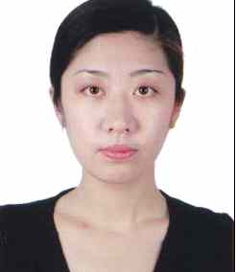 Liming Zhang: 15863038069:
zhanglimingupc@163.com
Category: Oral
:



