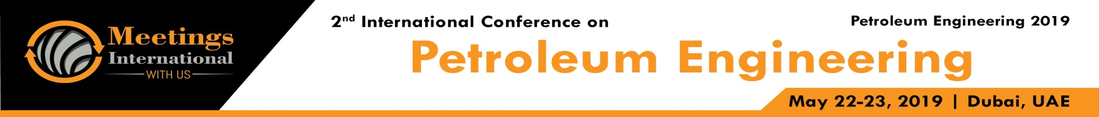

Title: Production of a Multilevel reservoir through Alternative selective well Production

Bist Namrata1, Sircar Anirbid 2,
1Lecturer, School of Petroleum Technology, Pandit Deendayal Petroleum University, Gandhinagar,Gujarat,India
2 Professor, School of Petroleum Technology, Pandit Deendayal Petroleum University, Gandhinagar,Gujarat,India
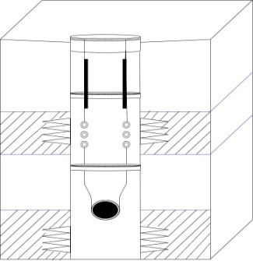
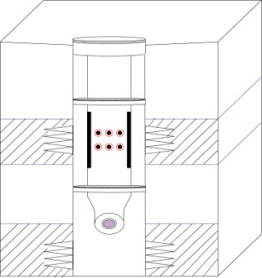

Keywords: workover, multi zone, sliding sleeves, selective well production, multi level

- Abstract Body
In a reservoir several fluid bearing pay zones are present in the same formation. Our objective is to produce several levels in the same well separately but one after the other through the same tubing without any work over. This type of completion is suited to a situation where more than one pay zones can be produced by drilling through one well. Besides packers this technology requires extra down hole equipment such as:
Circulating device consisting of sliding sleeves to open or obstruct communication ports between tubing and annulus.
Circulating device is placed above the packer and allows communication between tubing and annulus. This is useful when the well is brought on stream.
A landing nipple that allows a plug to be set in the well. It provides space where mechanical tools can be seated( commonly done through wire line).
By using the conventional method, we case and cement the open hole and perforate the multiple target zone, followed by running in the production tubing with sliding sleeve assembly (Perrin,1999).
But, for the selective production through multi-level , the sliding sleeves are and number used is equal to the number of producing formation.
Surface-controlled sliding sleeve are a new technology that open from surface for selective production of multilevel reservoir and stimulation operation in multi zone formation (Shaw, 2011). These valves are like conventional sliding sleeve, but they are shifted from the surface and therefore, do not require intervention (Schlumberger, 2017).
Since the system does not require ball seats, the production casing provide full bore access and flow area all the way to the toe of the completion.
At first the formation is drilled through multiple pay zones. According to the productivity index and fluid flow rate we allow the pay zone to flow. Then along with the time reservoir pressure declines, in this case we can produce fluid from the other pay zone without any work over.
Conclusion & Significance: This method is highly efficient in reducing workover costs, advantageous in selective production of any order and an alternate approach for life extension of mature reserves.

Image:
Representation of the working model

- Reference:

- Shaw J., 2011, “Benefits and application of surface-controlled sliding sleeve for fracturing operation”, SPE147546, pp. 1-8

- Perrin, D., 1999, “Oil and Gas Fields Development Techniques, well completion and services”, France: Technip Publishers.

- Schlumberger, Case study,2017 : “MZ-Xpress system saves 6.5 days of rig time by minimizing completion trips offshore Indonesia”,17 –CO-241523, pp.1-2

Biography:
Namrata Bist is lecturer in the school of petroleum technology, gandhinagar,Gujarat , India. Her areas of interest are Production Engineering, Renewable Energy, and applications of Petroleum Engineering in Software domain

Prof. Anirbid Sircar is Professor, school of petroleum technology, Pandit deendayal petroleum engineering, Gandhinagar, Gujarat,India. He has a rich 24 years of industrial and academic experience. His areas of interest are Petroleum Exploration, Geothermal Energy,Reservoir Tomography & City Gas Distribution

Presenting author details

Full Name: Namrata Bist
Contact number: +91- 8141724956
Twitter account: NA
Linked In account: https://www.linkedin.com/in/namrata-bist/
Session name/ number: Other
Category: (Oral presentation/ Poster presentation): Oral presentationa


