

Title: Reduction of electricity load that is generated by non renewable sources, by utilization of hybrid Solar and Geothermal energy for electricity generation: A case study of Dholera, Gujarat

Bist Namrata1, Sircar Anirbid 2,
1Lecturer, School of Petroleum Technology, Pandit Deendayal Petroleum University, Gandhinagar,Gujarat,India
2 Professor, School of Petroleum Technology, Pandit Deendayal Petroleum University, Gandhinagar,Gujarat,India

Keywords: fossil fuels, energy, Gujarat, India, pilot scale, solar, geothermal, electricity, non renewable, renewable

- Abstract Body (up to 250words)
We have been heavily dependent on fossil fuels for the energy requirements and this reliance has made our ecosystem unsustainable. This is also putting tremendous burden on oil and gas to fulfill our fuel needs. At Dholera, Gujarat,India; we have setup a pilot scale plant which utilizes Geothermal water for space heating and cooling. Now, we are designing an integrated setup with the solar energy where the solar collectors can be augmented with the existing system and the produced water (at approximately 180ºC) can be utilized to produce electricity.
This electricity then can be utilized by the nearby areas and will reduce the load on the electricity department and hence the fossil fuel consumption for the generation of electricity can be reduced.
This will be one of its kind setup in India. Utilizing projects like these can help load sharing of 50-50 percent by both non renewable and renewable energy sources.

Image:
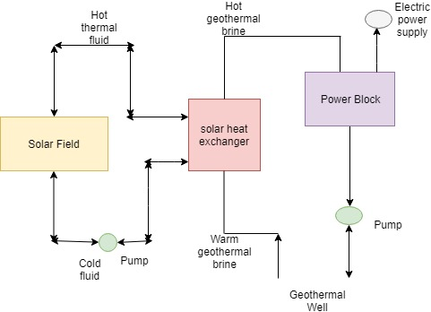

- Reference:

1 Shah M., Sircar A., Patel K., Shaikh N., Thakar V., Vaidya D., & Chandra S. (2018), Comprehensive study on Hybrid Geothermal-Solar cooling systems with special focus on Gujarat, Western India.

- Hassani V., & Prince H. (2001), Modular Trough Power Plants. ASME Forum 2000 “Solar Energy: The Power to Choose”.

- Zhang, H., & Zhang, H. (2012). Application of the Hybrid System of Solar Energy and Geothermal Heat Pump in Buildings. In Advanced Materials Research (Vol. 374, pp. 137-140). Trans Tech Publications.

Biography:
Namrata Bist is lecturer in the school of petroleum technology, gandhinagar,Gujarat , India. Her areas of interest are Production Engineering, Renewable Energy, and applications of Petroleum Engineering in Software domain

Prof. Anirbid Sircar is Director, school of petroleum technology, Pandit deendayal petroleum engineering,gandhinagar, Gujarat,India. He has a rich 24 years of industrial and academic experience. His areas of interest are Petroleum Exploration, Geothermal Energy, Reservoir Tomography & City Gas Distribution

Presenting author details

Full Name: Namrata Bist
Contact number: +91- 8141724956
Twitter account: NA
Linked In account: https://www.linkedin.com/in/namrata-bist/
Session name/ number: Other
Category: (Oral presentation/ Poster presentation): Oral presentation Passport Number: NA AN


