

Title: An Experimental and Optimization Study of Dynamic Interfacial Tension for Crude oil-brine system in the presence of non-ionic surfactants
Hooman mohammadshahi¹, Hamidreza Shahverdi¹, Mohsen Mohammadi¹
1 Department of Chemical Engineering, Isfahan University of Technology, Isfahan 84156-83111, Iran

Keywords: Enhanced Oil Recovery, Surfactants, Response Surface Method, Dynamic Interfacial Tension, Optimization

- Abstract Body (up to 250 words)
In this study, the interfacial tension is measured between brine and crude oil in the presence of two non-ionic surfactants such as KEPS 80 and Behamid D at different concentrations in order to optimize the concentrations of the surfactants. The surface response method is used to design the IFT measurement experiments. The experimental design and optimization is performed using the interfacial tension as objective function and temperature, concentration and time as independent variables. In addition to the IFT measurement, various experiments such as stability tests of the surfactants in the NaCl brine solutions, adsorption experiments on the carbonated rock surface and phase behavior tests are performed to investigate the behavior of KEPS 80 and Behamid D in the EOR process. At the end, a model using response surface statistical technique is designed for optimization of the concentrations of the surfactants and a surfactant molecular migration mechanism is used for explanation of the dynamic IFT variation versus time.
The results show that the oil-brine IFT values can be reduced to about 4 mN/m in the presence of Behamid D and to the amounts of 1 mN/m in the presence of KEPS 80 at low concentration.

Image:

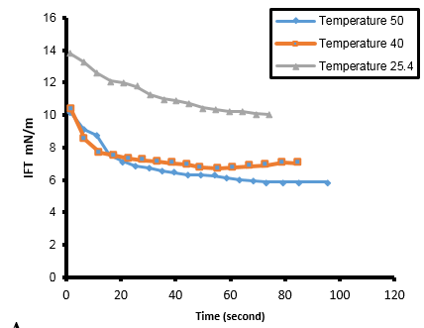
Reference:

- Mohammadkhani, S, S Marie Nielsen, A Shapiro, H Shahverdi, and M Nasr Esfahany. 2018. "The Potential of Temperature-activated CO2 Production In Situ as an Enhanced Oil Recovery Process." 80th EAGE Conference and Exhibition 2018.
- Vankayala, J.S., et al., Surfactants and fatty alcohol based novel nanovesicles for resveratrol: Process optimization, characterization and evaluation of functional properties in RAW 264.7 macrophage cells. Journal of Molecular Liquids, 2018. 261: p. 387-396..
- Zaeri, Mohammad Reza, Rohallah Hashemi, Hamidreza Shahverdi, and Mehdi Sadeghi. 2018. "Enhanced oil recovery from carbonate reservoirs by spontaneous imbibition of low salinity water." Petroleum Science 15 (3):564-576.
- Mohamed, A.I.A., et al., Influence of Surfactant Structure on the Stability of Water-in-Oil Emulsions under High-Temperature High-Salinity Conditions. Journal of Chemistry, 2017. 2017: p. 11.

Biography:
Hamidreza Shahverdi is an assistant professor in Isfahan University of Technology, at department of Chemical Engineering. He is head of petroleum department at university. He has 15 years of experiences in petroleum reservoir engineering in particular in EOR techniques and multi-phase flow in porous media. He is consultant of EOR project at Heriot-watt university. Shahverdi holds a PhD degree in petroleum engineering from Heriot-Watt University (at UK).

Presenting author details
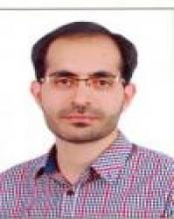

Full Name: Hamidreza Shahverdi.
Contact number: +98 (0)9134033465, +98 (031)33915603
Email: Hr_Shahverdi@cc.iut.ac.ir
Category: (Oral presentation/ Poster presentation)
Passport Number: B43559407



