

Title: New Flotation technique for investigation of carbonate rock wettability alteration in presence of low salinity water and nano-fluids

Mehdi Sadeghi1, Rohallah Hashemi 1, Hamidreza Shahverdi 1,
1 Department of Chemical Engineering, Isfahan University of Technology, Isfahan 84156-83111, Iran

Keywords: Enhanced Oil recovery, Flotation, Wettability, Nano-fluid, Carbonate rock

- Abstract Body (up to 250 words)
As a modern approach towards EOR studies, a new flotation technique was introduced as a fast cost-effective repeatable quantitative method for determination of wettability alteration in carbonate rocks in presence of low salinity water and nano-fluids. In this regard, the impact of low-salinity water and nano-silica fluid were investigated using a new flotation method, and flotation data was compared with those from classic methods including contact angle measurement and spontaneous imbibition. Flotation results are in great agreement with the other findings, while enormously reducing the time required for experiments from at least 60 days to less than two weeks. 10-times diluted Persian Gulf water was found to be the optimum low-salinity water, demonstrating a better performance in comparison to brines with higher or lower salinity. Also nano-silica fluid containing 0.05% weight of nanoparticles was determined as the most satisfactory nano-fluid.

Image:

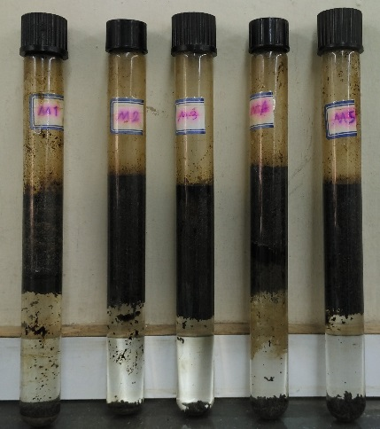
Reference:

- Mohammadkhani, S, S Marie Nielsen, A Shapiro, H Shahverdi, and M Nasr Esfahany. 2018. "The Potential of Temperature-activated CO2 Production In Situ as an Enhanced Oil Recovery Process." 80th EAGE Conference and Exhibition 2018.
- Mohammadkhani, Samira, Hamidreza Shahverdi, and Mohsen Nasr Esfahany. 2018. "Impact of salinity and connate water on low salinity water injection in secondary and tertiary stages for enhanced oil recovery in carbonate oil reservoirs." Journal of Geophysics and Engineering 15 (4):1242-1254.
- Zaeri, Mohammad Reza, Rohallah Hashemi, Hamidreza Shahverdi, and Mehdi Sadeghi. 2018. "Enhanced oil recovery from carbonate reservoirs by spontaneous imbibition of low salinity water." Petroleum Science 15 (3):564-576.
- Zaeri, Mohammad Reza, Hamidreza Shahverdi, Rohallah Hashemi, and Mohsen Mohammadi. 2018. "Impact of water saturation and cation concentrations on wettability alteration and oil recovery of carbonate rocks using low-salinity water." Journal of Petroleum Exploration and Production Technology:1-12.

Biography:
Hamidreza Shahverdi is an assistant professor in Isfahan University of Technology, at department of Chemical Engineering. He is head of petroleum department at university. He has 15 years of experiences in petroleum reservoir engineering in particular in EOR techniques and multi-phase flow in porous media. He is consultant of EOR project at Heriot-watt university. Shahverdi holds a PhD degree in petroleum engineering from Heriot-Watt University (at UK).

Presenting author details


Full Name: Hamidreza Shahverdi.
Contact number: +98 (0)9134033465, +98 (031)33915603
Email: Hr_Shahverdi@cc.iut.ac.ir
Category: (Oral presentation/ Poster presentation)
Passport Number: B43559407



