

Title: Optimizing Field Depletion Plan in Heavy Oil Reservoirs Using Numerical Simulation: Gulf of Suez –Egypt

Fayed M.1, Hassan Z.2, Edward G2
1. Gulf of Suez Petroleum Company, Cairo, Egypt
2. BP Company, Cairo, Egypt

Keywords: Heavy oil, Simulation, Depletion plan, Marginal field, Case of success

- Abstract
The Gulf of Suez Petroleum Company (GUPCO) is a leading Offshore Egyptian petroleum company, produced more than 4.6 billion oil barrel, which represent more than 43% of Egypt’s total cumulative oil to date.GS327 field is one of marginal fields, has four compartments and two stacked reservoirs with strong aquifer support. The produced oil is relatively heavy oil and in such reservoirs, the oil viscosity is 10 times of water viscosity, which could decrease sweep efficiency and result too much bypassed oil.
Integrated Reservoir study done for Southwest compartment of GS327 field, ASL reservoir, using analytical and 3D simulation modeling approaches to evaluate the remaining reserves, locations, by passed oil, and optimize new wells locations. The analytical reservoir approaches included analyzing wells oil and water production performance, Field pressure/ production performance, reviewing saturation and production logs & estimate the remaining reserves of the current wells (DCA, WOR approaches). Comparing the recovery factor with other analogue fields to determine the need for drilling new wells.
The present study showed heavy oil reservoir management using different approaches. Poor sweep efficiency is expected heavy oil reservoirs so 3D simulation is mandatory to locate the bypassed and swept areas and optimize wells locations. Based on this study, we recommended drilling many new wells to maximize oil recovery and sweep efficiency because the fluid is relatively heavy oil. We have drilled and completed the first successful well in September 2017 with 2000 BOPD initial rate and add 2 mmbo and we are planning for drilling more wells to maximize the value of resources.

Image:
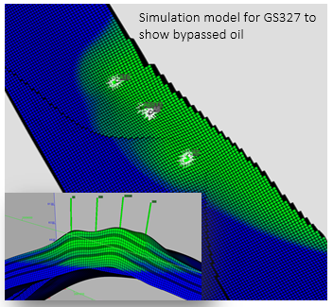
III. Reference:

- Yasser Abdallah, SPE-128533-MS “GS-327 Gas Lift Field Real-time Monitoring and Optimization Strategies”, North Africa Technical Conference and Exhibition, 14-17 February, Cairo, Egypt.

- Ganesh C. Thakur (Chevron Petroleum Technology Co.), SPE-39233-MS “Heavy Oil Reservoir Management ”, Latin American and Caribbean Petroleum Engineering Conference, 30 August-3 September, Rio de Janeiro, Brazil .

- P.J. Briggs (British Petroleum Co. Ltd.), SPE-15748-PA “Development of Heavy-Oil Reservoirs”, Journal of Petroleum Technology, February 1988.

Biography:
Mahmoud Sobhy Fayed has completed his B.Sc. of Petroleum Engineering in 2005 from Suez University in Egypt. He is team leader for Reservoir Engineering department in GUPCO and BP Egypt, technical member in MODERNIZATION project in Egypt and technical committee member in EGYPS conference, shared in many international conferences with technical papers such as MEHOC (Middle east heavy oil congress in Bahrain), SPE conference in Kuwait and NATC (SPE-North Africa technical conference).

Presenting author details



Full Name: Mahmoud Sobhy Emam Mostafa Fayed
Contact number: +201227856275
Linked In account: https://www.linkedin.com/in/mahmoud-fayed-12018727
Session name/ number: Session 6. Reservoir Engineering &Reservoir Simulation
Category: Poster presentation
Passport Number: A061596



