

Abstract

Title: Use of Global optimization methods to estimate subsurface property in inter well region: A case from the Penobscot region, Canada
Satya Prakash Maurya^{1*}, Nagendra Pratap Singh¹
1Department of Geophysics, Banaras Hindu University Varanasi, U.P. 221005, India

Keywords: Global optimization, Simulate annealing, Genetic Algorithm, Seismic inversion

- Abstract

In the present study two global optimization methods namely Genetic algorithm and Simulate Annealing are used to estimate subsurface property from seismic data. Impedance, velocity, density and ratio of $V_{P}/V_{S}$ are estimated in inter well region. For the analysis, seismic and well log data from the Penobscot Field, Canada is used. Both algorithms are performed in three steps; first, the algorithm is tested on synthetically generated data and the inverted and expected results points out good performance of the algorithm. Thereafter, in the second step, one composite trace is extracted from the seismic data and inversion is performed first using Genetic algorithm and then using Simulate Annealing. After getting satisfactory results, in the third step, entire seismic section is inverted and verities of attribute cubes are estimated. These attributes not only give information along the well log but also give in inter well region. The inverted results show very high resolution images of the subsurface. The correlation is estimated to be 0.84 and 0.82 and RMS error is 0.325 and 0.354m/s*g/cc for Genetic algorithm and Simulate Annealing respectively. The analysis of inverted cubes show smooth variation of the estimated attributes from top to bottom and hence concluded that the area does not have any major prospective zone. These analysis is performed for one inline and hence this can be not deny that the other part of the area have some other interpretation. The Figure 1 shows results for the composite trace.

Image:
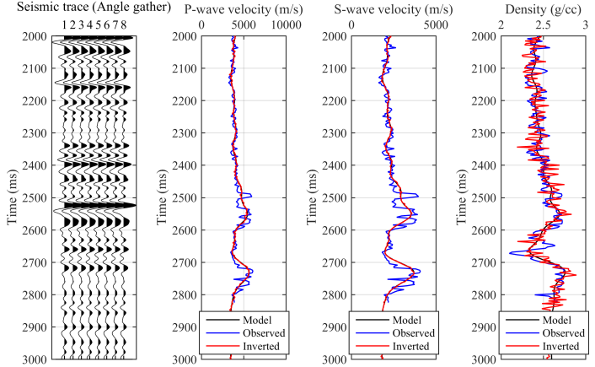

Biography:
Dr. Satya Prakash Maurya has completed his PhD at the age of 28 years from Indian Institute of Technology Bombay, India and Postdoctoral Studies from Department of Geophysics, Banaras Hindu University Varanasi, India. His Ph.D. thesis title was “Comparative Analyses of Seismic Inversion Methods for Reservoir Characterisation”. He is currently working on a project title “Study of Geomechanics behavior of reservoir due to the extraction of hydrocarbon” sponsored by Government of India. He has published more than 12 Journal papers in reputed journals and presented more than 15 conference papers.

Presenting author details

Full Name: Dr. Satya Prakash Maurya
Contact number: +91 9004008754
Twitter account:
Linked In account:spm.bhu@gmail.com
Session name/ number:
Category: Poster presentation
Passport Number: M7101503
Figure 1: Inversion results for the composite trace.



