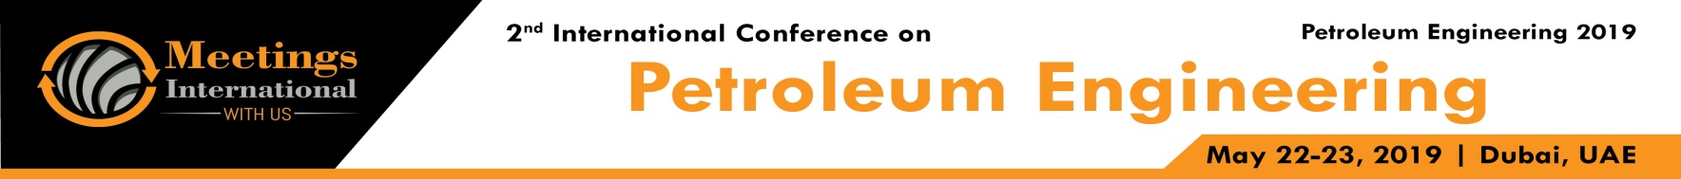

Abstract Template

Title: The effects of friction on diamond bits during drilling process

Authors:Nguyen Huynh Tri Trung
Scientific research supervisor: Nguyen Thanh Liem, Minnivaleev Timur Nailevich
Ufa State Petroleum Technological University- Oktyabrsky brand, Russian Federation; tritrung,spe@gmail.com

Keywords: Natural diamond bit, diamond particle, friction, wear

- Abstract Body
The process of rock destruction by natural diamond bits is also the process of erosion of diamond inserts (diamond particles), friction and heat lead to decrease the lifespan of the bits and increase more time as well as money for drilling operation. Therefore we have to choose the drilling technology reasonable to increase the working efficiency of the drill. This articles introduce a solution to reduce the bad-effected friction on the diamonds balls to increase efficiency of drilling as well as lifespan of the bits. The main method is find out the coefficient of friction between diamond particles and the rock, and from the formula of coefficient of friction we can find out the best solution to optimist the work of natural drilling bit as well as expand the lifespan of the bit.

Image:
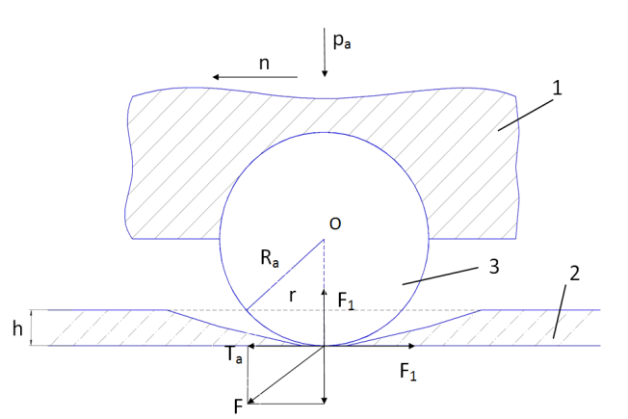

- Formula:
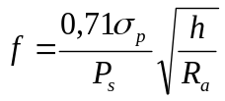
- Reference:

- Cumming J.D., 1979. Diamond drilling hanbook. Toronto.
- Heinz W.F., 2000. Diamond drilling hanbook. South Africa.
- Крагельский И.В и др., 1978. Трение изнашивание и смазка. “Машиностроение” Москва.
- Крагельский И.В и др., 1978.Трение изнашивание
- Нгуен Суан Тхао, 1990. Исследование процесса износа однослойных алмазных коронок при бурении с очистной забоя скважины воздухом. Диссертация на соискание ученой степени кандидата технических наук. Ленинград.

Biography:
Nguyen Huynh Tri Trung is a student from Vietnam, he got the best scores of PetroVietnam University and received full 5-years scholarship from Vietnamese government.
Now, he is a excellent student of Ufa State Petroleum Technological University - Oktyabeski branch, Russia Federation. He is 3rd-year student of drilling department and get the best average GPA 4.96/5 of the department as well as achieved high rank of Olympic contest in regional. He has published several papers in Russian student and SPE journals and his articles are appreciated by the appraisal committee.

Presenting authordetails



Full Name: Nguyen Huynh Tri Trung
Contact number: +89603918329
Facebook account: https://www.facebook.com/trungspe
Linked In account: https://www.linkedin.com/in/trung- nguyen-huynh-tri-b417a7178/
Session name: Advance Drilling Technologies and Safety
Category: Oral presentation
Passport Number: C0079190



