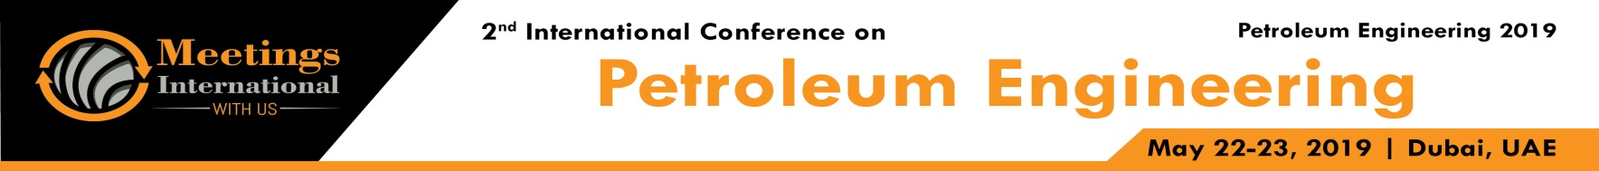

Abstract

Heavy Oil Water Coning Control Using Water Sink From An Offset Producer

KarimMagdy1, Ahmed Gaber 2,
1Department Reservoir engineering, Gulf of Suez Petroleum co., Cairo, Egypt
2Department Production Technology engineering, Gulf of Suez Petroleum co., Cairo, Egypt

Keywords: Heavy oil, water coning, sink well, controlling water

- Abstract Body (up to 250 words)
Maximizing recovery from strong water drive, permeable reservoirs in Gulf of Suez usually require a combination of approaches. Implementing partial perforating techniques across the oil column above the oil/water contact and installing tubing sizes that secure maximum natural flow life cycle are presently utilized to extend the natural flow life cycle in strong bottom- and edge-water drive reservoirs. Limiting production rate at or below critical coning rate, and conversion to Artificial Lift when the water cut increase forces cessation of natural flow, further improve the ultimate recovery of oil from these reservoirs.
In pilot Well-A, approximately 55% of the oil column above the Oil/Water contact was perforated on initial completion. Within short time, the Watercut increased from 0% to 53%, then gradually increased to 70% . Another Well-B dpwndip well was worked over to act as Downhole Water Sink completion. This completion design comprised of a very short perforated interval at the original depth of the Oil/Water contact and with another perforated interval across a highly permeable aquifer below the layer of interest. A shrouded ESP with Y-tool assembly was then installed, able to generate a drawdown just below the original OWC that is greater than the drawdown across the originally perforated interval.
This pressure sink created at the OWC controls the further development of the water cone around the wellbore thereby increasing the maximum coning rate, in addition to accelerating and increasing the ultimate recovery from this water-drive completion. The excessive water that is usually produced to surface, and processed along with the oil, is now significantly reduced since most of it is now re-directed to a deeper non-oil-producing aquifer.

- Reference:

1 Davies, D.R., Narayanasamy, R., Kristensen, B., Somerville, J.R.; "Analysis of Possible Applications of Dual ESP's – A Reservoir Engineering Perspective;" SPE-99878-MS; SPE Europec/EAGE, Vienna, Austria; June 12-15, 2006
Kabir, C.S., Dashti, Q., Al-Shammari, O.; "Understanding Coning Performance in a High-Anisotropy Reservoir: The Burgan Reservoir Case Study;" SPE-62993; SPE-ATCE, Dallas, TX, Oct 1-4, 2000
Yang, W., Wattenbarger, R.A.; "Water Coning Calculations for Vertical and horizontal Wells;" SPE-022931; SPE-ATCE, Dallas, TX; Oct 6 – 9, 1991

Biography:
Karim has completed his B.Sc Engineering at the age of 23 years from Suez University. Sparked his career as a field engineer then switched into reservoir engineering with total experience of about 5 years.I’ve participated in many well-known competitions by AAPG and SPE and recently participated in EGYPS conference and presented with my colleague Eng.Ahmed Gaber a technical presentation on best Acid Practice.

Presenting author details

Full Name :Karim Magdy
Contact number: 01022843666
Twitter account: NA
Linked In account: Karim Magdy
Session name/ number:
Category: (Oral presentation/ Poster presentation) Passport Number:A11567917



