

Silica Suspensions Combined Effect With PPG, Polymer And Low Salinity Water Flooding For Enhanced Oil Recovery
Imran Akbar ^{a *}, Zhou Hongtao ª , Muhammad Usman Tahir ª
ª School of Petroleum Engineering, China University of Petroleum, Huangdao District, Qingdao, Shandong, P.R.China (266580)

Keywords: LSWF, Preformed particle gel, Silica particles, Polymer, EOR

Abstract

Low salinity water flooding (LSWF) and preformed particle gel (PPG) have recently drawn great interest from the oil industry. LSWF can only increase displacement efficiency, and it has little or no effect on sweep efficiency whereas PPG can plug fractures and improve sweep efficiency, but they have little effect on displacement efficiency. The coupled method bypasses the limitations of each method when used individually and improves both displacement and sweep efficiency. Polymer gels have been widely applied to plug high permeability streaks or fractures, and to improve sweep efficiency of chase water floods. The oil recovery from fractured reservoirs is usually low, which is usually caused by the existence of areal formation heterogeneity. Combining two methods in one process to enhance oil recovery represents a needed cost savings in the oil industry. Microgels are used as conformance control agents to improve oil sweep efficiency and control excess water production. Low-salinity water flooding (LSWF) is used as a wettability alteration agent in carbonate reservoirs and improves displacement efficiency. We developed a cost-effective, novel, enhanced oil recovery (EOR) technology for carbonate reservoirs by combining the four technologies into one process. The objective of this paper is to provide a comprehensive understanding of the combined technology and to demonstrate how the combining method can improve oil recovery. The oil-wet carbonate cores provided a higher improved oil recovery than water-wet carbonate cores during LSWF compared to traditional bulk gel treatments, PPG forms stronger plugging but will not form an impermeable cake in the fracture surface; therefore, PPG allows low salinity water to penetrate into the matrix, thereby producing more oil from the matrix. Preformed particle gels (PPGs) is a diverting agent that is used to solve the conformance problem in low permeability rich oil zones. It is injected to reduce thief zone permeability and then divert displacing fluid into poorly swept zones. The focus of this study is to see how PPGs, low water salinity, polymer and silica particles perform in porous media by creating flow resistance to injected fluid thereby changing the wettability and enhancing the sweep and displacement efficiency . Silica particles modify the surface wettability and also modify the gel particles strength, LSWF modify the mechanical properties of PPG such as swelling ratio, polymer increase the sweep efficiency of chase water flood and PPG plug the high permeability zones to divert the water flow into low permeability zone to displace the remaining oil.

I- Image :

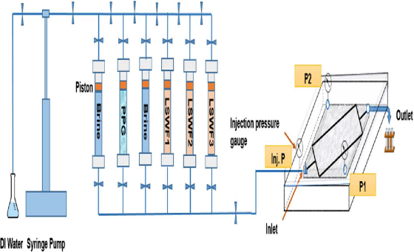
Fig.. Schematic diagram of the experimental apparatus.

II- Biography:
Imran Akbar, currently I am a PhD student in China University of Petroleum (East China). My major is Oil and Gas field development Engineering. My research interest is in (EOR). In Petroleum industry (EOR) enhanced oil recovery attracted the attention of researchers in recent years to recover the remaining oil to fulfill the energy demands, so I am also interested in this research area and I want to address my ideas.

III- Presenting author details



Full Name: IMRAN AKBAR
Contact number: +86-13061435278
Email:
imran_sixes@yahoo.com
Category: (Oral presentation/ Poster presentation) Passport Number:QL1338981

.



