Title: Microfacies analysis and depositional environment of the chorgali formation in khanpur dam section, south eastern hazara basin, khyber pakhtunkhwa, pakistan
Asad Jamil¹, Mumtaz Ali Khan²
¹Earth and Environmental Sciences Department, Bahria University Islamabad, Pakistan
²Department of Geology, University of Peshawar, Pakistan

Keywords: Chorgali Formation, Larger and smaller benthic foraminifera, Microfacies, Diagenetic features, Shallow environment of deposition, South eastern hazara basin, Pakistan.

I. Abstract
The Chorgali Formation of Eocene age is composed of medium to thick bedded limestone with shale interclations. The study area has been from one designated section that is the Khanpur Dam section. The Khanpur Dam section is situated in district Haripur, Khyber Pakhtunkhwa. Twenty rock samples were collected in the field, the microscopic study revealed four microfacies with fossil content, discrete texture and allochem types. The microfacies are Larger Foraminiferal mudstone to wackestone microfacies, Bioclastic mudstone to wackestone microfacies, Larger Benthic Foraminiferal wackestone microfacies and Bioclastic wackestone microfacies. The faunal association and depositional texture indicate that the microfacies represent deposition in a low energy that is inner to middle shelf settings. The further analysis on the Chorgali Formation indicates that Formation was subjected to numerous digenetic changes mostly showing the compaction, stylolitization, tectonically induced fracturing and calcite veins passing from marine diagenesis to meteoric diagenesis through burial diagenesis that leads towards the conclusion that the Chorgali Formation was deposited in shallow environment. The Chorgali Formation is one of the highly oil producing Formation in Pakistan.
II. Image
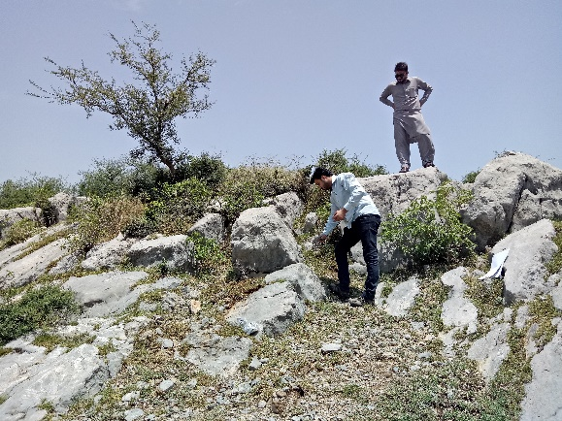

III. References
1. Ahsan, N., Chaudhry, M. N., 2008. Geology of Hettangian to Middle Eocene rocks of Hazara and Kashmir Basins, northwest Lesser Himalayas, Pakistan. Geol. Bull. Punjab University, 43, 131-151.

2. Sameeni, S.J., Ahmad. A., Ahmad. N., and Ahsan., N, 2013. Biostratigraphy of Chorgali Formation, Jhalar Area, Kala Chitta Range, Northern Pakistan: Sci-Int, v.25(3), p.567-577.

3. Mujtaba, M., 2001. Depositional and diagenetic environments of carbonates of Chorgali Formation (Early Eocene) Salt range- Potwar plateau,Pakistan. P.H.D Thesis, University of Punjab, Quaid-e- azam campus, Lahore, Punjab.

IV. Biography
Asad Jamil has completed his MS Geology at the age of 27 years from Bahria University Islamabad (2017-2019) and he also done his BS Geology from Bahria University Islamabad (2012-2016). His father name is Arif Jamil and he live in street no.4, mohalla pari, tehsil taxila, district rawalpindi, province punjab, pakistan. He is a hard worker, quick learner, a good team player and an effective coordinator. He will take challenges and deal with them with the best use of my knowledge while assisting in effectively carrying out the department's functions. The email address is asadjamil2000@gmail.com and contact number is +923340533646.
V. Presenting author details

Full name: Malik Asad Jamil
Contact number: +923340533646
Email address: asadjamil2000@gmail.com
Category: Oral presentation
Passport number: 11902502390

