

Abstract Template

Title: Geopetroleum assessment of the Ordovician and Triassic reservoirs in the Chotts region (Southern Tunisia) and maturity modeling of their supplying source rock (Fegaguira Formation)
Safa Kraouia1., Amina Mabrouk El Asmi1., Abdelhamid Ben Salem2 & Moncef Saidi2.
- Geology Department, Faculty of Sciences of Tunis, University Campus, 2060 Tunis, Tunisia.
- Entreprise Tunisienne d’Activités pétrolières, avenue Mohamed V, Tunis.

Keywords: Southern Chotts, Petrophysical evaluation, Reservoir, El Atchane, El Hamra, TAGI, 1D modeling, Fegaguira, expulsion.

- Abstract Body
This study targets the geopetroleum evaluation of the Ordovician series (El Atchane and El Hamra reservoirs) and the Triassic series (TAGI), in the Southern Chotts region, based on well logging data. The burial and thermal maturity history of the potential source rock Fegaguira Formation (Silurian in age) of the area, was accomplished using the software BasinMod. The generation and expulsion times of hydrocarbons in the region, as well as their quantities were also estimated.
The Ordovician reservoirs (El Atchane and El Hamra) generally show the same petrophysical characteristics (the porosity of the two reservoirs varies between 5% and 12%) with a decrease in thickness from West to East until the total disappearance of the El Hamra Formation. This variation was related on the one hand to the bevelling of the Ordovician on the Telemzane arch and on the other hand to the erosive effects of the orogenic phases during Paleozoic (Taconic, Caledonian and Hercynian phases).
However, the TAGI reservoir is absent towards the West where it is totally replaced by volcanic material which took place through faulting during the tethysian rifting. Its porosity varies between 9.5% and 23.2% with the best porosities recorded at the well 13.
A 1-D modeling of the Southern Chotts basin was carried out based on lithostratigraphic, thermal and geochemical data from 4 drilled wells (5, 7, 13 and 19) in the area. The results of the modeling showed that the Fegaguira source rock was subjected to temperatures of 110°C around 80 Ma in the well 13, 100°C around 90 Ma in the well 7, 90°C around 80 Ma in the well 5 and 80°C around 80Ma in the well 19.
The maturity history modeling of four wells in the south of the Chotts region shows that the Fegaguira source rock is mature and began generating hydrocarbons during the Early Cretaceous and expelled its hydrocarbons from the Paleogene in the wells 5 and 7 and from Cretaceous in the well 13 (at a SATEX of 10%). The Fegaguira source rock has not expelled in the well 19.
The quantity of oil expelled by the Fegaguira source rock reached 36.3 bbls/acre feet rock and 33 bbls/acre feet rock in the wells 5 and 7 during Paleogene and 53.5 bbls/acre feet rock in the well 13.

Image:
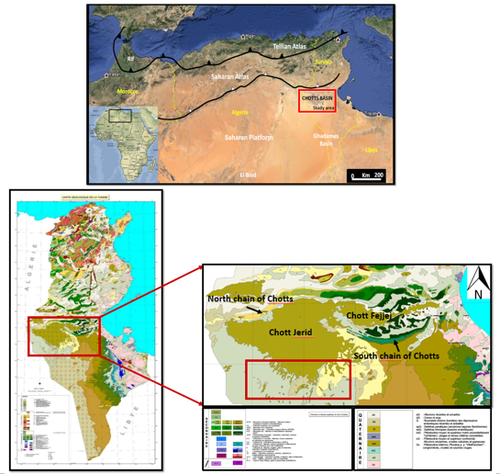
Figure 1: Geographical and geological maps of study area.

Biography:
safa kraouia is a PhD student at the Faculty of Sciences of Tunis (Manar University). She received her Master's degree in Earth Sciences specialized in Basin Analysis and Reservoirs characterization in 2017, whose memory is about Geopetroleum evaluation In the Southern part of Chotts area. Her study was carried out as a collaboration between the Faculty of Sciences of Tunis and the
Tunisian National Oil Company (ETAP). She holds a bachelor's degree in Earth Sciences specialized in Geology of Sedimentary Basins in 2015 and Baccalaureate in Experimental sciences in 2012. She had the chance to do several internships at the ETAP, the Societe Italo-Tunisienne d’Exploitation de Petrole (SITEP), MPS Company and at the National Office of Mines (ONM). These experiences allowed her to develop her skills by offering her the opportunity to know closely all aspects and methods related to geology and to master software related to this discipline.
She is currently working on writing an article that describes the main results found in her Masters memory.

Presenting author details


Full Name: Kraouia Safa
Contact number: (+216)58616009
Linked In account: @ safa kraouia
Category: Poster presentation



