

Abstract Template

Recovery of tight oil reservoir considering wettability alteration by adding surfactant additive agent

Shuai Li, Xin Wang, Bo Cai, Chunming He, Yang Li
Research Institute of Petroleum Exploration and Development, PetroChina, Beijing, China

Keywords: tight oil; hydraulic fracturing; surfactant additive; imbibition; wettability alteration

- Abstract Body (up to 250 words)
Based on contact angle and interfacial tension measurement, this paper concentrated on adding surfactants agent into fracturing fluids to increase oil output after hydraulic fracturing. Cationic, anionic and nonionic surfactants were added into slickwater to perform a serious of one end open (OEO) imbibition experiments at a certain concentration. Scanning electron microscope (SEM) and nuclear magnetic resonance (NMR) method were also applied in the detection before and after the imbibition process. Results demonstrated that core samples changed from oil-wet to intermediate-wet or water-wet after soaked in surfactants, cationic surfactant shows a better performance in changing contact angle while different kinds of surfactants have a similar ability in lowering IFT. In the soaking duration, NMR transverse relaxation time (T2) spectrum showed that oil recovered by counter-current imbibition mainly distributed in intervals of 10-1000 ms while oil remained uncovered mainly distributed in intervals of 0.1-10 ms. T2 spectrum moved towards left side and this indicated that aqueous phase migrate from larger pores to smaller ones. Both laboratory experiments and field applications have indicated that adding surfactants into fracturing fluids can significantly increase oil outputs for tight oil-wet reservoirs. Application of this technology can be a good way to solve low production problems for this type of reservoir.

Image:
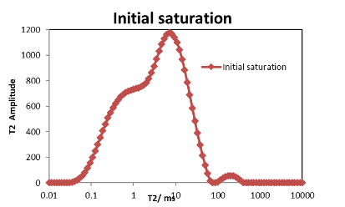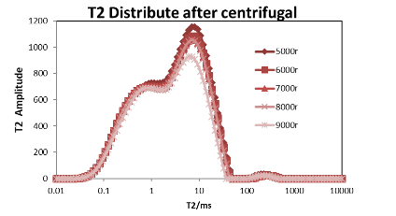
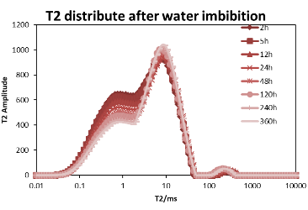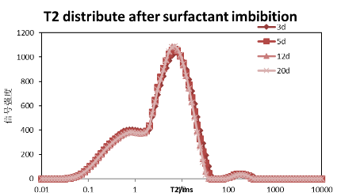
- Reference:

1 Almulhim, A., Alharthy, N., Tutuncu, A. N. & Kazemi, H. Impact of imbibition mechanism on flowback behavior: a numerical study. Presented at the Abu Dhabi International Petroleum Exhibition and Conference, Abu Dhabi, 10-13 November, SPE-171799-MS, doi:10.2118/171799-MS (2014).
- Odumabo, Sijuola M. & Zuleima T. K. Investigation of gas flow hindrance due to fracturing fluid leakoff in low permeability sandstones. J. Nat. Gas Sci. Eng. 17, 1-12, doi:10.1016/j.jngse.2013.12.002 (2014).
- Dutta, R. et al. Experimental investigation of fracturing-fluid migration caused by spontaneous imbibition in fractured low-permeability sands. SPE Reserv. Eval. Eng. 17(01), 74-81, doi:10.2118/154939-PA (2014).
- Hamidpour, E., Mirzaei-Paiaman, A., Masihi, M. & Harimi, B. Experimental study of some important factors on nonwetting phase recovery by cocurrent spontaneous imbibition. J. Nat. Gas Sci. Eng. 27, 1213−1228, doi:10.1016/j.jngse.2015.09.070 (2015).
- Morsy, S., Sheng, J. J. & Soliman, M. Y. Waterflooding in the Eagle Ford shale formation: experimental and simulation study. Present at Unconventional Resources Conference and Exhibition-Asia Pacific, Brisbane, Australia, 11-13 November, SPE-167056-MS, doi:10.2118/167056-MS (2013).
- Lai, F., Li, Z., Wei, Q., Zhang, T. & Zhao, Q.. Experimental investigation of spontaneous imbibition in a tight reservoir with nuclear magnetic resonance testing. Energy Fuels, 30(11), 8932-8940, doi:10.1021/acs.energyfuels.6b01324 (2016).
- Zhou, Z. et al. Experimental investigation of the effect of imbibition on shale permeability during hydraulic fracturing. J. Nat. Gas Sci. Eng. 29: 413-430. doi:10.1016/j.jngse.2016.01.023 (2016).

Biography:
Shuai Li, born in 1987, he holds a P.h.D degree at Research Institute of Petroleum Exploration & Development, PetroChina, majoring in oil and gas engineering. He also holds a bachelor’s degree (2011) and a master’s degree (2014) at China University of Petroleum (Beijing), both in petroleum engineering. He is also a visiting student at the Pennsylvania State University, USA from year 2017 to year 2018.

Presenting author details



Full Name: Shuai Li
Contact number: +86-178-8881-6345
Twitter account:
Linked In account:
Session name/ number:
Category: Oral presentation
Passport Number: E80792818
Affiliate: Research Institute of Petroleum E. & D., PetroChina
Title: Recovery of tight oil reservoir considering wettability alteration by adding surfactant additive agent



