

AN INTEGRATED APPROACH TO DETERMINE LOW-RESISTIVITY PAY ZONES IN THIN LAMINATED CLASTIC RESERVOIRS: A CASE STUDY FROM THE GULF OF SUEZ

Dahab A. M.1, Abdulaziz A. M.1, Elhadidy A. M. 2,
1Department of Petroleum Engineering, Faculty of Engineering, Cairo University, Giza, Egypt
2Gulf of Suez Petroleum Company, Cairo, Egypt
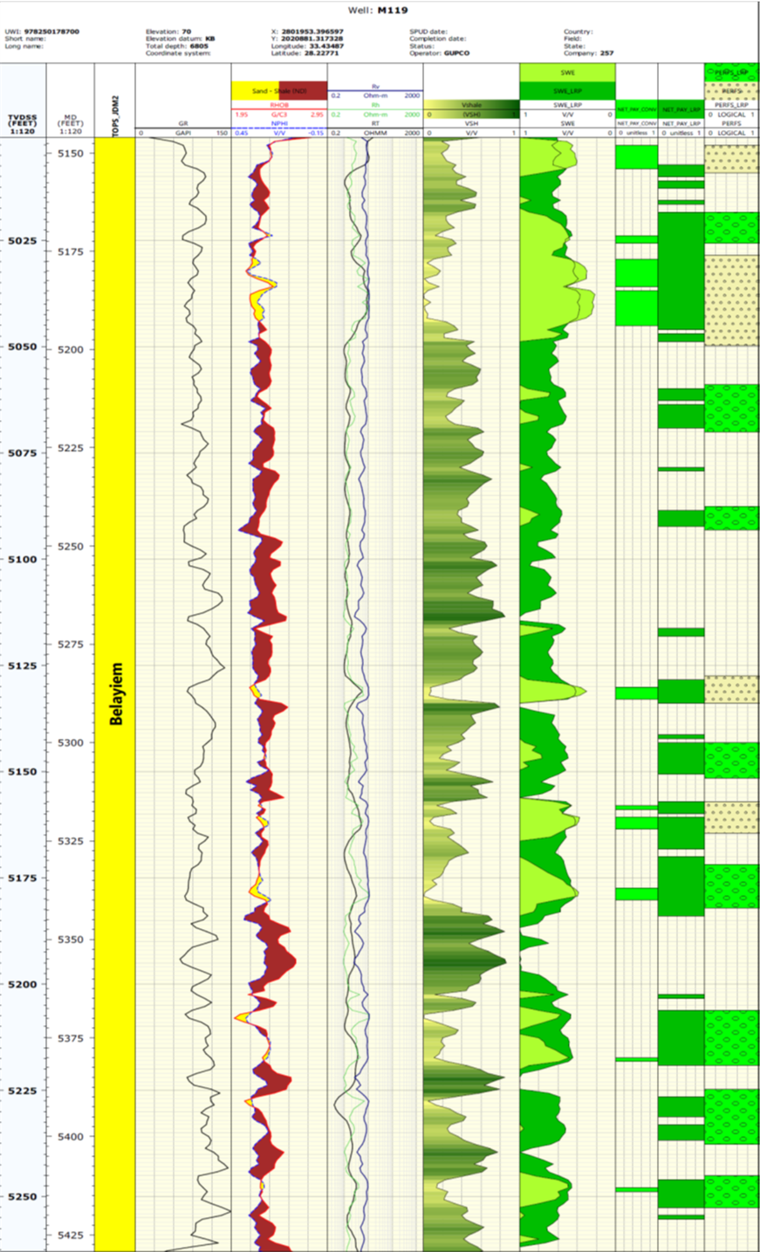

Keywords: Low Resistivity Pay, horizontal (Rh) and vertical (Rv) resistivity, Resistivity anisotropy, thin laminated reservoirs

- Abstract Body (up to 250 words)
The problem of LRP zone is that it is not recognized by conventional resistivity log. This problem causes a decrease in resistivity log response, so the estimated water saturation will be higher than the observed water cut. Resistivity anisotropy is observed in the interbedded parallel layers of laminations of sand-shale sequences. When these laminations thickness are less than the vertical resolution of conventional resistivity measuring device itself, the measured resistivity values is no longer representative to these laminations, however it becomes an average of the resistivities of these thin laminations, dominated by the laminations with lower resistivities. In Morgan Belayiem reservoir located in the Gulf of Suez in Egypt, a detailed interpretation analysis have been done to re-interpret thin sand shale laminations showing LRP phenomenon. Pay was identified using (Rv) and (Rh) calculations utilizing pervious conventional resistivity and lithology logs.
In the present study, an innovative technique is developed to calculate the resistivity of sand intervals within thin laminated reservoirs. This is achieved considering two main concepts; separating apparent resistivity in Rh and Rv using Moran and Gianzero (1979) formula and calculating sand resistivity using sand - shale resistivity connections (parallel and series connections). Archie Equation is applied to calculate water saturation using the obtained sand resistivity values and subsequently plotted versus the conventionally calculated values.
As a result of this study, Belayiem reservoir was proven to have a LRP zones, new water saturation estimation was calculated, which matched with the production well head samples.

Image:
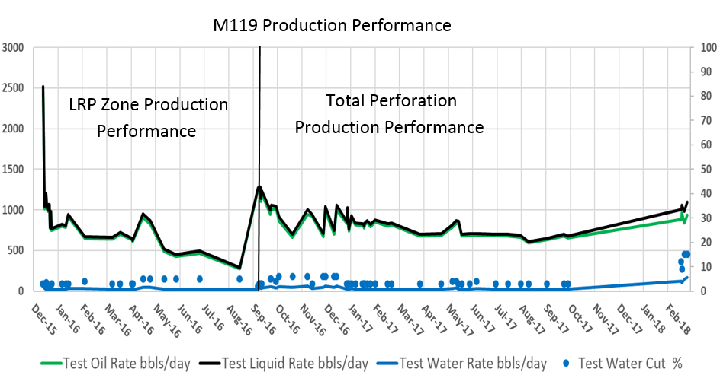
LRP Zone
Production profile of well M119

Computer processed Interpretation of the Well M119 showing the difference between conventional and new calculated water saturation in Track 8. And corresponding peroration intervals in track 11

Reference:

- Worthington, P. F., 1997, “Recognition and Development of Low-Resistivity Pay”, SPE Asia Pacific Oil and Gas Conference and Exhibition, Kuala Lumpur, Malaysia

2. Boyd, A., et al., 1995, “The Lowdown on Low-Resistivity Pay”, Oilfield Review, 7(3), 4-18.

3. Rosthal, R., et al., 2003, "Field Test Results of an Experimental Fully-Triaxial Induction Tool", SPWLA 44th Annual Logging Symposium, Galveston, Tx.

4. Moran, J. H., and Gianzero S. C., 1979, “Effects of formation anisotropy on resistivity-logging measurements” Geophysics, 44(7) 1266-1286.

5. Aldred, R., et al., 2017, “Improved Interpretation of Laminated Formations in Mature Fields Using Calculated Rh and Rv Logs From Conventional Resistivity Measurements in Multiple Wells”, 23rd Formation Evaluation Symposium of Japan, Chiba, Japan.

6. Martin G. L., et al., 2005, “Dielectric Effects on Resistivity Anisotropy in Laminates or When is Rv < Rh?”, SPWLA 46th Annual Logging Symposium, New Orleans, Louisiana.

Biography:
Abdulaziz M. Abdulaziz is an assistant professor at the Petroleum Engineering Department, Cairo University. He holds a B.Sc. and M.Sc. in geosciences from Banha University and a Ph.D. from The University of Texas at El Paso, USA.
Abdelsattar M. Dahab is an assistant professor at the Petroleum Engineering Department, Cairo University.
Abdelrahman M. Elhadidy is a 6 years reservoir engineer in Gulf of Suez Petroleum Company.

Presenting author details

Full Name: Abdelrahman M. Elhadidy Contact number: 00201098891200
Category: Oral presentation
Passport Number: A10321972



