

Title: Cloud Computing in Oil & Gas Supply-Chain Management -An Overview

Prathamesh Sapale1, P. Victer Paul2,
1Department of Petroleum Engineering, Vignan’s Foundation for Science, Research & Technology, Guntur, India
2Department of Computer Science and Engineering, Vignan’s Foundation for Science, Research & Technology, Guntur, India

Keywords: Supply-Chain Management, Cloud Computing, Software-as-a-Service, Oil & Gas Industry

Abstract
The oil & gas industry involved in a global supply-chain that includes movement and storage of raw materials includes domestic and international transportation of work in process inventory. Interconnected or interlinked channels and node businesses combine in the provision of import/export facilitation technology required by end customers in a supply-chain. The purpose of this paper is to investigate role of cloud based solutions to their primary sourcing application. This research examines to improve supply-chain in oil & gas industry by executing supply-chain transaction, managing supplier relationships & controlling business processes associated with cloud based technology.
Cloud computing is an emerging IT-based paradigm that enable ubiquitous access to shared pools of configurable system resources and provides on demand computing services with reliability, scalability and availability in distributed environment (Xun, 2012). If used properly this third party clouds enable organizations to focus on their core businesses which develops inimitable resource that helps organizations to create & sustain their competitive advantages (Truong, 2010). In recent times, there have been concerns regarding supply-chain sustainability in the oil and gas industry and supply-chain is highly concentrated business issue affecting organizations supply-chain logistic networks and it is frequently quantified by comparison with high-tech and low-tech operations and capital intensive operations. Currently oil and gas industry entered an era of very scarce resources. But despite of the fact there isn’t any worries of the resources; they are not the cause of supply constraints.

Image:

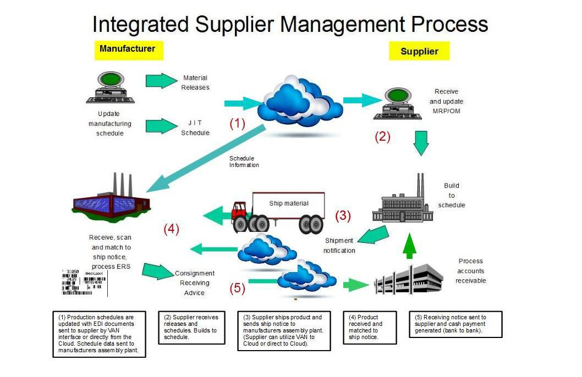

Reference:

- Aas, B., Buvik, A., Cakic, D.: Outsourcing of logistics activities in a complex supply chain: a case study from the Norwegian oil and gas industry. Int. J. Procure. Manage. 1, 280–296 (2008)

- Bahree, B. Investment by Oil Industry Stalls. The Wall Street Journal. November 8, 2006. A11

- Bartling, B. The Catalyst to Virtualization: Virtual Consolidation. Journal of Petroleum Technology. October 2003. 33.

- Casey G., Cegielski, L., Jones-Farmer A., Wu Y., & Hazen B.T. (2012). Adoption of cloud computing technologies in supply chains. International Journal of Logistics Management, 23(2), 184-211.

Biography:
Mr. Prathamesh Sapale has completed his M.Tech from University of Petroleum & Energy Studies, Dehradun. Currently he is working as an Assistant Professor in Petroleum Engineering department of Vignan’s Foundation for Science & Technology (Deemed to be) University. He is a Programme Coordinator of all Petroleum Engineering Courses.

Dr. P. Victer Paul is working as Associate Professor in the Department of Computer Science and Engineering at Vignan’s Foundation for Science, Technology & Research, Andhra Pradesh, India. He has completed his Ph.D. in the Department of Computer Science (2015) from Pondicherry Central University, Pondicherry, India. He has published over 90 research papers in various International Journals & Conferences. Currently, he is working in the fields of Cloud Computing, Evolutionary Computing and Data Analytics.

Presenting author details



Full Name: Prathamesh Sapale
Contact number: +91-983431835
Linked In account: Prathamesh Saple
Session name/ number:
Category: (Oral presentation)
Passport Number: K-8948670



