

Abstract Template

Environmentally friendly drilling muds based on green additives: Optimization and modeling the rheological and thixotropic characteristics

Kamal I.
Department of Chemical Engineering, Faculty of Engineering, , Soran University, Iraq

Keywords: Drilling fluids, Green additives, Rheology, Thixotropy, Modeling, Optimization

- Abstract
Drilling muds are fluids used to keep up well control and transport drill cuttings from the boreholes to the surface. They are complex formulations of a range of chemicals designed to have specific properties under very specific drilling conditions. Most of these chemicals are toxic and pose an excessive threat to mankind as well as the environment. However, drilling muds must be formulated with stabilized properties to achieve optimum drilling operations at lowest cost possible and minimum environmental impact. In connection, the increase in environmental awareness has made petroleum industries are demanding for high performance and environmentally friendly mud systems, therefore, the drilling mud service companies started to re-evaluate some of the chemicals and materials used as additives for mud systems, different naturally occurring materials with similar properties as these chemicals are evaluated for commercial applications. In the current presentation, the environmental issues and concerns for some of the chemicals used as additives for conventional drilling fluid system will be highlighted. Some green materials may be considered as possible substitutes for the chemicals used in formulation water and oil -based drilling fluid systems will be reviewed including agro waste materials and nano additives synthesized by biosynthesis routes in situ. The role of the green additives on rheological and thixotropic characteristics are demonstrated. Utilization of mathematical and statistical techniques for modeling and optimization the effect of the green additives content and properties on drilling mud performance will be discussed and overviewed. .

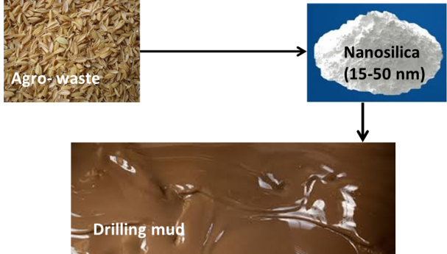
- Reference:

1 Karen, J.K.M., Ponmani, S., Samuel, R., Nagarajan, R., Sangwai, J.S., 2014. Effect of CuO and ZnO nanofluids in xanthan gum on thermal, electrical and high pressure rheology of water-based drilling fluids, Journal of Petroleum Science and Engineering, 117: 15–27.

- Wajheeuddin, M., Hossain, M.E., 2018. Development
of an Environmentally-Friendly Water-Based Mud
System Using Natural Materials. Arabian Journal for
Science and Engineering, 43: 2501–2513.

- Ekeinde, E.B., Okoro, E.E., Dosunmu A., Lyuke, s.,
2018. Optimizing aqueous drilling mud system viscosity
with green additives. Journal of Petroleum Exploration
and Production Technology. https://doi.org/10.1007/
s13202-018-0481-0

Biography:
Ibtisam Kamal is professor of process engineering. She holdt PhD in Polymer Technology from Basrah University-Iraq. She received later her HDR in Process Engineering from La Rochelle University-France. She held the position of head of chemical engineering departments for more than 12 years in faculties of engineering, Iraqi universities. She is currently dean deputy for scientific affairs, Faculty of Engineering, Soran University-Iraq. Her research activity is documented by more than 130 scientific peer-reviewed papers, and 2 patents. Prof. Ibtisam Kamal main research interests have focused on modeling, optimization and simulation of production processes of biofules and smart drilling fluids.

Presenting author details

Full Name: Ibtisam Kamal
Contact number: 009647506828710
Linked In account: Ibtisam Kamal
Session name/ number:
Category: Speaker
Passport Number: 11AY16673



