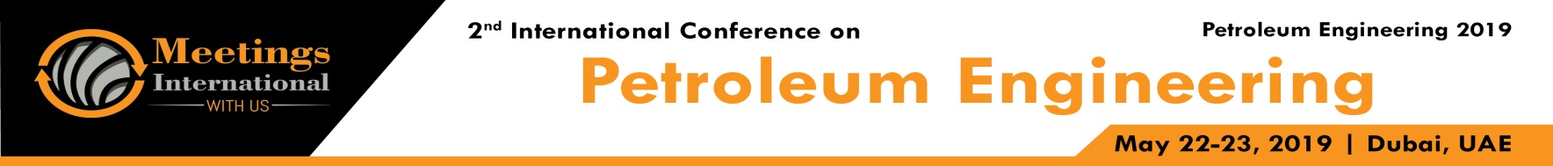

Abstract

Title: Enhancing the efficiency of oil and gas drilling by incorporating nanoparticles in drilling fluids: A review
Vryzas Z1
1Department of Industrial and Mechanical Engineering, Petroleum Engineering Program, Lebanese American University, Byblos, Lebanon

Keywords: nanoparticles, drilling fluids, nano-based drilling fluids, rheology, filtration, HP/HT drilling

- Abstract
Word of the promise of nanotechnology is spreading rapidly and nanomaterials are garnering considerable attention by several industries. Nano fluids have shown their distinctive properties and offer unprecedented potential for many applications. Oil and gas drilling industry could not be an exemption of this norm. Over the last five years, Nano fluids have been the center of activity for several researchers and are set to substantially influence the landscape of drilling fluid industry. This study summarizes progress in the past few years on the utilization of Nano fluids and presents a critical review of the results as well as evaluates the applications of nanomaterial for smart fluids formulation. Factors such as type, size and shape of nanoparticles, volumetric concentration, and addition of different surfactants and application of an external magnetic field are discussed and critically evaluated. Furthermore, challenges and directions for future research are also presented.
The critical review reveals the advantages of nanofluids compared to the conventional fluids. Their judicious customization allows the formulation of drilling fluids with made-to-order properties, which can mitigate problems such as formation damage, borehole instability, lost circulation, as well as rheological and chemical instability issues. Work has also shown that the microstructures that develop upon nanoparticle addition are the culprits for such superior performance as identified from critical comparisons of SEM/TEM images (see image).
Due to their unique features compared to the parent materials and their easy manipulation to perform certain functional tasks, nanomaterials can retain their properties over a wide range of operating conditions. Engineering high-performance drilling fluid systems with excellent characteristics can help operators run at peak efficiency by achieving the reservoirs’ highest potential, while eliminating the use of aggressive and potential damaging chemicals and minimizing Non-Productive Time (NPT).

Image:
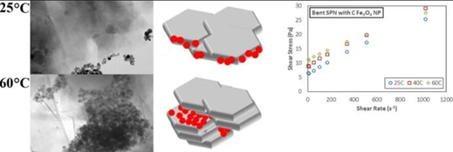
- References:

- Vryzas Z, Nalbandian L, Zaspalis V, Kelessidis V, 2018. How Different Nanoparticles Affect the Rheological Properties of Aqueous Wyoming Sodium Bentonite Suspensions, J. Petrol. Sci. Eng. 173:941-954.
- Mahmoud O, Nasr-El-Din H, Vryzas Z, Kelessidis V, 2018. Using Ferric Oxide and Silica Nanoparticles To Develop Modified Calcium Bentonite Drilling Fluids, SPE Drill. Completion. 33:1-15.
- Vryzas Z, Kelessidis V, 2017. Nano-based Drilling Fluids: A Review, Energies 10:540.
- Vryzas Z, Kelessidis V, Nalbandian L, Zaspalis V, Gerogiorgis D, Wubulikasimu Y, 2017. Effect of Temperature on the Rheological Properties of Neat Aqueous Sodium Bentonite Suspensions, Appl. Clay Sci. 136:26-36.
- Gerogiorgis D, Reilly S, Vryzas Z, Kelessidis V, 2017. Experimentally Validated First-Principles Multivariate Modeling for Rheological Study and Design of Complex Drilling Nanofluid Systems, SPE/IADC Drilling Conference & Exhibition, SPE-184692-MS.
- Reilly S, Vryzas Z, Kelessidis V, Gerogiorgis D, 2016. First-principles Rheological Modelling and Parameter Estimation for Nanoparticle- based Smart Drilling Fluids, Computer-Aided Chem. Eng. 38:1039- 1044.
- Vryzas Z, Mahmoud O, Nasr-El-Din H, Kelessidis V, 2016. Development of Novel Drilling-Fluid Nanoparticles for Enhanced Drilling Operations, J. Petrol. Tech. 68:48-50.

Biography:
Zisis Vryzas is an Assistant Professor in the Industrial and Mechanical Engineering Department (Petroleum Engineering Program) at the Lebanese American University. He received his PhD in chemical/petroleum engineering from the Aristotle University of Thessaloniki. He also holds an Executive Doctorate of Business Administration from the Paris School of Business, and an MSc in Petroleum Engineering from the UK’s Heriot-Watt University. He received his BSc and MSc in Environmental Engineering from Technical University of Crete, Greece. His research interests lie in the area of the development of “smart” drilling fluids and their interactions with rock formations, rheology of complex fluids and nanotechnology for oil and gas applications. He has authored or co-authored more than 30 journal articles and conference proceedings and has been serving as a reviewer in several reputed Journals. Vryzas is an active member of SPE and EAGE.

Presenting author details

Full Name: Zisis Vryzas
Contact number: +96171920899
Linked In account: https://www.linkedin.com/in/zisis-vryzas-73b05260/

Session name/ number: session 9 "Advance Drilling Technologies and Safety"
Category: Oral presentation
Passport Number: AM1376244




