Abstract

Title: design and synthesis of TADF compounds for attaching to peptides as a detector in identify cells

yasaman kayanian¹
¹Department of organic chemistry, Tarbiat modares university, Tehran, Iran

Keywords: TADF compounds, Time-Dependent Density Functional Theory, Amphiphilic peptide, Bioimaging

Abstract
Several phosphorescent nano-probes have been reported for optical imaging in vivo, especially for hypoxia bioimaging. Most of these complexes are based on rare-earth heavy metals like iridium, or europium, which faces the challenge of potential toxicity. The present study will have investigated interactions self-assembling between TADF compounds (TPA-DCPP, DMAC-DPS, BTZ-DMAC, and 4CZIPN and their corresponding derivatives) and three kinds of an amphiphilic peptide, which designed for Cell-penetrating. This work tries to employ Time-Dependent Density Functional Theory (TD-DFT) to explore the best TADF derivatives from the point of view fluorescence lifetime and high brightness, which so important factor at efficiency emission compounds. Furthermore, quantum mechanical methods have been used (QM) electronic and steric effects between selected compounds and amphiphilic peptides investigate.

Image:
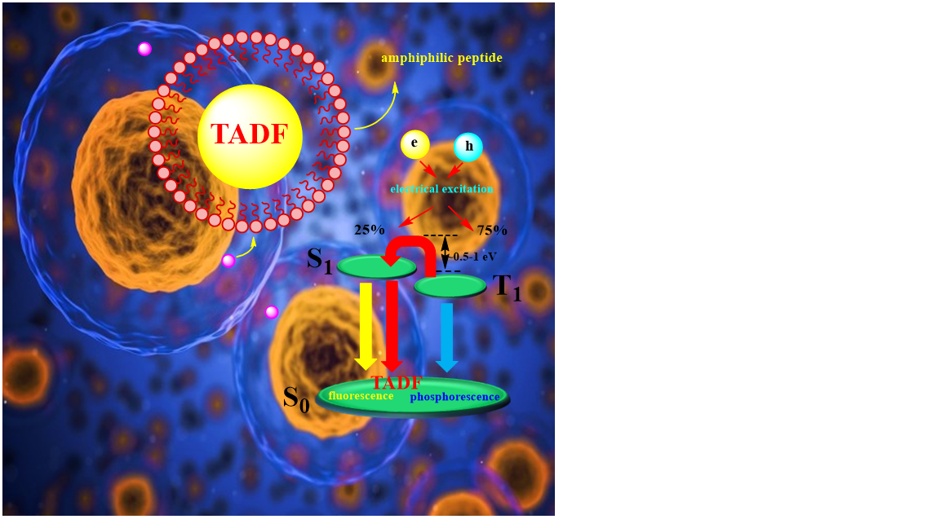

Reference:
- Zece, Zhu., D.Tian, P. Gao, K.Wang, Y. Li, X. Shu, J. Zhu and Q. Zhao, 2018. Cell-Penetrating Peptides Transport Noncovalently Linked Thermally Activated Delayed Fluorescence Nanoparticles for Time-Resolved Luminescence Imaging. J. Am. Chem. Soc., 50:17484-17491
- Tingting Li, D. Yang, L. Zhai, S, Wang, B. Zhao,N. Fu, L.Wang, Y. Tao and W. Huang, 2017. Thermally Activated Delayed Fluorescence Organic Dots (TADF Odots) for Time-Resolved and Confocal Fluorescence Imaging in Living Cells and In Vivo. Adv. Sci., 4: 1600166
Biography:
I am a Ph.D. candidate in computational organic chemistry at tarbiat modares university (TMU) and part of my work is to designing TADF compounds with TD-DFT methods and finding applications for them, such as use of TADF compounds in biology or electro-optic
- Presenting author details


Full Name: yasaman kayanian
Contact number:+989388134499
Twitter account:
Linked In account: https://www.linkedin.com/in/jasmine-kayanian
Session name/ number:
Category: Oral presentation
Passport Number:

