Effects of Extrusion and Enzyme Combined Extrusion on the Structure of Pea Protein
Zhou Quancheng^{1.2}, Li Hui^{1.2}, Wang Meng^{1.2}，Wang Sai^{1.2}，Sun Wanting^{1.2}, Sheng Guihua^{1.2.*}

1. Department of Food Science, School of Agricultural Engineering and Food Science, Shandong University of Technology, Zibo, 255049, China;

2. Key Laboratory of Shandong Provincial Universities for Technologies in Functional Agricultural Products, Zibo, 255049, China
* corresponding author

Abstract (300 word limit)
The aim of this paper was to explore the effect of extrusion and enzyme combined extrusion on the structure of pea protein. Pea protein was pretreated with extrusion and enzyme co-extrusion. The effect of pretreatment of extrusion on pea protein was further studied by measuring the microstructure, disulfide bond, secondary structure, functional group and amino acid composition of the optimal substrate. The results showed that the extrusion and enzyme co-extrusion could cause significant change to the microstructure of pea protein, reduce the content of disulfide bond, cause change to the content of secondary structure and the composition of amino acids, but no change to the functional group.

Image
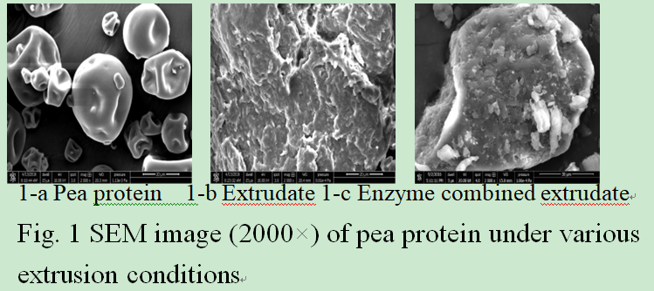Recent Publications (minimum 5)

Charu Kathuria, Deepti Mehrotra, Navnit Kumar Misra. (2018). Predicting the protein structure using random forest approach. Procedia Computer Science, 132, 1654-1662.

David P. Clark, Nanette J. Pazdernik, Michelle R. McGehee. (2019 ). Chapter 14: Protein Structure and Function Molecular Biology (Third Edition), 445-483.
- Valerie L. Pietsch, Frederic Schöffel, Matthias Rädle, Heike P. Karbstein, M. Azad Emin. (2019). High moisture extrusion of wheat gluten: Modeling of the polymerization behavior in the screw section of the extrusion process. Journal of Food Engineering, 246, 67-74.

Amara Jabeen, Abidali Mohamedali, Shoba Ranganathan. (2019). Protocol for Protein Structure Modelling Encyclopedia of Bioinformatics and Computational Biology, 3, 252-272.
- Quan-Cheng Zhou, Na Liu, Chuan-Xing Feng. Research on the Effect of Papain Co-extrusion on Pea Protein and Enzymolysis Antioxidant Peptides[J]. Journal of Food Processing and Preservation. 2016：e13301.

Biography (150 word limit)
- Zhou Quancheng has his expertise in evaluation and passion in improving the health and wellbeing. His open and contextual evaluation model based on antioxidant peptide creates new pathways for improving healthcare. He has built this model after years of experience in research, evaluation, teaching and administration in education institution. The foundation is based on Key research and development plan of shandong province (special medical food plan) （17YYSP033、2018YYSP017）
.
Email: 271977361@QQ.com

Notes/Comments:

