Strategies to Help in the Improvement of Pediatric Emergency Care Quality in the United States
Chris Moses, MPH, MPP. CEO, PIPC Consulting LLC

Abstract
Statement of the Problem:
The provision of quality as pediatric emergency is the beginning point of ensuring health growth for children. This is done by establishing an enabling environment and infrastructure that provide the much needed care to pediatric patients. Improvement of emergency knowledge among professionals in the field is also necessary for long term success and efficiency. Also of importance is taking stock of threats to pediatric patient safety, and then see what is being done within individual healthcare institutions in order to develop best practices to be rolled out across the country. The findings, together with contents of other research projects would be used to develop long term recommendations.
Findings:
Individual pediatric hospitals and emergency services have been implementing evidence based approaches to ensuring patient safety, especially reducing the frequency of trauma and errors in the course of treatment processes. Government agencies dealing with healthcare issues as well as non-profit organization in the sector are involved in providing the much-needed guidance on patient safety. There is continued research that is improving awareness of medical errors involving pediatric patients. Continued research on this issue is being undertaken so as to ensure that best strategies to reduce its occurrence are employed accordingly.
Recommendations:
Raising awareness on patient safety at an institutional level and encouraging employees to volunteer such information can aid in reducing prevalence of such cases. Appointment of patient safety manager at every facility would help in ensuring continued improvement and reduction of errors. Individual employees must feel confident in reporting near misses and errors without reprisal from management. The use of pediatric human simulators and associated technologies would equip healthcare workers with opportunities to perfect their patient handling skills without making mistakes on real human patients. An additional approach is using barcodes system to label medicine to ensure that correct ones are being a insisted to patients.

Image

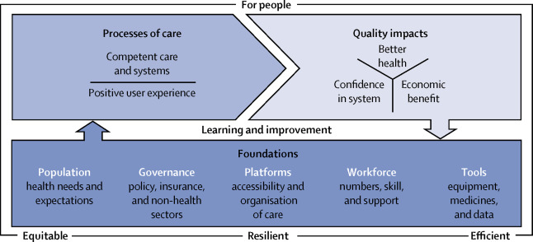
Kruk, M., Gage, A., Arsenault, C., Jordan, K., Leslie, H. & Roder-DeWan, S. (2018). High-quality health systems in the Sustainable Development Goals era: time for a revolution. The Lancet Global Health Commission. Vol. 6 (11), E1196-E1252
Recent Publications
- Alpern, E. (2017). Improving the Quality of Pediatric Emergency Care Using an Electronic Medical Record Registry. Chicago: Northwestern University.
- Chamberlain, J., Krug, S. & Shaw, K. (2013). Emergency Care For Children In The United States. Health Affairs. Vol. 32 (12): 2109-2115.
- Institute of Medicine. (2007). Emergency Care for Children: Growing Pains. Washington, DC: The National Academies Press. doi: 10.17226/11655.
- Ku, B., Shaw, K. & Chamberlin, J. (2018). Quality Improvement and Safety in Pediatric Emergency Medicine. Padeatric Clinics. Vol. 65(6): P1269-1281
- Macias, G. (2013). Quality improvement in pediatric emergency medicine. Acad Pediatr. Vol. 13(6 Suppl):S61-8. doi: 10.1016/j.acap.2013.06.007. PMID: 24268087.
- Sills, M., Fairclough, D. & Ranade, D. (2011). Emergency department crowding is associated with decreased quality of care for children. Pediatr Emerg Care.Vol. 27: 837-845


Biography
Chris Moses is a highly accomplished epidemiologist who holds two Master’s Degrees (one in Public Health and the other in Public Policy). He has served in various epidemiologist capacities. As the founder and CEO of PIPC Consulting LLC, Moses has been instrumental in improving global infection prevention and control services through collaboration with the other healthcare facilities, businesses and governments at various levels.

Email: chris_moses8@outlook.com

