A study on parental satisfaction with extremely premature neonatal care services across United States.
Chris Moses, MPH, MPP. CEO, PIPC Consulting LLC

Abstract
Statement of the Problem:
The quality of care services provided to extremely premature neonatal patients has key bearing on parental satisfaction and therefore the improvement of knowledge of best practices for care beyond hospitalization. There exists a gap in current research on neonatology when it comes to parental satisfaction of the services provided. It is therefore necessary to undertake regular Neonatal Satisfaction Survey at the national level, compare results and finally provide recommendations for improvement. Having a large sample size of about 50 women in every state and therefore 2,500 total participant ensured diversity and wide range in highly valid data. Both logistic regression and nonparametric analysis were used to analyze the resulting data and produced the following findings.
Findings:
According to the data, the biggest source of parental satisfaction was the involving parents in decision making procedures for the infant. Medical professionals are to understand the emotional element of the issue and consider the parents as a team member. Another source is being shown empathy and respect from medical practitioners as well as showing interest to continue with care and treatment until the point of discharge. Another source of support was being received from close friends and family. The level of support from these sources developed from the level of awareness regarding issues related to neonatal hospitalization.
Recommendations:
Extensive public awareness campaign is necessary to ensure people come to understand various issues surrounding extremely premature neonatal hospitalization and the need to support parents. Parents too also need more education and training on best practices for child care.

Image

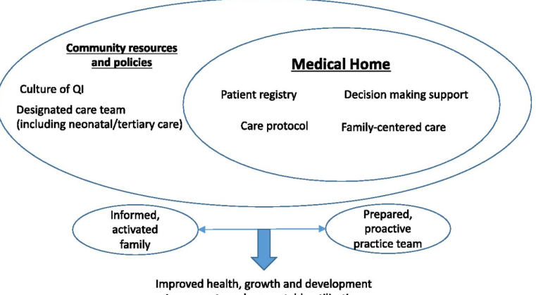
Kuo, D., Lyle, R., Casey, P. & Stille, C. (2017). Care System Redesign for Preterm Children After Discharge From the NICU. Pediatrics. Vol. 139 (4) e20162969; DOI: https://doi.org/10.1542/peds.2016-2969
Recent Publications
- Edwards, T. Abrams, K. & Baron, J, (2014). Structuring payment to medical homes after the affordable care act. J Gen Intern Med. Vol. 29(10):1410–1413.
- Hagen, I.H., Iversen, V.C., Nesset, E. et al. Parental satisfaction with neonatal intensive care units: a quantitative cross-sectional study. BMC Health Serv Res 19, 37 (2019).
- Jarjour, T. (2015) Neurodevelopmental outcome after extreme prematurity: a review of the literature. Pediatr Neurol. 2015. Vol. 52(2):143–152.
- Johnston KM, Gooch K, Korol E, et al. The economic burden of prematurity in Canada. BMC Pediatr. 2014;14:93
- O’Donnell R. (2013). Reforming Medicaid for medically complex children. Pediatrics. Vol. 1312):160–162.


Biography
Chris Moses is a highly accomplished epidemiologist who holds two Master’s Degrees (one in Public Health and the other in Public Policy). He has served in various epidemiologist capacities. As the founder and CEO of PIPC Consulting LLC, Moses has been instrumental in improving global infection prevention and control services through collaboration other healthcare facilities, businesses and governments at various levels.

Email: chris-moses8@outlook.com

