Early sensorimotor relations between respiratory - and postural imbalances and oral imbalance. (R.P.O.imbalances)
A new area of shared responsibility between medical and dental paediatricians.
Dr. Michael Lacroix, DDS-DFO.(Dento-Facial Orthopedics), Orthoglobal, Switzerland.

Abstract (300 word limit)
Introduction: The gap between medical and dental world is the reason why nobody has never published about this multifactorial topic.
We are now able to explain how dental malocclusions and oro-facial dysfunctions are linked to imbalances during the perinatal sensorimotor coordinations, often leading in adulthood to general posture (lumbo-sciatic) and/or respiratory disorders (OSA).
If, since the first neurodevelopmental steps, the determination of the primary oro-facial balance is the witness as well as a relay of an accurate implementation of the child’s posture balance (both being under the required control of the respiratory balance between nasal ventilation and mouth breathing), this means that we are heading towards a new daily concern and an additional responsibility for paediatricians in monitoring children’s growth.
Method: building on more than 40 years of study, practice and experience in Pediatric Orthodontics, my expertise has been fast-tracked and consolidated through my education in Bullinger’s early sensorimotor assessment (UNIL-Lausanne 2014). From then, I am pursuing personal clinical research by collecting and comparing pre-neo-and postnatal data for sensorimotor development with tridimensional cranio-facial imbalance and malocclusions (more than 150 cases).
Results: The critical period is the first vertical balance determination from sitting to standing position where occur the primary incisor eruptions and connections. (the three loops theory)
Through this new integrative and anterograde analysis of the early and tight coordination between the implementation of the first 3D determinants for R.P.O balances, we can offer a helpful daily tool for paediatricians: Orthoglobal Concept’s early assessment for a first quick and global synthesis of these Respiratory – Postural – Oro-facial (RPO) balances.


Image
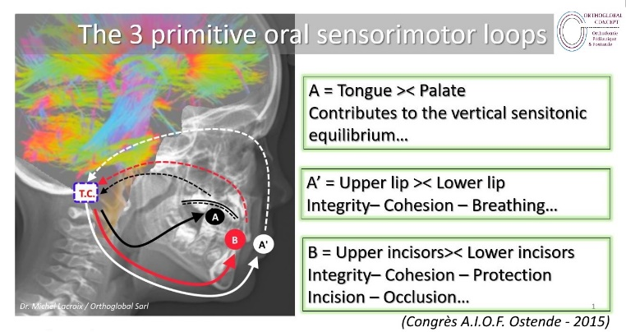
Recent Publications (minimum 5)
Issued on Swiss Medical Weekly/Supplementum 228/2018:148/May 17,2018-27S)
(Swiss Society of Paediatrics symposium- Lausanne - May 2018)
TRANSITION: from the first swallowing to the first adult molar
Dr. Michael Lacroix. Orthodontie Pédiatrique. Renens-CH
https://smw.ch/fileadmin/content/supplements/SMW_Suppl_228.pdf

Biography (150 word limit)
From more than 40 years, Dr. Michael Lacroix has oriented his clinical practice and research on early orthodontic treatment .
1977 – 2007: Dentofacial Orthodontic Practice on the French side of the French-Swiss border
From 2007: living and practicing in Switzerland
2009: creation of ORTHOGLOBAL (Lausanne) for the promotion of pediatric orthodontics. (www.orthoglobal.ch)
Nov. 2010: Member of the French Society of Pediatric Orthodontics.
2013-2014: teacher at the Swiss Federation of Osteopaths.
2015----- : research and communications on the early determinants of occlusion according to the early sensorimotor determinants of posture at AIOF (International Association of French-speaking Orthodontists) and CIMF - (International Club of Facial Morphology) - SEROPP (International Society for Research in Pediatric and Perinatal Osteopathy)
2017: Member of the Swiss Pediatric Society
2019: Active member of CIMF and AIOF
2020: Member of IPOS and AAMS (International Pediatric Orthodontic Society) (Academy of Applied Myofunctional Sciences)

Email: orthoglobal.ml@gmail.com

Notes/Comments:

