Title: Persistent abnormal vaginal flora was associated with increased risk of late miscarriage and preterm birth in Bangladesh women

Abdullah H. Baqui¹, MBBS, MPH, DrPH^{1 *}, Anne CC Lee, MD, MPH², Alain K. Koffi, MD¹, Rasheda Khanam, MBBS, MPH, PhD¹, Dipak K. Mitra, MBBS, MPH, PhD³, Sushil Kanta Dasgupta, MA⁴, Jamal Uddin, MBBS⁵, Parvez Ahmed, MBBS⁴, Iftekhar Rafiqullah, MSc⁵, Mahmoodur Rahman, MBBS⁴, Abdul QuaiyumMBBS⁴, Parul Christian, PhD⁶, Samir K Saha, PhD⁵, Luke C. Mullany, PhD¹, Alain Labrique, MD, PhD¹ for the MIST Study Team of the Projahnmo Study Group in Bangladesh

¹International Center for Maternal and Newborn Health, Health Systems Program, Department of International Health, Johns Hopkins Bloomberg School of Public Health, 615 N Wolfe Street, Baltimore, MD 21205

Keywords: Abnormal vagina flora, bacterial vaginosis, vaginal microbiome, risk factors, adverse pregnancy outcomes, Bangladesh

- Abstract Body (up to 250 words)
We conducted a cluster-randomized trial to evaluate the impact of population-based antenatal screening for abnormal vaginal flora (AVF) in rural Bangladesh. Here, we report the risk factors for AVF and association of persistent AVF with adverse perinatal outcomes. Pregnant women (n=4,221) were enrolled at <19 weeks of gestation. Self-administered mid-vaginal swabs were obtained and smears Nugent scored. AVF was treated with oral Clindamycin, and persistent AVF was re-treated. We examined risk factors for AVF and association of persistent AVF with adverse pregnancy outcomes. The prevalence of AVF was 16.5%; 9.8% had bacterial vaginosis (BV) and 6.8% had intermediate flora. Lower economic and educational status of women were associated with increased risk of AVF. One third of the women had persistent AVF; these women had higher risk of preterm birth [RR 1.34; 95% CI (1.07-1.66)], late miscarriage [RR 4.22; 95% CI (2.15-8.27)], and late fetal deaths [RR 1.57; 95% CI (1.03-2.40)] compared to women without AVF. In Bangladesh, rates of AVF and persistent AVF were high and persistent AVF was strongly associated with adverse pregnancy outcomes, particularly late miscarriage. Further characterization of the microbiome and relative bacterial species density associated with persistent AVF is needed.

Image:

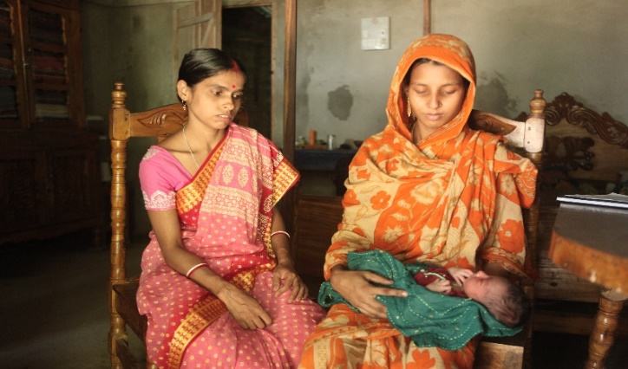
- Reference:
1 Nugent RP, Krohn MA, Hillier SL: Reliability of diagnosing bacterial vaginosis is improved by a standardized method of gram stain interpretation. J Clin Microbiol 1991, 29(2):297-301.
2. Romero R, Espinoza J, Chaiworapongsa T, Kalache K: Infection and prematurity and the role of preventive strategies. Semin Neonatol 2002, 7(4):259-274.
3. Marrazzo JM: Interpreting the epidemiology and natural history of bacterial vaginosis: are we still confused? Anaerobe 2011, 17(4):186-190.
4. Lee AC, Quaiyum MA, Mullany LC, Mitra DK, Labrique A, Ahmed P, Uddin J, Rafiqullah I, DasGupta S, Mahmud A et al: Screening and treatment of maternal genitourinary tract infections in early pregnancy to prevent preterm birth in rural Sylhet, Bangladesh: a cluster randomized trial. BMC Pregnancy Childbirth 2015, 15:326.
5. Leitich H, Kiss H: Asymptomatic bacterial vaginosis and intermediate flora as risk factors for adverse pregnancy outcome. Best Pract Res Clin Obstet Gynaecol 2007, 21(3):375-390.

Biography:
Dr. Abdullah Baqui is a professor of International Health and Director of the International Center for Maternal and Newborn Health at Johns Hopkins University in USA. He is trained in medicine, public health, and infectious diseases epidemiology. His current research interests include design and evaluation of health interventions to improve health and survival of mothers, newborns, and children and implementation research to improve coverage, quality and equity of preventive and curative health interventions in large programs in low- and middle-income countries of South Asia and Sub Saharan Africa. He has authored about 300 scientific articles published in peer-reviewed journal.

Presenting author details

Full Name: Abdullah H. Baqui, Contact number: +1 410 967 1656,
Session name/ number: Neonatal and Perinatal Medicine
Category: (Oral presentation/ Poster presentation)
Passport Number: US 50547714

