Title: Contribution of maternal nutritional status on risk for preterm birth and small for gestational age in rural Bangladesh

Khanam R^{1*}, Lee ASC², Mitra DK³, Ram M¹, Gupta SD⁴, Quaiyum A⁴, Choudhury A⁵, Christian P⁶, Mullany LC¹, and Baqui AH¹

¹International Center for Maternal and Newborn Health, Health Systems Program, Department of International Health, Johns Hopkins Bloomberg School of Public Health, 615 N Wolfe Street, Baltimore, MD 21205
² Department of Pediatric Newborn Medicine, Brigham and Women’s Hospital, 75 Francis Street, Boston, MA 02115, USA
³ North South University, Dhaka, Bangladesh
⁴ International Centre for Diarrhoeal Disease Research, Bangladesh (icddr,b), Dhaka 1212, Bangladesh
⁵ Department of Epidemiology, Johns Hopkins Bloomberg School of Public Health, Baltimore, MD 21205, USA
⁶ Bill and Melinda Gates Foundation, Seattle, Washington

Keywords: Preterm births, small for gestational age, maternal short stature, maternal underweight, adverse pregnancy outcomes, Bangladesh

- Abstract Body (up to 250 words)
Background: To estimate the risks of term-small for gestational age (SGA), preterm-appropriate for gestational age (AGA), and preterm-SGA associated with maternal height and body mass index (BMI) and to calculate the population attributable fractions (PAF) of term-SGA, preterm-AGA and preterm-SGA associated with maternal short stature.
Methods: A population based cohort of 13,230 women with pre-pregnancy height and weight followed from 2012 to 2016 in rural Sylhet, Bangladesh. We analyzed data of 2655 singleton live born infants. The babies born before <37 completed weeks of gestation were considered preterm and weight <10th percentile of Intergrowth sex specific gestational age were considered SGA. Risk factors for term-SGA, preterm-AGA, and preterm-SGA were examined using multivariate multinomial regression analysis that estimated relative risk ratios (RRR) after controlling for selected covariates.
Results: Maternal short stature <145 cm was significantly associated with term-SGA (RRR 1.88, 95% CI 1.37, 2.58; p <0.001), preterm-AGA (RRR 1.45, 95% CI 1.02, 2.05; p < 0.05), and preterm-SGA (RRR 14.40, 95% CI 1.82, 113.85; p <0.05). Maternal underweight status (BMI <18.5 kg/m²) was significant predictor of term-SGA (RRR 1.32, 95% CI 1.10, 1.59; p <0.01), and preterm-AGA (RRR 1.39, 95% CI 1.12, 1.71; p <0.01). PAF for maternal short stature were 23.2%, 7.3%, and 73.9% for term-SGA, preterm-AGA and preterm-SGA, respectively.
Conclusions: Evidenced based interventions including nutrition education and protein energy supplementation targeted to women with short stature and low BMI would reduce the burden of SGA and preterm birth in Bangladesh.

Image:

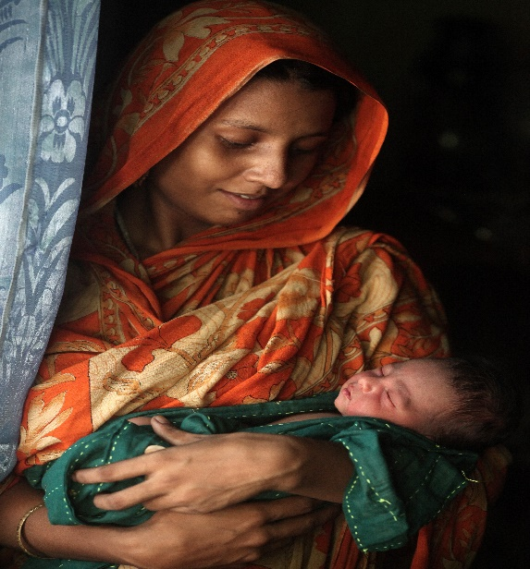
III. Reference:

1. UNICEF, WHO. Low Birth Weight: Country, Regional and GlobalEstimates. New York. http://www.unicef.org/publications/index_24840. Accessed 12 Nov 2017; 2004.
2. Blencowe H, Cousens S, Oestergaard MZ, Chou D, Moller A-B, Narwal R, et al. National, regional, and worldwide estimates of preterm birth rates in the year 2010 with time trends since 1990 for selected countries: a systematic analysis and implications. The Lancet. 2012;379(9832):2162-72.
3. Schlaudecker EP, Munoz FM, Bardaji A, Boghossian NS, Khalil A, Mousa H, et al. Small for gestational age: Case definition & guidelines for data collection, analysis, and presentation of maternal immunisation safety data. Vaccine. 2017;35(48 Pt A):6518-28.
4. Lee AC, Kozuki N, Cousens S, Stevens GA, Blencowe H, Silveira MF, et al. Estimates of burden and consequences of infants born small for gestational age in low and middle income countries with INTERGROWTH-21(st) standard: analysis of CHERG datasets. BMJ (Clinical research ed). 2017;358:j3677.

Iv. Biography:
Dr. Rasheda Khanam is an Assistant Scientist, Department of International Health and Associate Director of the International Center for Maternal and Newborn Health at Johns Hopkins University in USA. Dr. Khanam is trained in medicine, public health, and infectious diseases epidemiology. Her current research interests include improvement of maternal, newborn and child health in low-middle-income countries by enhancing the understanding of the major causes of maternal, neonatal, and child morbidity and mortality and by designing and testing cost-effective public health interventions against them.

Presenting author details


Full Name: Rasheda Khanam
Contact number: +1 443 362 0350
Session name/ number: Neonatal and Perinatal Medicine
Category: Oral presentation or Poster presentation
Passport Number: BF0800318

